herring enhancement project 2021
  - SECHELT ROTARY CLUB
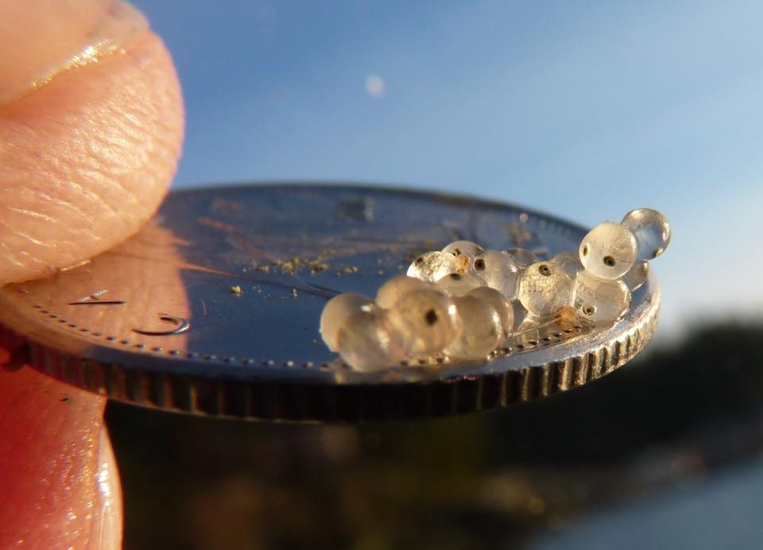

HEP 2020-21
EXECUTIVE SUMMARY
The idea for the Herring Curtain Project originated 10 years ago when a group of Squamish Stream Keepers had observed herring spawning on creosote pilings near West Terminal, a week later, all the eggs would be dead. The Stream Keepers
wrapped the toxic pilings in different materials, and when the next round of herring spawned the eggs were observed to survive and successfully hatch into fish larvae.

Over the years, much has been learned about the timing and placement of curtains, although the success of this method of enhancement is difficult to quantify, Jon Paine of the Pender Harbour Rotary Club states, “One of the main benefits has been public awareness of how essential the health of the marine environment is to all of us.”
(This reports cover picture of eggs on a coin, is by Jon Paine.)

Tiny eyes appear in herring larvae which groups in British Columbia are trying to save. The small silvery fish are a crucial part of the Pacific food web, but have declined in numbers. (Squamish Streamkeepers)

In 2018 and 2019 there were no eggs laid on the PH curtains even though there was anecdotal evidence that the herring were in areas of Pender Harbour. As a result of this, in 2020 the PH Rotary Club passed all its herring materials over to Lee-Ann Ennis.
During the 2019 season, herring spawning was observed in Sechelt Inlet at the end of March. Herring curtains placed at the Porpoise Bay government wharf were covered in eggs and successfully hatched in mid-April. A smaller spawning occurred at the curtains placed at the Maclean Bay salmon hatchery, with the endorsement of the shishalh Nation. Other curtains that were installed in late February at docks in Gibsons, Hopkins, Gambier and Halfmoon Bay, did not manage to intercept any herring spawn in 2019.
A total of 90 herring curtains were deployed on the lower Sunshine Coast in 2019. Most were hung on the side of ocean docks.

Now in 2020 all of the four Rotary Clubs on the lower Sunshine Coast have jointly stepped up to support the herring enhancement program and especially the youth educational piece proposed by Lee-Ann Ennis. Lee-Ann had already been into the HS’s to work with the youth in Pender Harbour, Sechelt and Gibsons.

Lee-Ann Ennis is a great school educator for the environment. She wanted to be involved personally with the herring projects and was willing to help with PH if she got some volunteer help installing curtains. She lives in Halfmoon Bay and has herring curtains stored there.
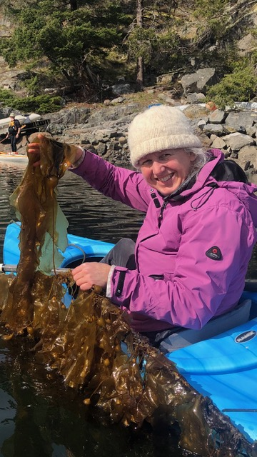
Her kelp growing project is going exceedingly well. She now grows her own seed and creating new methods for growing kelp on a line. Lee-Ann grew 3,000m of kelp out at Nelson Island! The kelp on a line attracted other forage fish to spawn, tube snouts eggs as shown in the photo.

A grand success that now needs further funding and volunteer support!!

One idea Rotary will follow-up on is possibly sinking some kelp growing lines at the dock locations where we hang herring curtains. To see if the new kelp lines will also attract the herring.

Similarly, the concept of using more of the traditional first nation methods will be pursued.

There are discussions taking place amongst a few key herring supporters that would like to see large numbers of curtains installed in more remote areas (not at docks) and then the egg laden curtains towed by boat to other locations where the eggs can safely hatch.

Unfortunately, none of the 100+/- curtains hung on the Sunshine Coast in the Spring of 2021 had any success with attracting the herring to spawn. While spawn was spotted on dock pilings in Porpoise Bay.

Finally, a big heartfelt Thank You to all of the volunteers for your diligent and committed stewarding of this project in your various locations this past 2020-21 season! Although we didn't do much for the population of herring in the Georgia Strait, certainly the primary goal, there were a number of wins which were important as a project this big gets started.
  - Table of Contents

Background 4
The Sunshine Coast Program 2018 - 2020 7
Impacts of Covid 19 in 2020 9
HEP 2021 10
Next steps 2021/22 11
Some key points from 2021 12
Results from 2021 13

Background
Pacific herring are an important forage fish for salmon, whales and other marine life. Herring have been coined ‘the big little fish’, the small silver fish that plays a major role in the life of every coastal species in BC. Herring are the keystone species of the marine food web, feeding seals, sea lions, cetaceans and seabirds. For generations herring have also fed coastal First Nations, who view herring roe on kelp as an important traditional food. Placement of hemlock boughs in water is still used as a traditional method to harvest herring roe on the Central and North Coast.

Years ago, many herring spawned on the Sunshine Coast side of the Georgia Strait, but over the years the schooling fish have spawned en-masse on the Vancouver Island side near Comox, a local fisherman had an early hypothesis, “herring evolved in darkness and are attracted to light, they were possibly attracted to Vancouver Island shores when it became built up and lit up over there, around the best estuaries.”

The idea for the Herring Curtain Project originated 10 years ago when a group of Squamish Stream Keepers had observed herring spawning on creosote pilings near West Terminal, a week later, all the eggs would be dead. The Stream Keepers
wrapped the toxic pilings in different materials, and when the next round of herring spawned the eggs were observed to survive and successfully hatch into fish larvae. Continued efforts to wrap pilings and later hang landscape fabric surfaces for herring to spawn on has resulted in an observed increase in survival of herring eggs to larvae stage around docks and floats. John Matsen of the Squamish Stream Keepers was eager to share their successful enhancement effort with any other coastal community group who were interested. Matsen contacted local newspaper and media outlets to share the story.

It did not take long for the success story to travel, Jon Paine, member of the Rotarians of Pender Harbour, was quick to tune in. Jon connected with Lagoon Society Lee-Ann Ennis, and soon a speaking engagement with John Matsen for Pender Harbour Secondary School students was booked. Everyone who heard Matsen speak that day was inspired, and before long Rotarians were sewing curtains, Pender Harbour fisherman were donating floats, ropes and lead line. The innovative Herring Curtain Project was hatched. Local residents offered their docks and the curtains went into the water on Christmas Eve, maybe a little too eagerly.

Over the years, much has been learned about the timing and placement of curtains, although the success of this method of enhancement is difficult to quantify, Jon Paine says, “One of the main benefits has been public awareness of how essential the health of the marine environment is to all of us.”

Tiny herring have big impacts on the food web as a source of nourishment for many species

Greg Rasmussen · CBC News · Posted: Apr 05, 2021 1:00 AM PT |

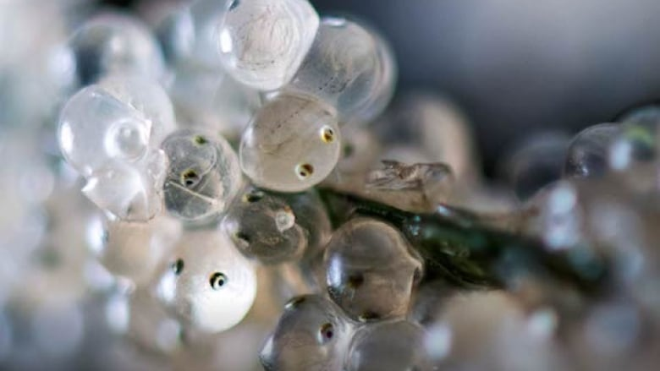

Tiny eyes appear in herring larvae which groups in British Columbia are trying to save. The small silvery fish are a crucial part of the Pacific food web, but have declined in numbers. (Squamish Streamkeepers)

Vancouver's Coal Harbour hardly looks like a setting for a potential wildlife refuge. Noisy float planes skitter to and from a nearby dock, storm sewers empty into the saltwater, and high rise towers loom over the water.
But marine biologist Doug Swanston thinks the place has huge potential as a home for herring.
Recently, he rolled three big plastic coolers onto the dock before opening them to reveal a three-metre-long piece of fabric mesh covered with tiny white dots.

"This is probably getting close to a million, maybe 1.5 million eggs if you counted them all," he said as he pulled them into the sunlight.
"The goal is to return herring to Coal Harbour. Historically, we had a spawn here in the 1800s, and it was a source of food for First Nations communities."
The eggs had been collected in a nearby area and the hope is that they will seed future runs.
Herring are a vital, but not very well understood part of the Pacific Ocean's complex food web.
But efforts are underway, in the courts and the ocean, to help the herring.

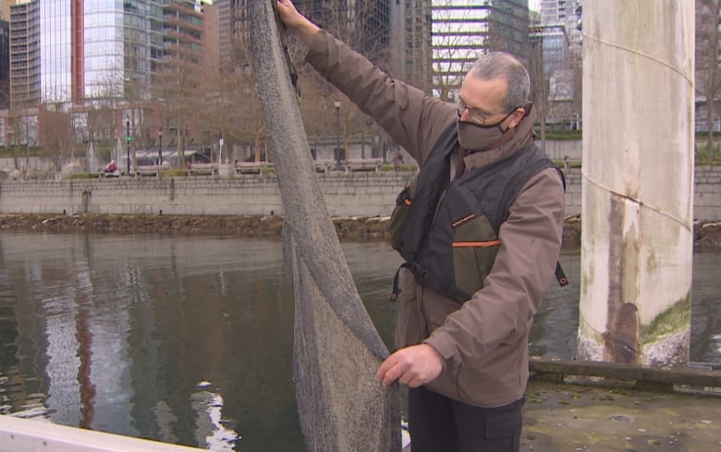

Marine biologist Doug Swanston holds up mesh fabric covered with tiny fertilized herring eggs. He is researching the impact of transplanting the eggs in the urban inlets of Vancouver. (CBC)

The Sunshine Coast Program 2018 - 2020
Based on the initial success in Pender Harbour by the Rotary Club from 2015-2017, Sam
Bowman with the sponsorship of SCREDO, organized and supported volunteers hanging herring curtains from Halfmoon Bay down to Gibsons.
In 2018 and 2019 there were no eggs laid on the PH curtains even though there was anecdotal evidence that the herring were in areas of Pender Harbour. As a result of this, in 2020 the PH Rotary Club passed all its herring materials over to Lee-Ann Ennis.
During the 2019 season, herring spawning was observed in Sechelt Inlet at the end of March. Herring curtains placed at the Porpoise Bay government wharf were covered in eggs and successfully hatched in mid-April. A smaller spawning occurred at the curtains placed at the Maclean Bay salmon hatchery, with the endorsement of the shishalh Nation. Other curtains that were installed in late February at docks in Gibsons, Hopkins, Gambier and Halfmoon Bay, did not manage to intercept any herring spawn in 2019.
A total of 90 herring curtains were deployed on the lower Sunshine Coast in 2019. Most were hung on the side of ocean docks.
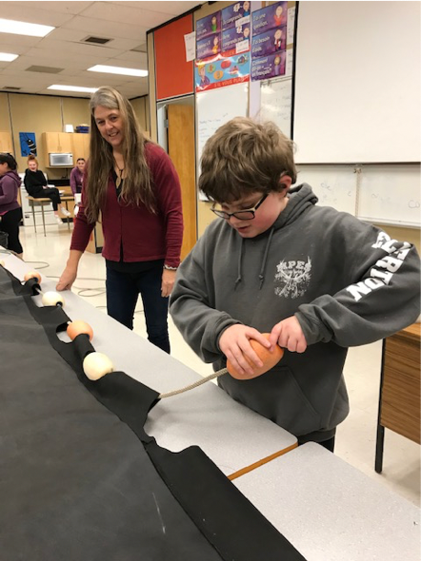
Now in 2020, Sam Bowman was unable to devote the time to coordinating the project. SCREDO had indicated it does not have the staff resources to support the coordination, but will help where possible. As a result of all this the four Rotary Clubs on the lower Sunshine Coast have jointly stepped up to support the herring enhancement program and especially the youth educational piece proposed by Lee-Ann Ennis. Lee-Ann has already been to work with the high schools in Pender Harbour, Sechelt and Gibsons. There is a presentation on the Program, an explanation of the connection between the J-Pod Orcas, Salmon, Herring and the health of the streams. This is followed by a practical session on creating new curtains.
The four Rotary Clubs on the lower Sunshine Coast are keen to pursue any projects aimed at bringing back the herring to spawn along the Coast. Raising funds and applying for grants towards research and enhancement projects is envisioned. The key is educating our youth about the need to support the Orca food chain.
Part of the 2020 and 2021 Program is data collection to support and enhance future herring egg habitats and this research will be useful to the future Pender Harbor PODS.
The coast wide Herring Enhancement Project is designed to emulate the successful herring enhancement work conducted in Pender Harbour and Squamish over the last decade. It will continue on the Sunshine Coast in future years through the sponsorship of the four Rotary Clubs, with support and help from Lee-Ann Ennis, SCREDO the Nicholas Sonntag Marine Education Centre, plus the participating marinas, community associations, dock owners and the many dedicated volunteers.

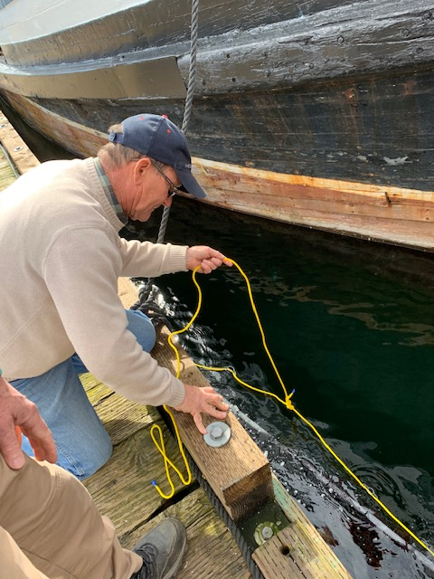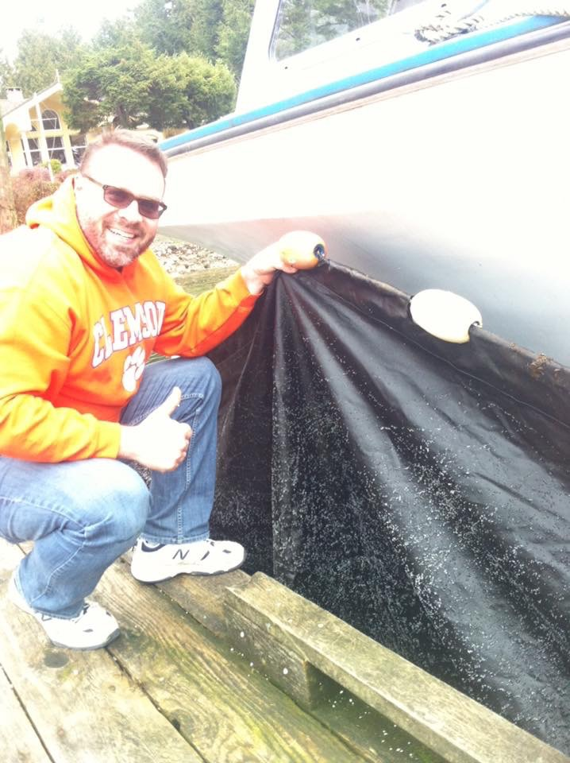

Installing and checking the curtains.
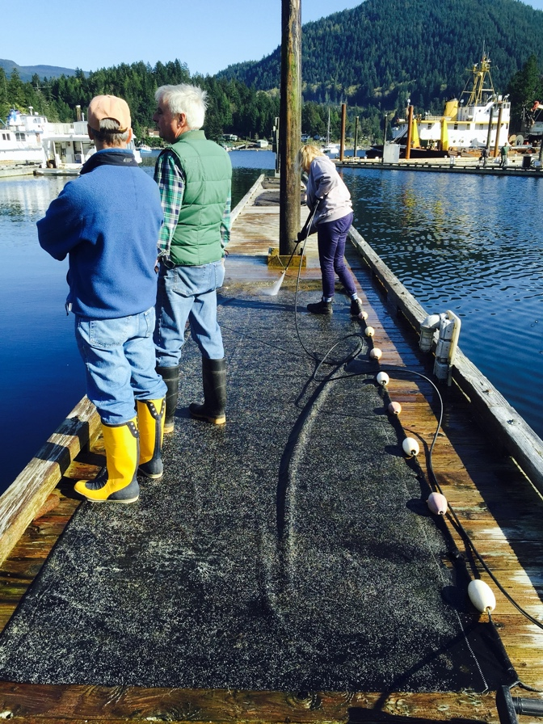
Cleaning the curtains by pressure hose.
A young female lawyer was working while two old guys watched!

Impacts of Covid 19 in 2020
Rotary is unable to get into the High Schools due to Covid restrictions, so we are unable to work with the Rotary Interact Clubs.
Lee-Ann Ennis is a great school educator for the environment. She wanted to be involved personally with the herring projects and was willing to help with PH if she got some volunteer help installing curtains. She lives in Halfmoon Bay and has herring curtains stored there. Her kelp growing project is going exceedingly well. She now grows her own seed and creating new methods for growing kelp on a line. Lee-Ann grew 3,000m of kelp out at Nelson Island! The kelp on a line attracted other forage fish to spawn, tube snouts eggs as shown in the photo below.
A grand success that now needs further funding and support!!

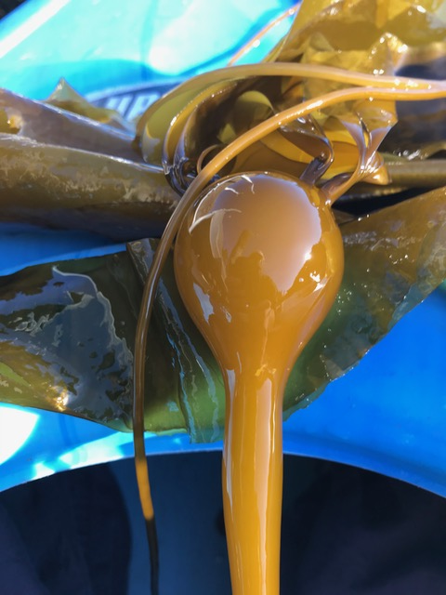
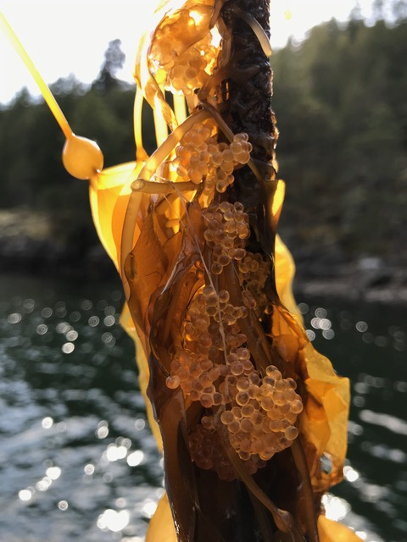

HEP 2021
Rotary had a few dozen people interested in helping here on the Sunshine Coast even without the students in the Rotary Interact Clubs, due to Covid restrictions. We had what we needed to proceed forward in this upcoming year. In 2019, 2020 and 2021 there were around 100 curtains installed on the lower Sunshine Coast from Egmont down to Langdale.

After Zooming in with the Bowen Island Rotary Club on November 26th 2020,
and hearing that the lack of results during the past 2 years has Bowen Rotarians willing to only give it one more year, it was a wake-up call! Their Rotary Club, like ours, wants to think more broadly to protect the Orca food chain.

There were two guests on the BI Zoom who represented the fish and wildlife NGO’s. They were sad to say they operated under the “Build it and they will come” syndrome!

The Sechelt Rotary Club was contacted by Jim Shortreed in Victoria looking for help.
“I am part of a volunteer herring spawning curtains project that set 71 curtains in Victoria harbor last spring.
I heard that Mike Price gave a Zoom meeting to Bowen Island Rotary Club about their herring program. I would be grateful if I could get a copy of your program.
Our program is getting set, we will have curtains set in Pedder Bay, Victoria Inner Harbour, the Gorge, Port of Sidney, in addition we hope to have 3 patrol boats looking for naturally occurring spawn.
My interest in your work revolves around getting High School students to volunteer to maintain and record the status of our curtains.’
It transpires that they also operated under the misapprehension of “Build it and they will come”.
They have had no eggs laid on any of their curtains in two years. Unfortunately, they had zero spawn again in 2021.

If many coastal Rotary Clubs understand the need to coordinate efforts, there would be a lot of goodwill and commonality produced as well, a huge notable benefit to the Environment. Now a new Rotary Area of Focus is the Environment. Rotary has the capacity to help coordinate efforts in the NW waters, by linking these clubs to work in their communities, all of us working together on a huge problem.
Further, by working as a large Rotary project in the NW, perhaps this may even create data and rationale to question the overfishing of herring all over the NW.
Rotarians in other locations in the northwest could be preparing their curtains for their areas, if we get the information and invitation out soon enough before the next Herring run in March 2022.
Grants are available for community education. This has the scope to be a Rotary Grant project, one that could add value to the whole northwest, the range of the Orca J pod.

Next steps 2021/22
The Sechelt Rotary Club will continue to run with this HEP Project. A sub-committee has been struck and Mike Price will act as Co-ordinator.
The curtains are inexpensive to make, and we can handle showing people what to do. However, because of Covid, we need a simple video showing how to make and hang the curtains. Show them being dropped and hung properly, some Do's and Don'ts, then how to clean, dry and store them well for the following year. Eastlink TV has offered to take video footage of the process. Then we will blend the segments into an educational piece.
With a Toolkit of video, flyer, PP presentation, briefing notes and an invitation to other clubs to join the movement of HEP 2022, we can leverage efforts, thus increase the probability of creating much stronger results, working together,
Then collectively we stand a chance of being in the right places, maybe working with other First Nations to attract herring to cedar and spruce boughs. Plus, possibly relocate eggs to other carefully chosen areas to increase herring population.
A webpage set up to incorporate materials to help increase herring population would be a great start, giving full credit for leadership of Squamish and Pender Harbour groups.
By doing this we'd gain more interest than we could possibly use, with a steering committee of interested volunteers dividing up the tasks.
This is an excellent large project proposal, considering the scale of what needs to be done, requiring both communication and organization.
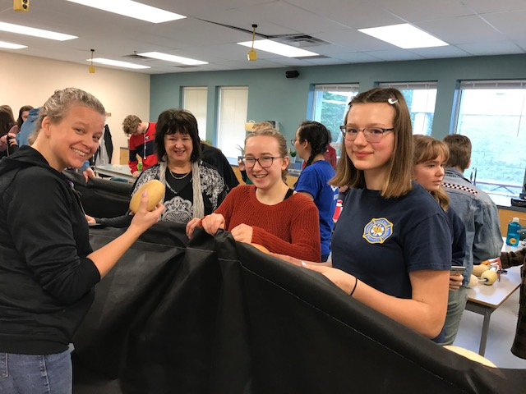
Lee-Ann taught two Rotarians and two Chatelech HS students how to make curtains!
L-R Tanya Hall and Margie Garrard.

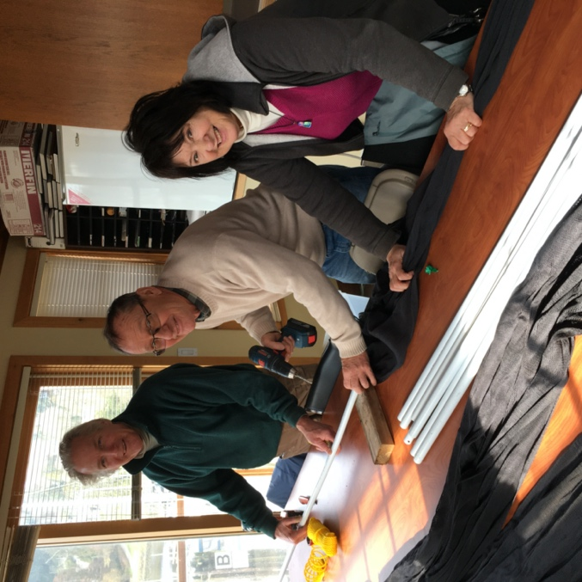
Below L-R Doug Martinsen, plus Ken & Margie Garrard

Some key points from 2021
On the Sunshine Coast from Pender Harbour to Langdale a total of around 100 curtains were hung off floating docks in the ocean. A key location involved installing some herring curtains in McLean Bay in Sechelt Inlet, at the gated shishalh Nation hatchery. These curtains are made of nylon netting and are able to be power washed and are still good after their 3rd season. After 2 seasons of experimenting, the netted ones are definitely preferable to landscape fabric, and although Rotary still has enough netting for another 2 curtains for next year, we will source more of the netting provided we can also access the lead core rope for the bottom which works best to keep net curtains from folding over on themselves in current and tides.

At McLean Bay four shishalh Nation educators, including their cultural head person, brought over 40 school children to the docks to see the herring curtains and make a cedar & hemlock swag. The classes were from Kinnikinnick School, under the guidance of Rita Poulsen, language coodinator, and they learned the importance of the herring in the marine food chain. They brought boughs and hung some off the dock, then had a history lesson and sang the Honor song with Andy Johnson. As Rotarian Margie said, ‘It was powerful and inspiring to witness the children lowering boughs into the water, using the traditional ways again!’

Picture is from a website showing traditional boughs loaded with herring eggs!

While there were negligible herring eggs on the curtains in Porpoise Bay it should be noted that spawn occurred on all the Lighthouse Pub dock pilings, just not on our curtains, as they were lowered too late in 2021. Both years have seen good spawn there on the pilings, and many have commented on it as being notable given the dirty water there. As well the spawn at the mouth of Sechelt Creek up the Inlet has been strong, layers deep in both years as well.

Rotarian Margie Garrard was ably assisted by Chatelech HS student Avery Lane with the curtains in Porpoise Bay.

Results from 2021
Unfortunately, none of the curtains hung on the Sunshine Coast had any success with attracting the herring to spawn. While spawn was spotted on dock pilings in Porpoise Bay.

As Jim Shortreed reports from Victoria on Vancouver Island, - “Unfortunately it shows that there was no herring spawning south of Dodd Narrows. The herring in our section of the Strait of Georgia are extinct. I'm urging everyone to call and write DFO to stop the Food and Bait Fishery as recommended by the David Suzuki Foundation. We've overfished our herring to death, and we don't need to overfish the last herring.”

But as Sechelt Rotarian Margie Garrard puts it,

“A big heartfelt Thank You to all of the volunteers for your diligent and committed stewarding of this project in your various locations this past 2021 season! Although we didn't do much for the population of herring in the Georgia Strait, certainly the primary goal, there were a number of wins which were important as a big project gets started. Together the volunteers accomplished several important goals:

1...We mobilized herring curtains in 4 locations in Sechelt, and have the addition of a 5th, at McKenzie Marine next year.
2.. We assisted and encouraged both Bowen Island and Gibsons Rotary clubs to hang curtains in their areas.
3...We facilitated local shishalh Nation to show 40 elementary school children traditional hanging of swags for herring roe at McLean Bay
4...We responded to DFO with feedback on the extent of commercial herring fishing and asked for lower quotas
5.. We were ready to capture on video a herring spawn and track the development of roe to maturity. Next year we hope!

With all the background material Rotary has collected and with Avery Lane’s high school assignment she is preparing (part of her course credit) plus next year's video, we can anticipate a first rate Herring Project Report 2022 from our Herring Team collective efforts. Our Herring Project will be a valuable addition to Rotary's new Environment focus. By then we should also have solid stats on the extent of the surface trash cleanup from our Seabin in Porpoise Bay at the Sunshine Coast Air dock to add to our report!”

