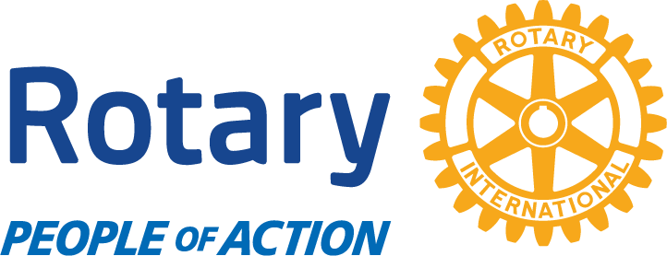
NEWSLETTER #1 for ‘FRIENDS of ROTARY’
in cha’tlich BC.

Thank You Volunteers
We would be unable to do all our local community projects without our great volunteers! Whether it’s writing those 1,200 Thank You cards for the SC healthcare workers or making, hanging and checking the herring curtains as part of our Herring Enhancement Program that is supported by all 5 Rotary Clubs on the Sunshine Coast. We can’t do it without you! This Newsletter is a way of letting you all understand the role you play, and maybe, get you interested in other items!

Recent projects with volunteers - Spring 2022
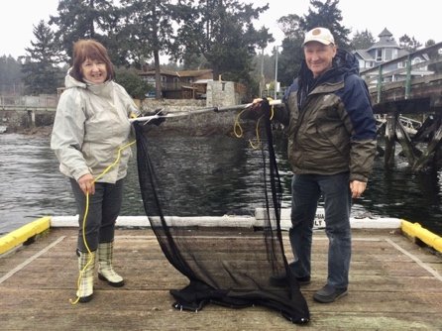
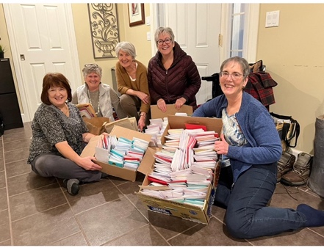
Thank You cards to SC healthcare workers for Valentines Day.
Ready for delivery!

Herring Enhancement Program 2022

Ongoing local activities
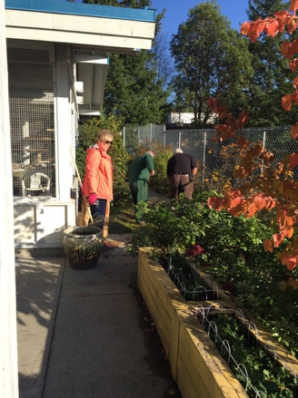
Garden maintenance at the SPCA building in Wilson Creek.

PLUS: Painting parties (of the buildings) at the Salmon Hatchery
Hwy 101 litter clean up in Wilson Creek followed by a social.

Your Club in action – LOCAL projects
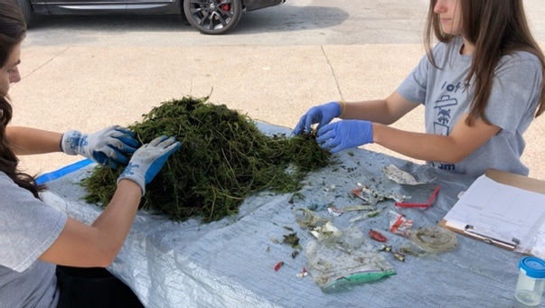
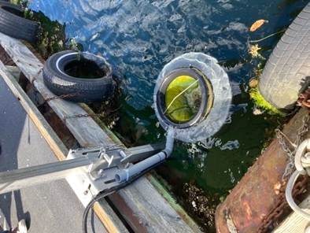
The ‘Seabin’ is an ocean surface trash collector and is now located at the MacKenzie Marina in Porpoise Bay.

Next step is to create a ‘Trash Team’ to analyse the collection

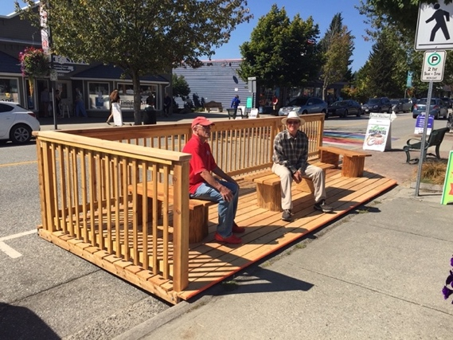
Reinstalling the two seating decks on Cowrie Street in Spring 2022

PLUS: -

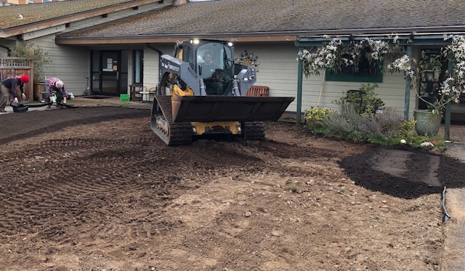
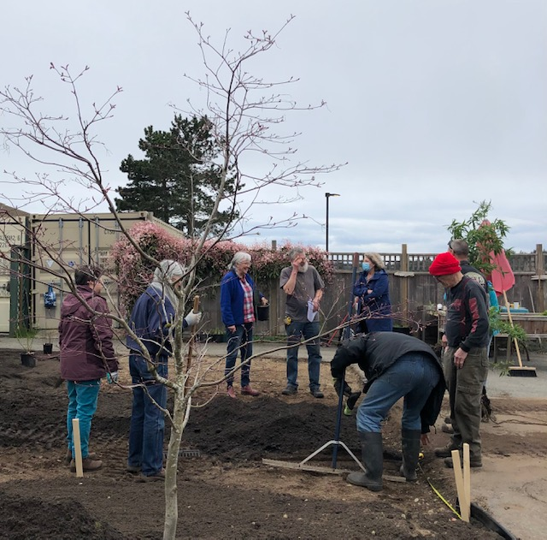
Remaking the garden space at Totem Lodge with the Sunshine Coast Garden Club. Jointly funded with Totem Lodge.
Supporting the youth in Sechelt
Participating in the
Herring Enhancement Project
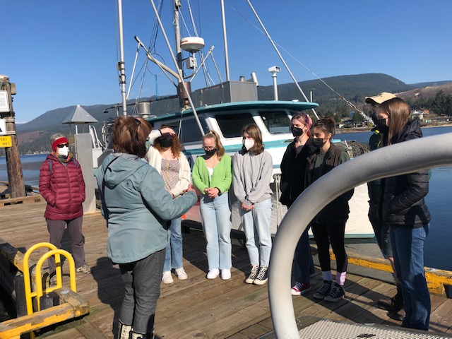
Fundraising at the Cowrie Street
Festival of Lights.
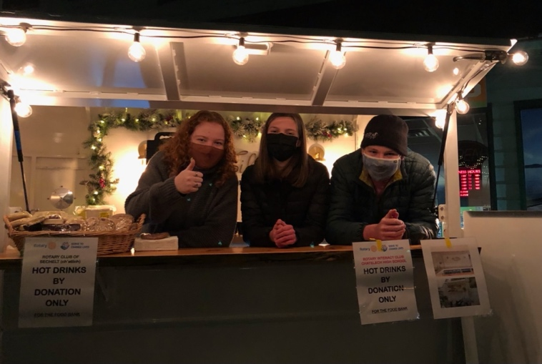

We provide scholarships annually to eligible graduating High School students.
Plus, we encourage, and pay for, HS youth to attend Rotary Leadership courses.

Now the Covid restrictions are lifted….
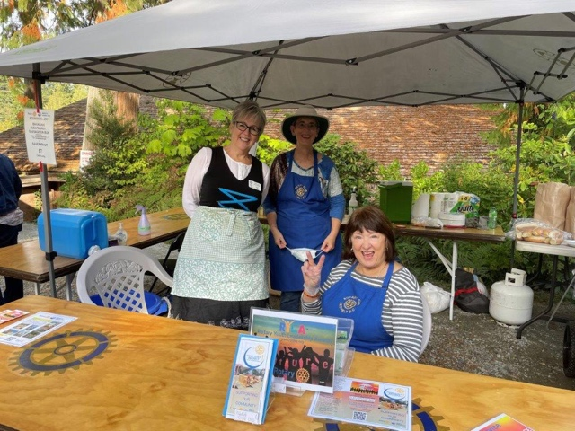
We can get back to the BBQ fundraising events!

And handing out cheques to many worthy local causes!
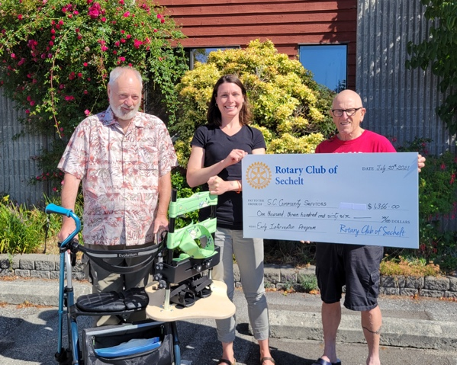

Next BBQ is Canada Day in Hackett Park.
Ongoing INTERNATIONAL project participation ($’s)
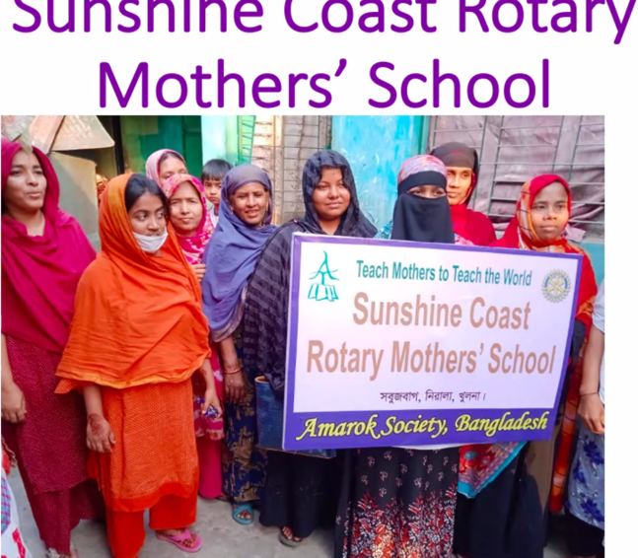
Teaching ‘Mothers to Teach Others’ at our Sunshine Coast Rotary school in Bangladesh through the Amarok Society.

In Uganda our Club has contributed towards a farm start-up costs. Will include orphanage and school for 6yr olds and up. Property fencing and a bored well to start the project here.
PLUS: -
KIVA small business loans to developing countries
Rotary World Helps – currently sending medical supplies in container to Tanzania
Shelter Boxes (for disaster relief including currently Ukraine)

And of course, our #1 international goal, the eradication of Polio!
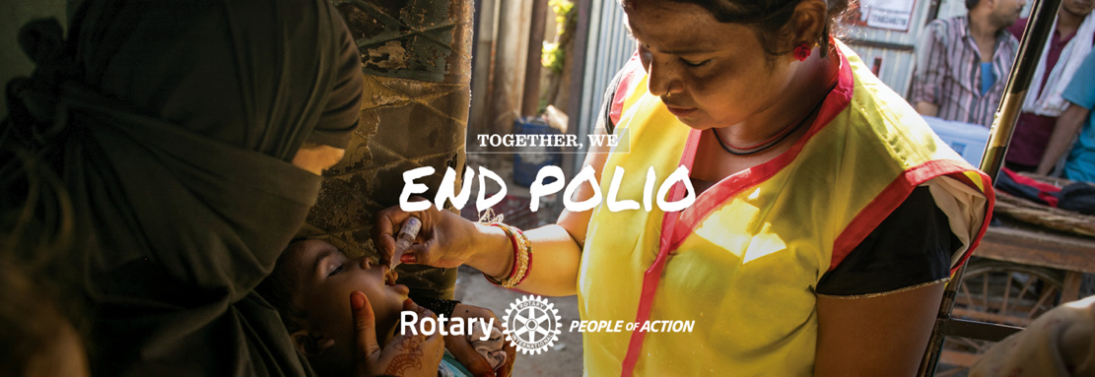

Remember Friends, we can’t do it without you! It takes a TEAM!
TOGETHER EVERYONE ACHIEVES MORE!

