**Rotary Club of South Everett-Mukilteo**

PO Box 3391

Everett, WA 98213

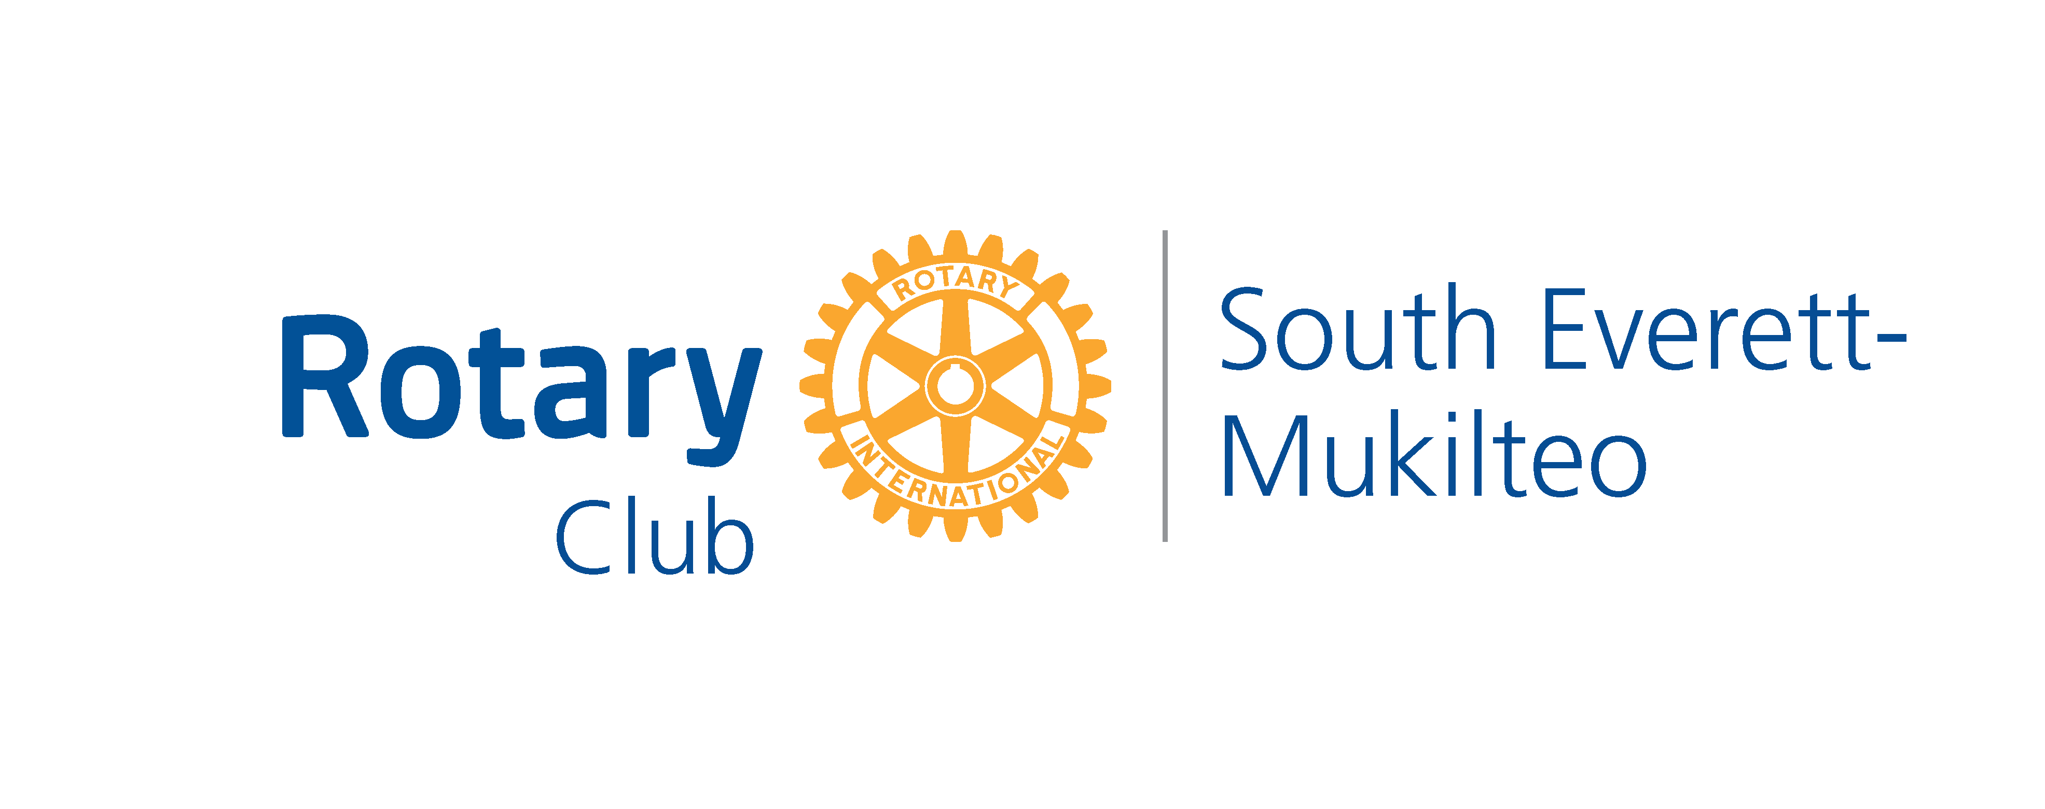

# ROTARY CLUB OF SOUTH EVERETT MUKILTEO

**DOMESTIC FUND ALLOCATION COMMITTEE GUIDELINES**

The Rotary Club of South Everett Mukilteo (SEMR) is a fellowship of community members who volunteer their time and raise money through fundraising efforts to support and fund local community projects and services.

**GUIDELINES**

SEMR accepts funding requests from charitable organizations whose requests fall within its general guidelines.

1. Grants are for local projects and programs only and will not fund operating expenses, deficits, for-profit activities, retroactive requests, salaries, sales ventures or capital campaigns.
2. We direct our efforts to enhance local impact. We utilize Rotary’s Areas of Focus as thematic guidelines for funding request approval: promoting peace; fighting disease; providing clean water; saving mothers and children; supporting education; growing local economies; and protecting the environment.
3. Proposals are limited to a single year. Rotary cannot commit to funding projects on an ongoing basis, although this does not preclude the applicant from submitting requests each year. Multiyear grants require Board of Directors approval.
4. No funding requests will be accepted or reviewed without a completed SEMR Funding Application form.
5. SEMR favors projects that have a long-lasting impact on our local community.
6. SEMR favors groups who help themselves and who demonstrate sound planning, administration and fiscal practices.
7. Subject to the discretion of SEMR, applicants may be required to provide financial statements and disclose other funding sources in support of your application.
8. Preference is given to requests that benefit a significant number of citizens, the South Everett Mukilteo community at large, or smaller groups in special circumstances.
9. Fund Allocation grants may not be used for programs that are considered furthering religious doctrine or political campaigns.
10. Fund Allocation Committee members who draw a salary from a requesting organization or serve in some capacity in that organization may answer questions regarding the request, but must abstain from voting on the request.

## HOW TO APPLY

1. Determine if your project or program fits our guidelines and funding priorities.
2. Fully complete SEMR’s “Funding Application Form.” This document can be found on our website at [www.semrotary.org](http://www.semrotary.org). Go to Home Page Download Files, then Rotary Club of South Everett Mukilteo Domestic Fund Application Request Form.
3. E-mail the form to the Fund Allocation Chairperson listed on the form.

## REVIEW / APPROVAL PROCESS

1. Fully completed “Funding Application Forms” will be reviewed by SEMR’s Fund Allocation Committee at the next scheduled meeting. The committee either supports the funding request by making a financial support recommendation to SEMR’s Board of Directors or they deny the request.
2. Funding recommendations are presented to and voted upon by SEMR’s Board of Directors at their monthly meeting.
3. Once approved, the fund allocation committee chairperson or other designated person will contact the applicant and arrange for the presentation of a check and media coverage as appropriate.

Revised February 2023