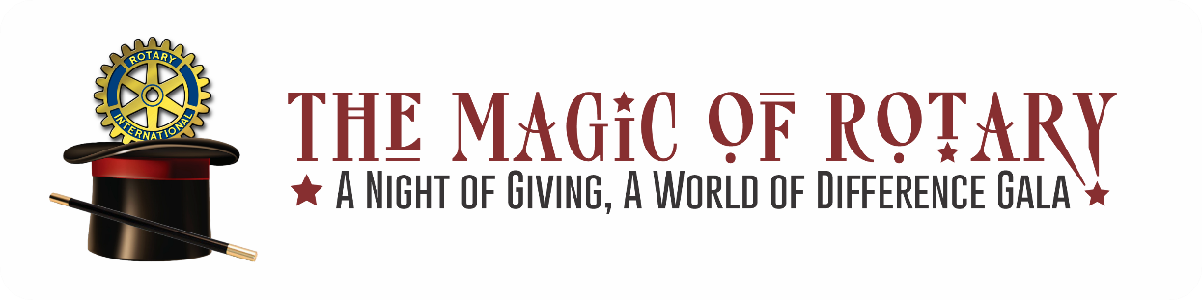

The South Everett-Mukilteo Rotary Club (SEMR), a group of professional men and women from our local area, has been giving back and acting in our community for more than 20 years through financial support and hands-on service projects.
Each year, SEMR supports worthy non-profit groups though grants funded with dollars raised at our annual dinner and auction. This year’s auction, our 24th annual auction, will take place on Saturday, April 15, 2023, at the Tulalip Resort Casino.
SEMR supports projects both locally and internationally, ranging from peace and conflict prevention/resolution, disease prevention and treatment, clean water and sanitation, maternal and child health, to basic education and literacy, and economic and community development. Each year our club provides sponsorships to graduating high school students, over 350 Thanksgiving baskets to low-income families, and we take children shopping to provide holiday gifts for their families.
I hope you will consider donating an auction item to allow our club to maintain its support of charities who serve our greater area. We will be honored to recognize you at our event and in our auction catalog to thank you for your generous support. Our procurement deadline is April 3, 2023.
I’d be happy to answer any questions you may have regarding your donation and have enclosed an auction procurement form to help with the process.
Thank you in advance for contributing to the success of our event and supporting our community. I look forward to speaking with you soon.

Sincerely,
South Everett-Mukilteo Rotary Club

South Everett ~Mukilteo Rotary Club Foundation: Federal Tax ID #91-1971896

