

The South Everett-Mukilteo Rotary Club (SEMR), a group of professional men and women from our local area, has been giving back and taking action in our community for more than 35 years through financial support and hands-on service projects.
Each year, SEMR supports worthy non-profit groups through grants funded with dollars raised at our annual dinner and auction. This year’s auction, our 29th annual auction, will take place on Saturday, April 18, 2026, at Archbishop Murphy High School in Everett, WA.
SEMR supports local projects in the areas of peace and conflict prevention and resolution, disease prevention and treatment, clean water and sanitation, maternal and child health, basic education and literacy, economic and community development, and providing scholarships to local students. Our club takes initiative by providing over 365 Thanksgiving baskets to low-income families, taking children shopping to provide holiday gifts for their families, helping build schools in Guatemala, and much more.
I hope you will consider donating an auction item to allow our club to maintain its support of charities that serve our greater area. We will be honored to recognize you at our event and in our auction catalog to thank you for your generous support. Our procurement deadline is April 5, 2026.
I will be happy to answer any questions you may have regarding your donation and have enclosed an auction procurement form to help with the process.
Thank you in advance for contributing to the success of our event and supporting our community. I look forward to speaking with you soon.

Rotary Club of South Everett-Mukilteo
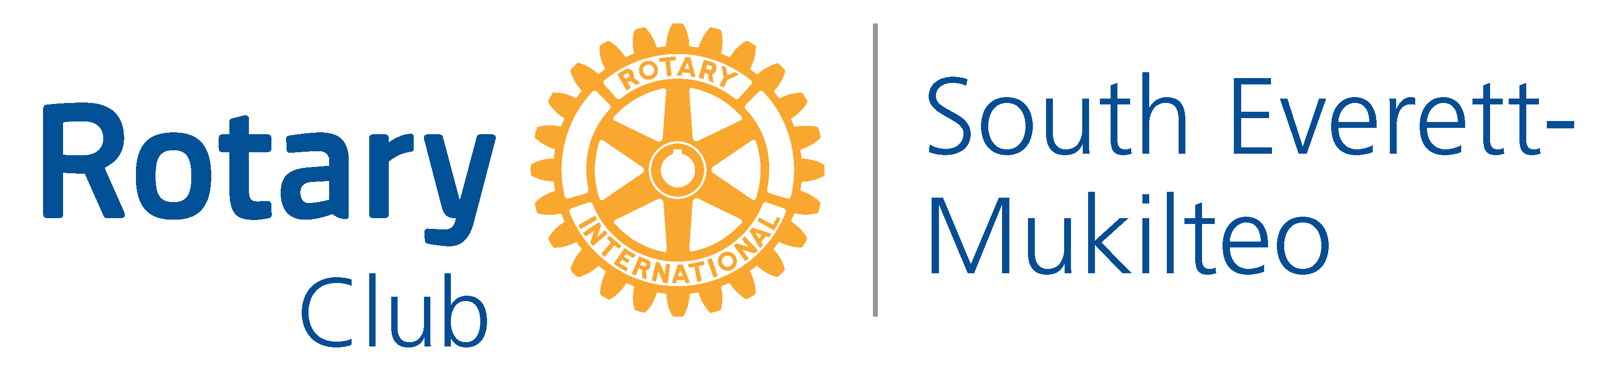

South Everett ~Mukilteo Rotary Club Foundation: Federal Tax ID #91-1971896
South Everett-Mukilteo Rotary Foundation PO Box 3391 Everett, WA 98213

