THE WHIP

March 28, 2018

Newsletter for the Rotary Club of Kelowna Capri
Edited by John Mullock

President Peter Spek President Elect Vacant
Secretary Mike Flynn Treasurer Dan Nichvoldow

Mar 29 Update on fundraiser
Mar 31 Bowling for Rotary Fundraiser
Apr 5 Central Okanagan Search and
Rescue
Apr 12 Johann Berger – RC Munich –
spouses and partners welcome
Apr 19 Tourism Kelowna
Apr 26 TBA
May 3 Rhino Project – location and
time to be confirmed
May 10 Amarok Society

RAMBLING

Ron is…

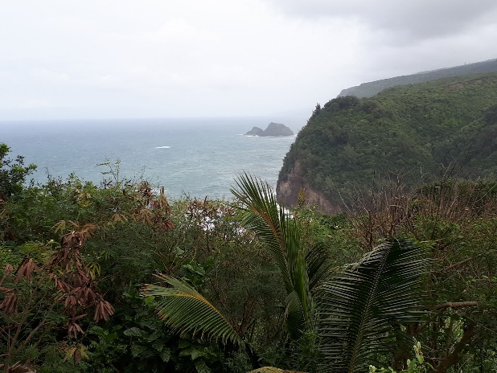
Still on Hawaii…

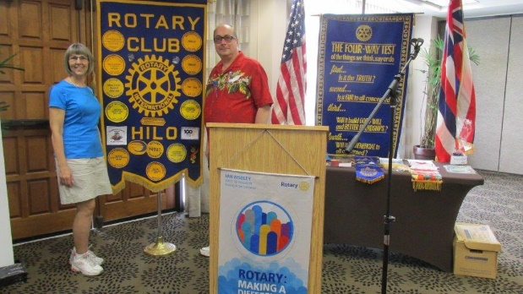
Attending meetings of the local club and…

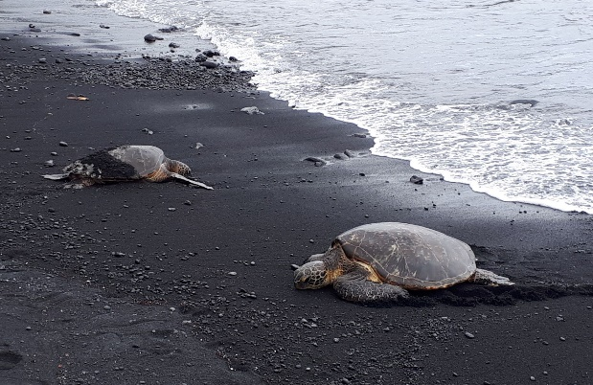
Watching turtles lay their eggs on Punalu'u
or Black Sand Beach

Meanwhile…

Happy Easter to everybody!!

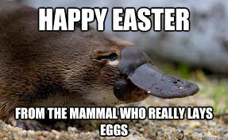

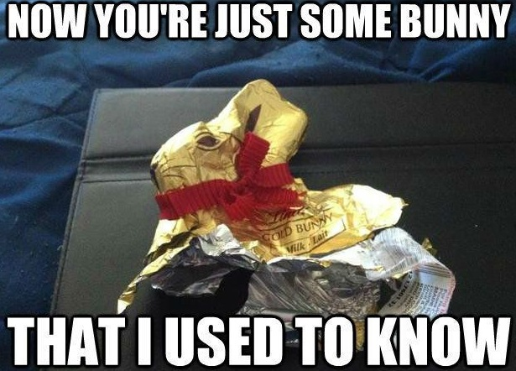

MEETING OF MARCH 22, 2018

ATTENDANCE – 82%

Mike won the $10 this evening.

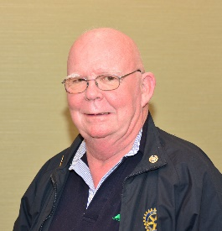

There is something about an Assistant
District Governor being Sheriff that is scary. They just can’t resist asking nasty questions about Rotary.(questions become nasty when they cost me fines) So what type of questions did he ask? Do you have the new Rotary lapel pin? Did you donate to Heart & Stroke during their campaign? What special event is happening on May 5th? (Spring Assembly in Summerland). There were more questiojs but I stopped noting them because my loonies were all gone.

ROTARY THEME FOR 2018-2019

SIGNS SIGNS EVERYWHERE THERE’S SIGNS

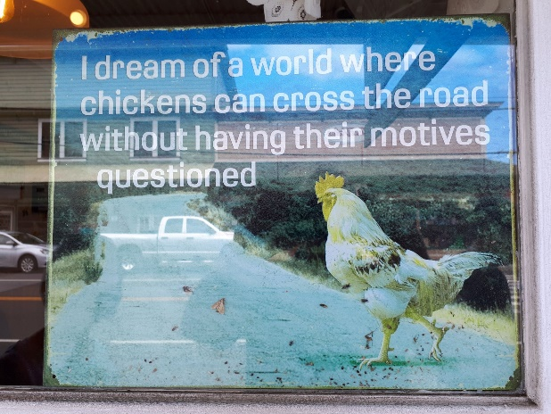

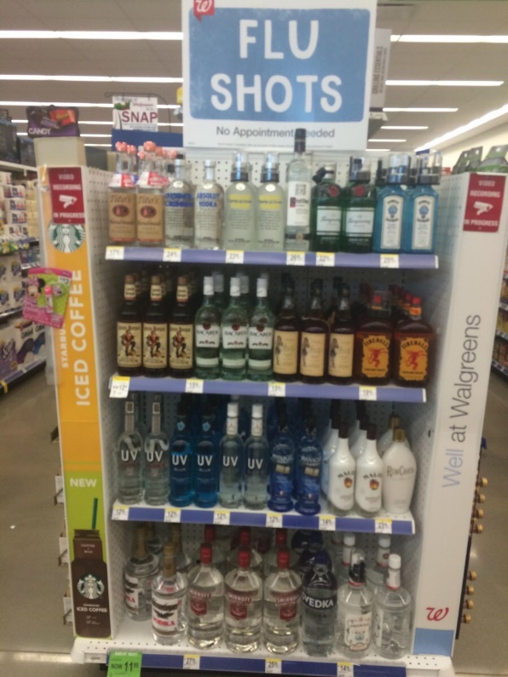

The Rotaract Club will be celebrating its 10th Anniversary on April 30th. Plans are in the
works and more information will follow.

Upcoming events
Apr 4 Speaker: Interview Skills
Apr 18 Club and Exec Meeting
Apr 26 Speaker: Save a Rhino Fund
Apr 30 Super Huge Party

In the News -

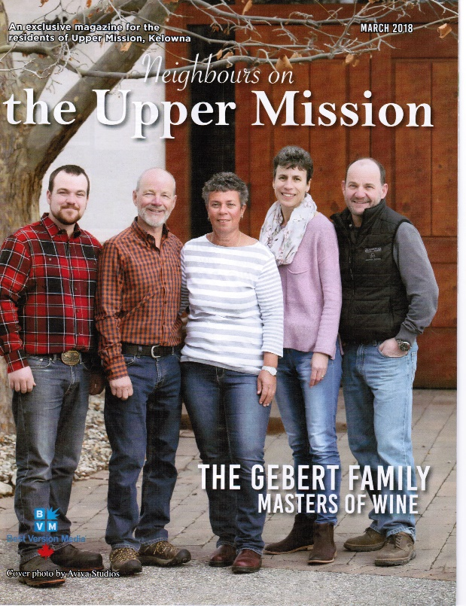

Fund Raiser – final arrangements have been made, prizes are waiting and all we need now is for you and your guests to come out and have a good time.

Missionwood Visit – we have current and former members of the club that we don’t see very often because of various medical reasons. On March 22nd club members went to Missionwood Retirement Resort to visit with Dan, Jim, Gordon and Glen. In addition to the joy of socializing with them, the club presented each with a bottle of wine, a card and a Christmas in a Bottle to let them know that they are not forgotten.

Len will be organizing the next one near the end of March or early April.

Trivia Night – The Okanagan-Mission Club will be holding their annual Trivia Night on April 15th.

Food Drive for the Foodbank – this year’s joint Rotary club food will be held on April 30th.

Friends of Rotary ‘Christmas in a Bottle’ Fundraiser -

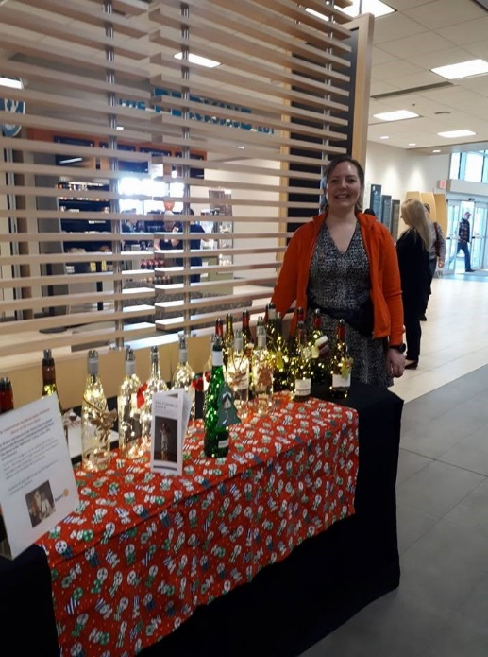

"Christmas in a Bottle" sells for $20 per bottle and includes: a string of lights and switch in a wine bottle, an AA battery, a Christmas decoration that can be taken off when it's not Christmas, a wine gift bag, and a pamphlet explaining the Rotary Club of Kelowna Capri sponsorship of the annual Cottonwoods Christmas Party. Sales are ongoing with the next hospital sale to occur in early April.

HUMOUR

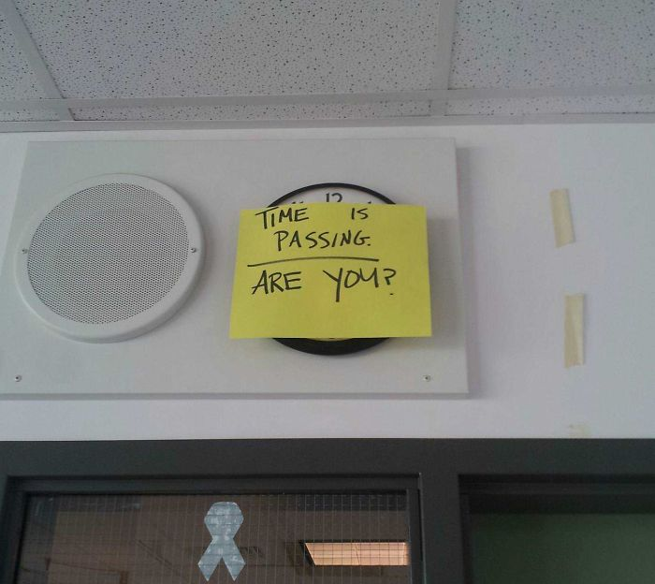

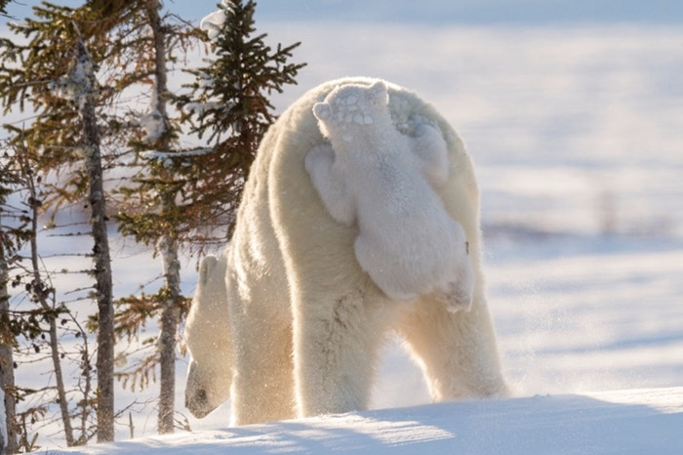
Does this qualify as a Klingon?

GUEST SPEAKER

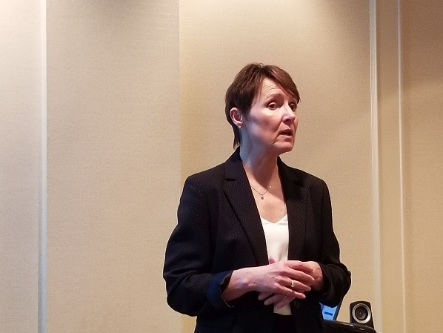
Gail Harrison speaking to the club

Our guest speaker this evening was Gail Harrison who spoke on the KGH Joanna’s House project named after Joe and Anna Huber. The KGH Foundation has committed to raising $8 million to build and operate JoeAnna’s House, a home-away-from-home for families to stay while a loved one receives treatment at KGH.

The presentation was very interesting and I invite to check out their website at

https://www.kghfoundation.com/joeannas-house/

where you can also donate.

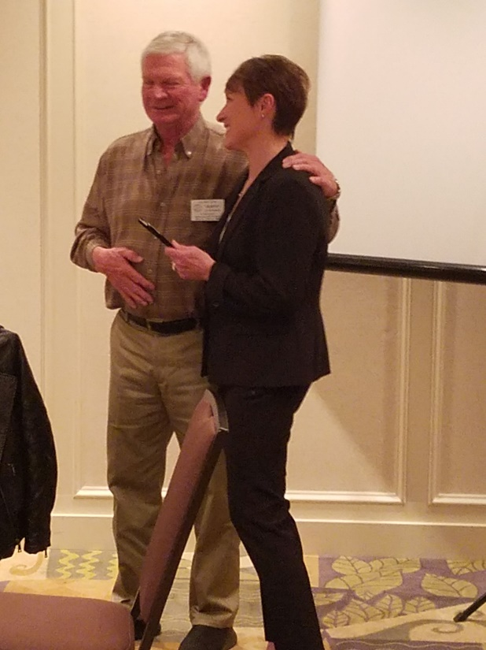
Gail Harrison receives our coveted speakers pen from Rusty

ART GALLERY

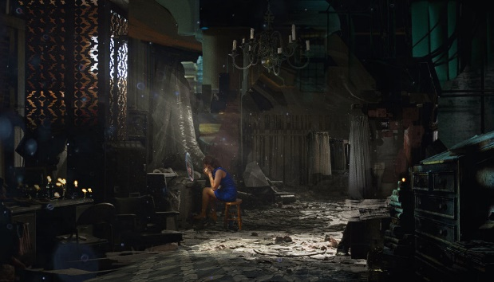
Alone by Aleksei Liakh (Russia)

Lonely Lights by Renata Petras (Romania)

Alone by David Richards (USA)

ADVERTISING

www.tristartravelandcruise.com/

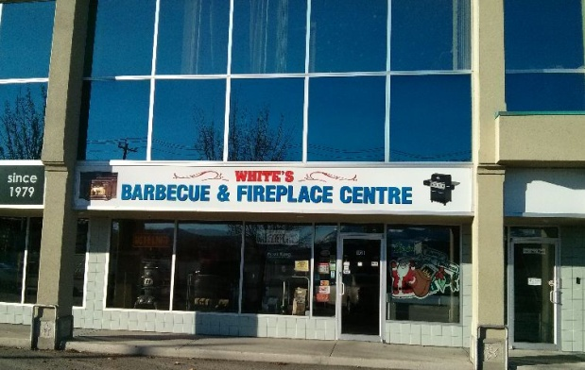
White’s Barbecue and Fireplace Centre
160-2000 Spall Road, Kelowna, B.C.
V1Y 9P6 250-862-3240
www.barbecueandfireplacecentre.com/

www.spekconsultancy.com

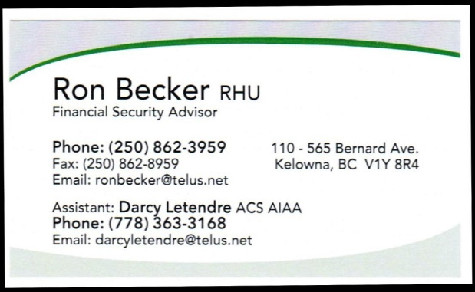
https://ca.linkedin.com/in/ron-becker-68087817

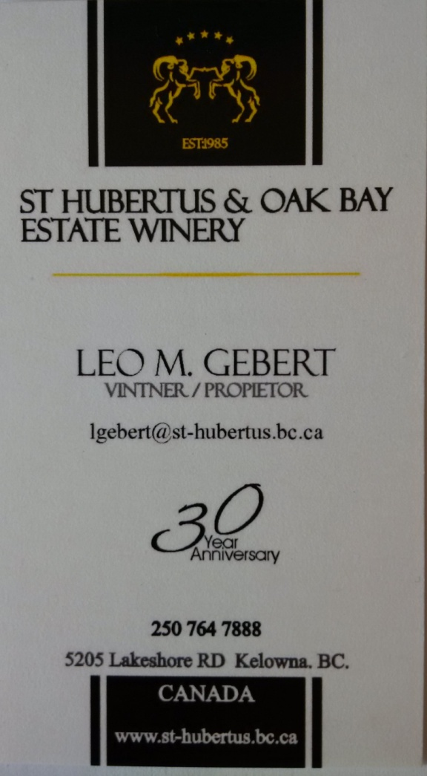

www.cdikelowna.com/

www.illichmanns.com/

