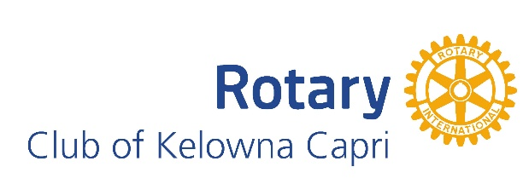

CAPRI ECHO
November 20, 2025

Newsletter for the Rotary Club of Kelowna Capri
Website: https://caprirotary.ca/

President Peter Spek
Treasurer Lockie Bracken Secretary Carola Spek Editor John Mullock ( jmullock7766@gmail.com)


Birthdays
Nov 24 - Regular Meeting Dec 3 – Brian Street
Dec 1 – Regular Meeting Dec 13 – Kurt Hoeschle
Dec 8 – Regular Meeting Dec 22 – Carola Spek
Dec 15 – Regular Meeting Anniversaries
Dec 8 – Regular Meeting None in December
Dec 22- RC Christmas Party


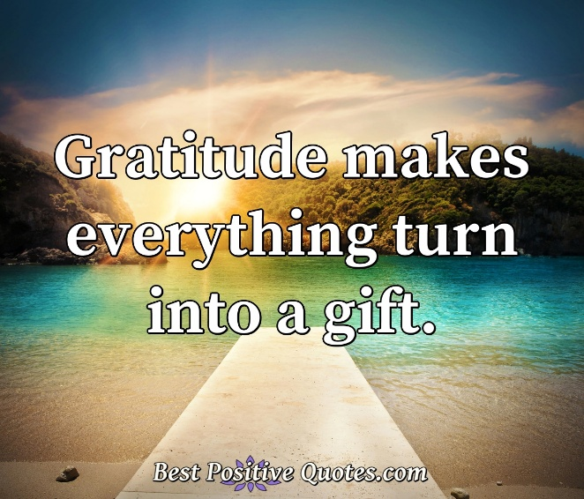
SIGNS ON SHIRTS
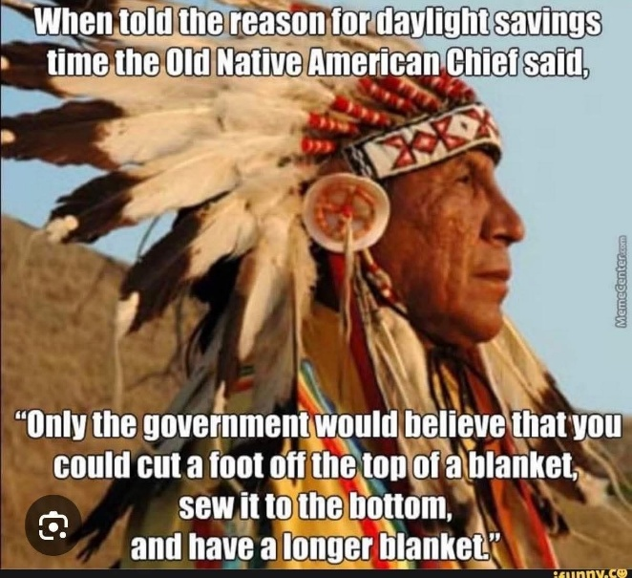

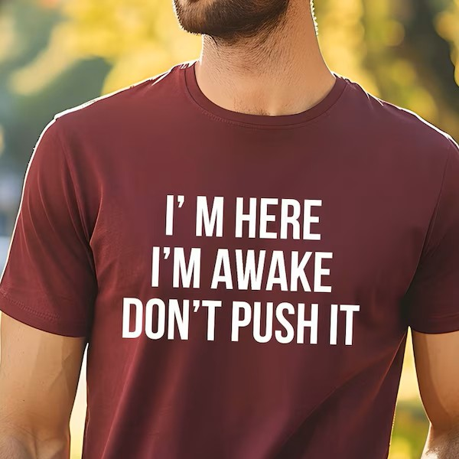

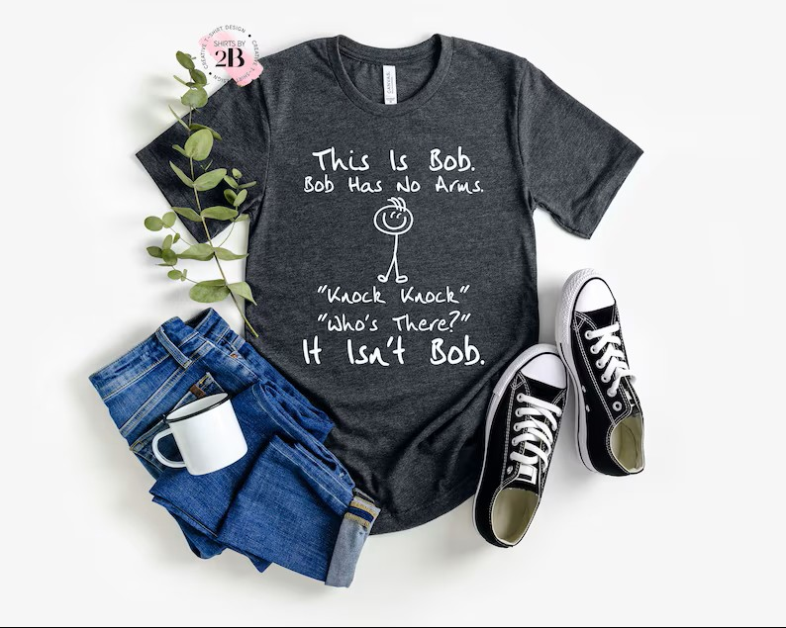

The Sheriff this week was Peter Spek. He had a few expensive facts for the members.

Wombat poop is cube-shaped. The cube form prevents it from rolling away, allowing wombats to stack it like Lego bricks to mark territory.

The unicorn is Scotland's national animal. Chosen in Celtic mythology as a symbol of purity and strength—because nothing screams "fierce" like a sparkly horse with a horn.

Honey never spoils. Archaeologists have found pots of honey in ancient Egyptian tombs over 3,000 years old that are still perfectly edible. Nature's eternal snack.

The shortest war in history lasted 38 minutes. In 1896, Britain and Zanzibar duked it out; Zanzibar surrendered faster than you can microwave popcorn.

Sloths can hold their breath underwater for up to 40 minutes—longer than dolphins. They achieve this by slowing their heart rate to one-third normal speed. Extreme napping pays off.

There's a basketball court on the top floor of the U.S. Supreme Court building, nicknamed the "Highest Court in the Land." Justices dunk on justice.

As you can see he has raised the bar on quality and has clearly challenged the Sheriff to do better.

Rotarian Art Gillan

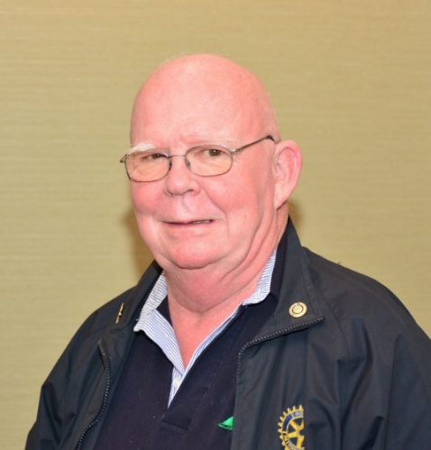

2025-2026 Capri Rotary Club President – we are looking for a volunteer to serve as next year’s President.

Rotary Day July 2026 – things look good for 2026.

RC Capri Fundraising

As I recall we have an order going out.
RC CHRISTMAS PARTY
The 2025 Christmas Party for our club members and guests will be held on December 22nd. There is also a voluntary gift exchange with the maximum value of the gift set at $20.00

HUMOUR
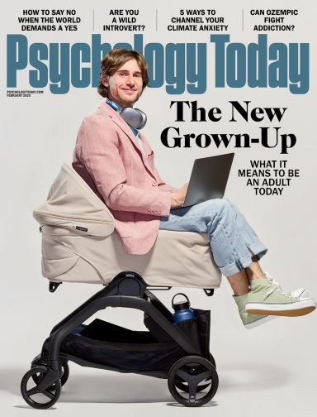An old joke but does this ring bells about how our society is running?

GUEST SPEAKER


Tonight’s speaker was Wendy Williams, Kelowna Community Resources, Fund Development Facilitator.

At the heart of a thriving community are those who give back. This year, our Community Services team mobilized over 15,753 volunteer hours, hosted transformative workshops, and deepened our diversity, equity, and inclusion initiatives. Together, we’re helping non-profits and volunteers make lasting change.

2025 & Beyond — Future-Focused • Integrated services continue in: Newcomer & Refugee Support, Family & Early Years, Community & Volunteer Engagement, Employment • Commitment to equity, reconciliation, and systemic change deepens.

It was an interesting presentation and an organization worth considering if you are looking for someone to volunteer with check out

https://kcr.ca/about-us/contact-us/

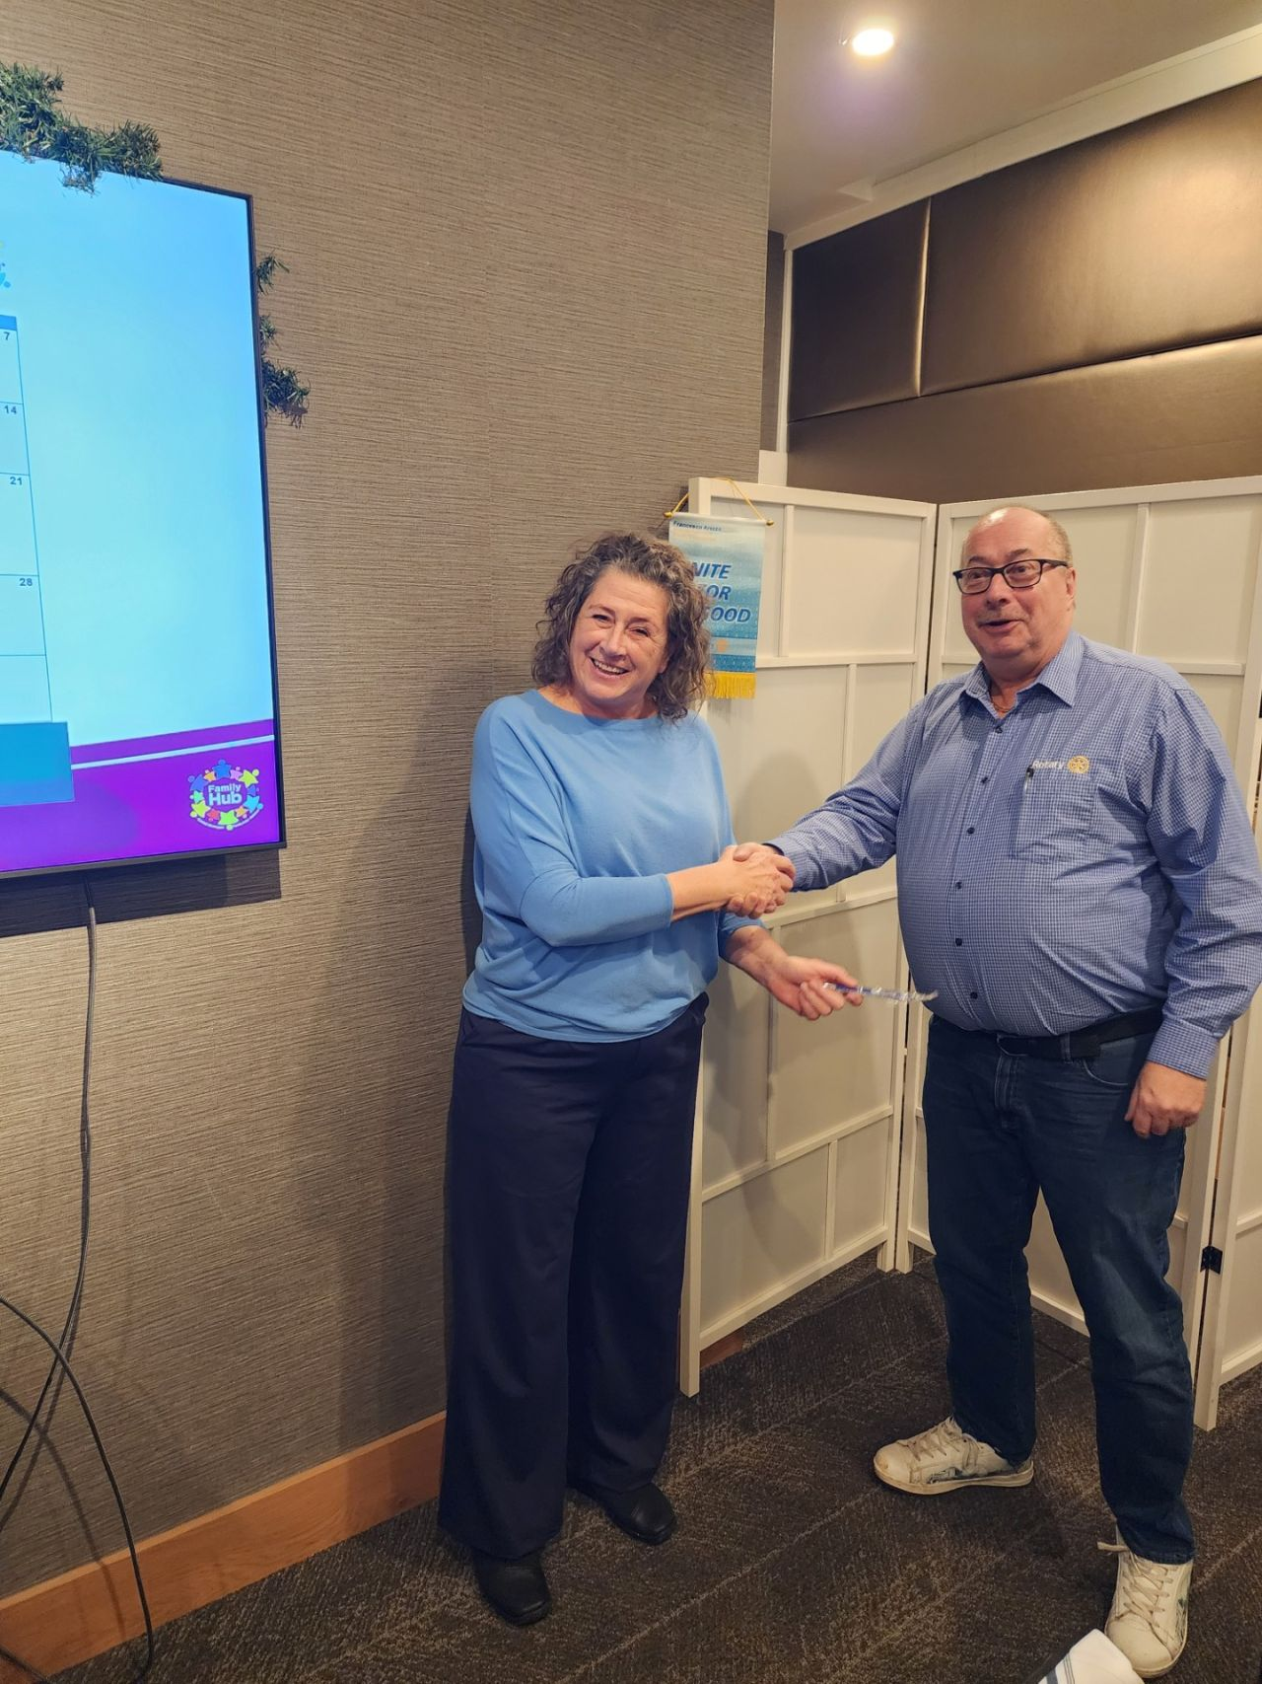

Wendy Williams being thanked by Ron Becker. Photo by Peter Spek

