

CAPRI ECHO
October 8, 2025

Newsletter for the Rotary Club of Kelowna Capri
Website: https://caprirotary.ca/

President Peter Spek
Treasurer Lockie Bracken Secretary Carola Spek Editor John Mullock ( jmullock7766@gmail.com)


Oct 13 – Cancelled - Thanksgiving Birthdays
Oct 20 - Regular Meeting None
Oct 27– Regular Meeting Anniversaries
Nov 3 – Regular Meeting Oct 23 – Ron Becker and Irene Kowalchuk


. 
SIGNS ON SHIRTS
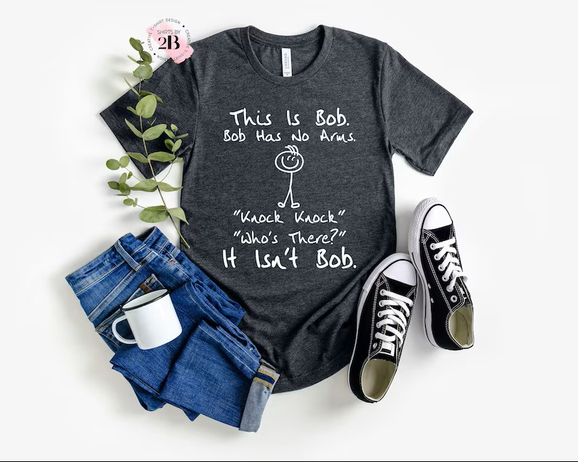



The Sheriff chose to ask members attending the meeting some simple questions about their plans for Thanksgiving. They were:
When is Thanksgiving Day in Canada? (Monday, Oct 13)
How many are planning a trip to join family outside of Kelowna?

How many are having guests over that day?
Simple questions but he took their money anyway. Such is the way of Sheriffs!

UPCOMING SPEAKERS
Laura Dunne from Elevation Outdoors will be our guest speaker on October 20th. Their website: https://elevationoutdoors.ca/?gad_source=1&gad_campaignid=11971626414
Helmut Hubert from Freedom’s Door will be our guest speaker on October 27th. Their website is: https://freedomsdoorkelowna.com/
Gord Lovegrove, city councillor and Professor of Engineering at UBCO will be our guest speaker on November 3rd.

On November 24th, Shannon Christensen from MamasforMamas will be giving a presentation to our club. Their website is: www.mamasformamas.org

Rotarian Art Gillan

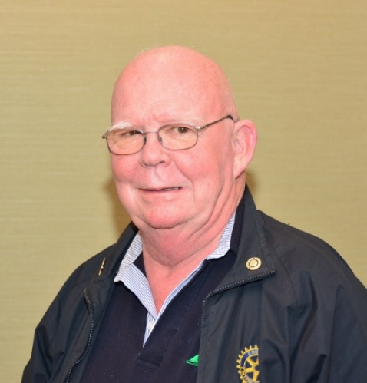

Due to not feeling well I was unable to get over to see Art this week. I have no updated info from other club members, but Glenna sent me a couple of recent pictures that show his recent progress. Pictures that that I misplaced somewhere on my computer.

2025-2026 Capri Rotary Club President – we are looking for a volunteer to serve as next year’s President.

Rotary Day July 2026 - Peter reported that early planning has begun, and things look good for next year.

RC Capri Fundraising

Carola Spek has provided to each club member a colour catalogue of Canadian Safety Supplies materials they have for sale. The more we sell the more discount we receive so look it over, talk to family and friends and let’s raise some funds.

GUESTS
We had some guests this evening. They were Catherine Gohee from the Ogopogo Club along with Sean and Catherine Braunlee from District 5360.

HUMOUR

GUEST SPEAKER
Marjolein Lloyd (PDG 2023-2024) was our guest speaker this evening. Her topic was changes at Shelterbox Canada and their changing mission. As she explained Shelterbox began as the iconic green box which contained shelter materials for 10 people and at the time enough boxes were available for about 300 people per day. Things have changed over time and now Shelterboxes arrive on pallets ShelterBox provides a variety of aid such as shelter kits, tents, kitchen sets, solar lights, mosquito nets, water filters, water carriers and blankets.
It was an interesting talk and really expanded our understanding of their evolving mission and needs.
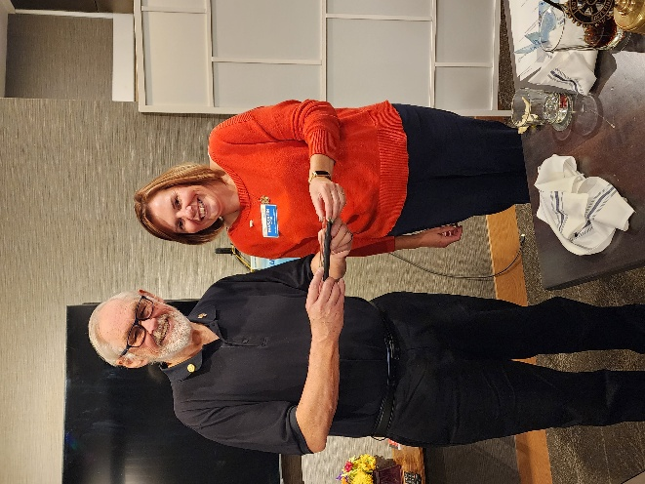 Marjolein Lloyd receives our club pen from John Mullock Photo by Peter Spek

GALLERY
Magnetic Dreams byZenitaris (ukn)

When Souls Collide in Color by Hypnoeros (USA)

