

CAPRI ECHO
September 3, 2025

Newsletter for the Rotary Club of Kelowna Capri
Website: https://caprirotary.ca/

President Peter Spek
Treasurer Lockie Bracken Secretary Carola Spek Editor John Mullock ( jmullock7766@gmail.com)


Sep 8 – Regular Meeting
Sep 15- Regular Meeting
Sep 22 – Regular Meeting
Sep 29– Regular Meeting



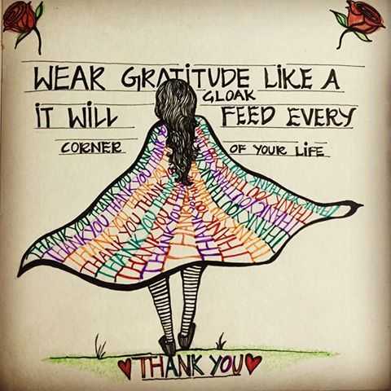

SIGNS ON SHIRTS





No Sheriff this meeting as there were too few club members in attendance.
HUMOUR
Clever shirts showing you the lethality of the periodic table.
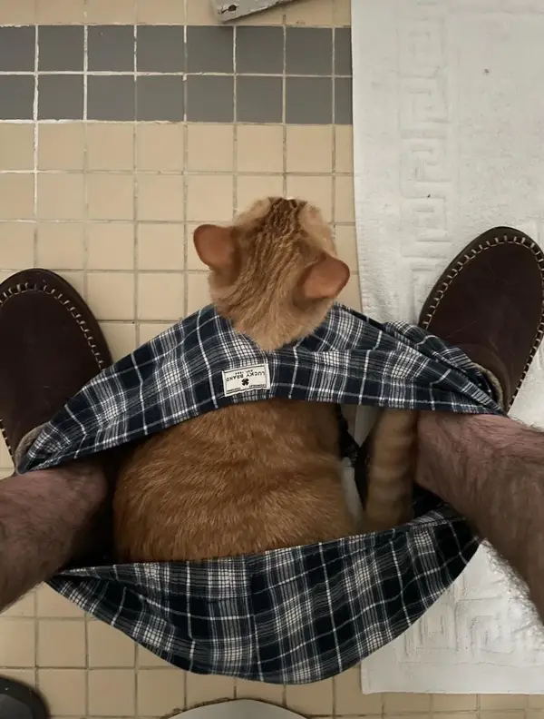Cat won’t leave you alone even while visiting the can.
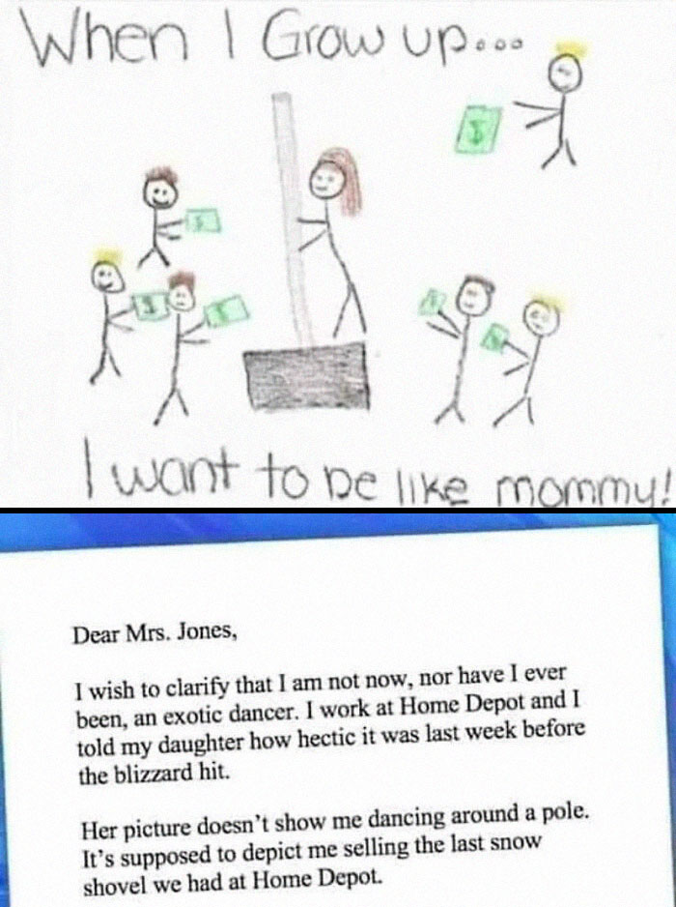

UPCOMING SPEAKERS
Sarah MacDonald from the Child and Youth Advocacy Centre Kelowna will be our guest speaker on September 22nd. Their webpage is: https://cyackelowna.com/
Marjolein Lloyd, Ambassador to ShelterBox Canada will be our guest speaker on October 6th. She will be making a presentation on Shelterbox and requires our laptop.

Laura Dunne from Elevation Outdoors will be our guest speaker on October 20th. Their website: https://elevationoutdoors.ca/?gad_source=1&gad_campaignid=11971626414

Helmut Hubert from Freedom’s Door will be our guest speaker on October 27th. Their website is: https://freedomsdoorkelowna.com/
Gord Lovegrove, city councillor and Professor of Engineering at UBCO will be our guest speaker on November 3rd.

On November 24th, Shannon Christensen from MamasforMamas will be giving a presentation to our club. Their website is: www.mamasformamas.org

Guests are welcome if they would like to hear any presentation. Let us know ahead of time so we can advise Moxies.

2025-2026 Club President – we are looking for a volunteer to serve as next year’s President.

Rotary Day July 2026 - Peter reported that early planning has begun, and things look good for next year.

Labour Day Thoughts
What follows is an edit version of Carola Spek’s presentation.
Labour Day in Canada is commended on the first Monday of September. It firstly allowed workers the opportunity to lobby for better working conditions and pay.
The Labour Day protests started in Canada with the 1870’s work debates in Toronto. In 1872 a motorcade was organized as a protest of the 58-hour weeks. The action saw twenty-four of the organizers of the protest arrested under the enemy of association laws.
Things have changed quite a bit from those days but like everything else in a society, they will continue to evolve.

Club Excellence Award
The Kelowna Capri Rotary Club has received a Club Excellence Award for fostering a positive experience for its members and reflecting the values of Rotary. The award came from Stephanie A. Urchick, President – Rotary International and Mark Daniel Maloney, Chair – The Rotary Foundation.

GALLERY
 British Navy Frigate by Aria360 (USA)

Chief Assistant to the Artist by Alymoon12 (Kazakhstan)

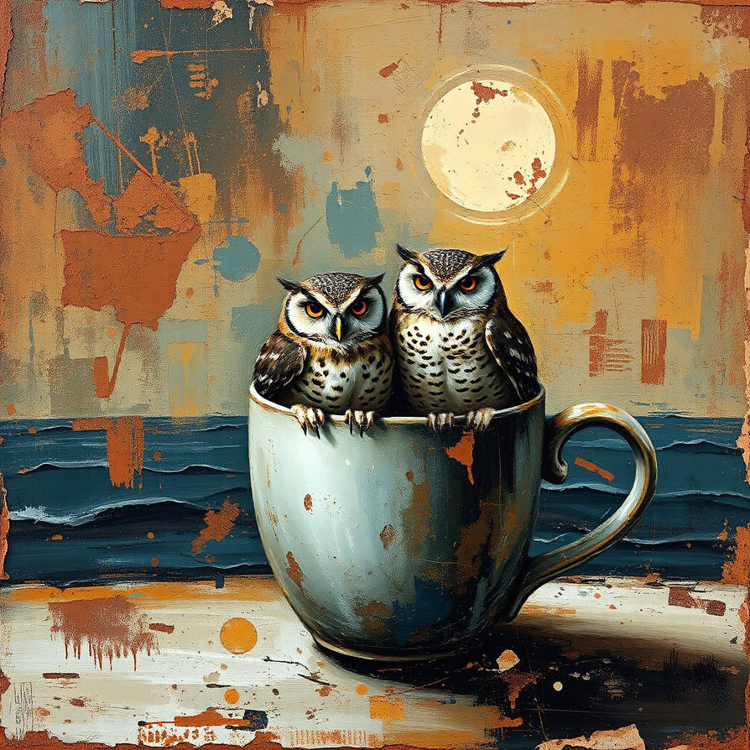Owlets by Darcyie (Ukn)

Snoozlebrew by VictoriaA-4Arts (Brazil)
A picture that strongly reminds me of most early mornings around my house.

