Club Member Jane Fletcher Receives District 5060 Unsung Hero Award

Posted and written by Ed Kolybaba on May 27, 2016

Jane Fletcher, a member of the club since 2005, was recognized for her outstanding contributions to the Rotary Club of Kelowna Sunrise at the District 5060 Conference held in Yakima from May 13-14, 2016. She was awarded the Unsung Hero award, the first ever awarded by the district.

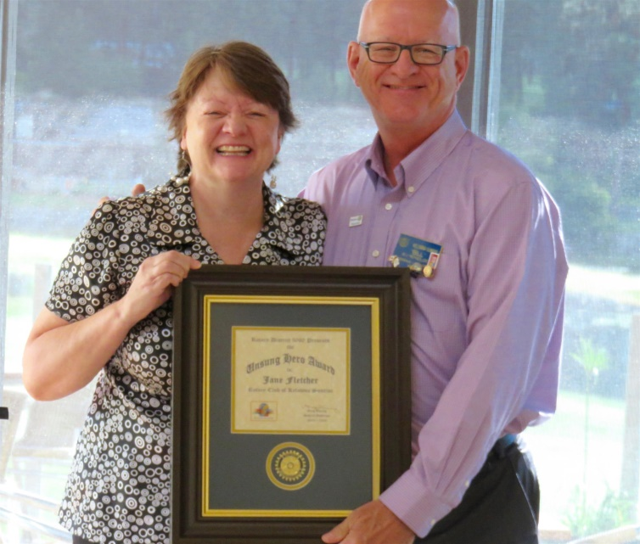

The Unsung Hero Award was presented to a nominated member in each and every club in the district. To be nominated for the award, Rotarians were recognized by their club members and their executive for their dependability, competence, and support of club activities and other members, while always looking for opportunities to help their colleagues and to assist the club in achieving its goals.

The Unsung Hero Award, a beautiful brass on wood plaque, was formally presented to Jane by President Bill Reynolds during the club’s regular meeting on May 20, 2016.

