Kelowna Rotary Club and Local Crusader Recognized for Making Kelowna a Welcoming Community

Posted by Ed Kolybaba on Apr 15, 2016

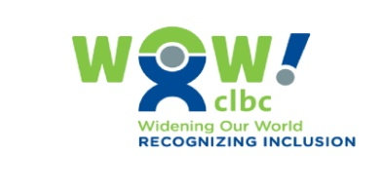
Reprinted in part with permission from Community Living British Columbia; and authored by Lisa Porcellato, CLBC

The Kelowna Sunrise Rotary and local diverse ability crusader, Shelley DeCoste, have been breaking down the barriers and building strong partnerships with a goal to make Kelowna one of the most diverse and inclusive cities in the Province. They were both recognized for their efforts on April 08, 2016 with Community Living British Columbia (CLBC) Widening Our World (WOW) Awards for exceptional contributions to people with developmental disabilities.

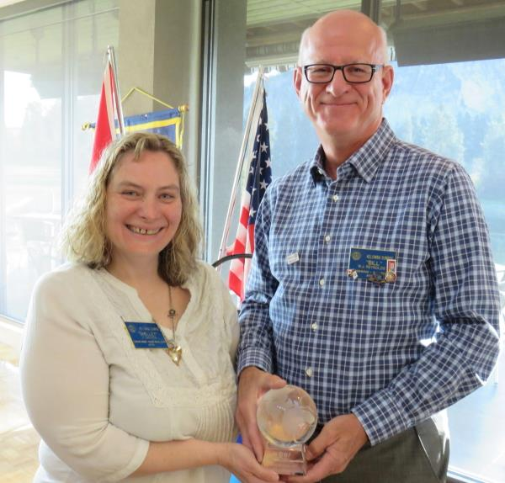

Through Rotary at Work, the Kelowna Sunrise Rotary has been supporting the people CLBC serves to develop skills and find employment. The Rotary won a WOW Award because they believe in inclusiveness and work hard to make a better community for everyone. People of all abilities participate in all aspects of the club, including helping with club business and representing the club at events and through public speaking engagements.

Shelley DeCoste is a change maker. Shelley is a tireless advocate for true inclusion throughout the Okanagan. In 2010, Shelley launched the province-wide campaign to change the word ‘disability’ to ‘diverse ability’. Shelley is a self-advocate liaison with Pathways Ability Society, volunteers with a variety of organizations in community, participates in Special Olympics and supports other individuals with developmental disabilities to participate in recreational activities, is a proud Rotarian who promotes inclusion wherever possible and is a motivational speaker around Employment for People with Disabilities. Shelley is the true example of what the WOW Awards represent.

Each year, CLBC presents WOW Awards to recognize British Columbians who are creating opportunities for full citizenship for people with developmental disabilities, one where they lead good lives, have rich relationships, choices in how they live, and employment opportunities.

CLBC received over 50 nominations and the winners were chosen by an evaluation committee of community and family members, CLBC community council members, CLBC staff, service providers and individuals served by CLBC.

Community Living BC (CLBC) is a provincial crown agency, mandated under the Community Living Authority Act that funds supports and services through service agencies for adults with developmental disabilities and their families in British Columbia. CLBC is working to create communities where people with developmental disabilities have more choices about how they live, work and contribute.

