Club Celebrates 30 Years during 2016 Installation Dinner

Written and posted by Ed Kolybaba on Jun 24, 2016

The Rotary Club of Kelowna Sunrise during its 2016 Installation Dinner on Saturday, June 25th, marked its 30th Anniversary of the founding of the club. Past-President Greig McPhee, Master of Ceremonies for the evening Installation Dinner, took a moment to recognize the Charter members whom are highly valued and still actively engaged as members of the club. Bruce Brown, Wayne Duchart, Andy Griffin, Jack Martin and Paul Mulvihill were members of the club when the club was founded on April 26, 1986. During the years of 1987 to 1989, five other current Rotarians, who are also active and valued in the club, joined…Fred Lindsay (1987), Wayne Evans (1987), Graham Bell (1988), Don Turri (1988), and Jerry Sedmak (1989).

During his opening remarks, as MC, McPhee expressed that it was a
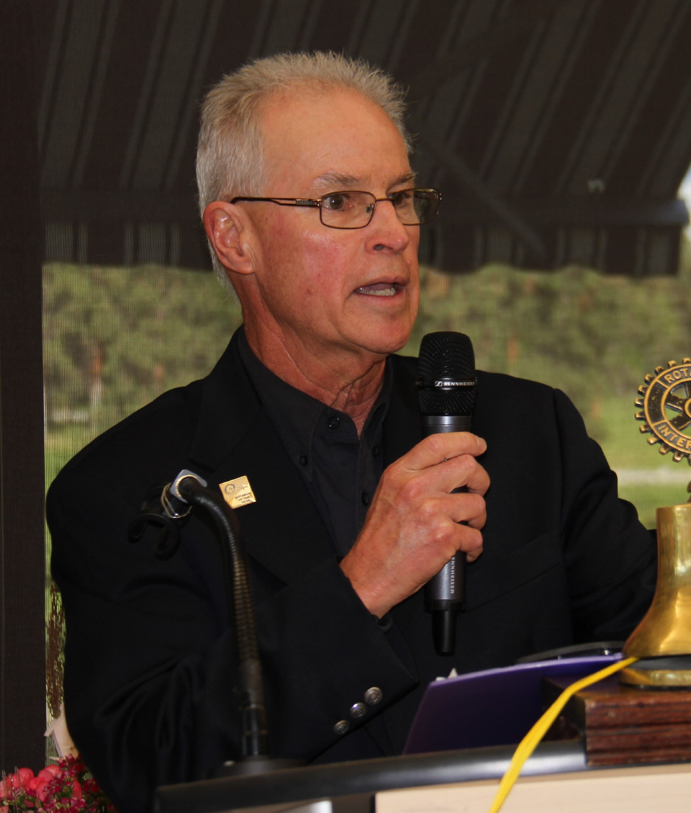
privilege to be part of serving within the Rotary Club of Kelowna Sunrise and
that he was extremely grateful for the opportunity to serve the club on the
executive over the past five years. He pointed out that as a club, “we
continue to make a significant difference in our local community and
through our International projects in the greater world.” “When the passion
each of us feels to make a difference combines with work that is well done,
we are drawn out of ourselves and into connection with people and projects
beyond ourselves. CONNECTION; ENGAGEMENT; COMMITMENT! Happiness
comes from getting these connections right,” (unknown author).

Following a reception with music courtesy of the Kelowna Music School and the call to order by Greig McPhee, chair of the 2016 event, Karen Belshaw on behalf of the club, offered gratitude to our Creator and expressed that “as we move into another year of service, we ask for guidance and blessings as we strive to paint a picture of vibrancy that is stimulating to all involved and attracting to those that may join our club or wish to contribute in their way” and that “for each task we put our hearts and energy into, that they be relevant not just to Sunrise Rotary and its members, but to our community and extending into the lives of others in the world.”

Following dinner, In-coming Pat McAllister presented an Honorarium to the Kelowna Music School; and 2015-16 Foundation Director recognized Bob Fortier with a pin for his achievement of a Multiple Paul Harris Fellow (PHF+2) and Barb Penner for attaining Major Donor status. Chair Grieg McPhee also recognized Linda Frandsen for becoming the club’s latest “Bequest Society” member; while pointing out how her gift would reach out and touch someone’s life in a significant manner.

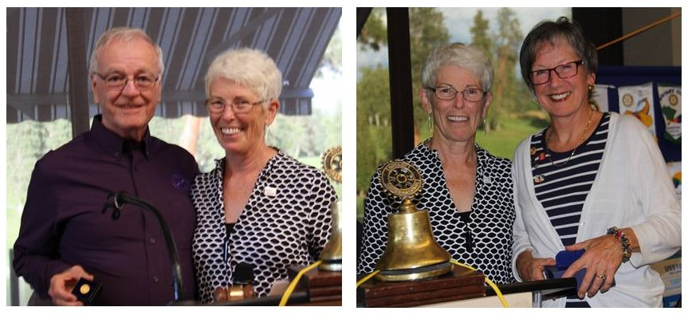

President Bill Reynolds delivered his out-going speech with words of appreciation and celebration, and with special recognition of individuals who provided exceptional service during the 2015-16 Rotary year before turning over the floor to 2016-17 District Governor Vern Nielsen, who formally inducted Pat McAllister as President of the club for 2016-17. McAllister introduced his executive and officers for 2016-17, and presented each with a pin which signified their position on the 2016-17 Board. The evening concluded with an inspiring presentation by McAllister at which time he outlined his goals and aspirations and announced the club’s theme for the new Rotary year - MY ROTARY; VIBRANT and RELEVANT. (Note: Articles on these presentations are detailed in the additional stories in this website.)

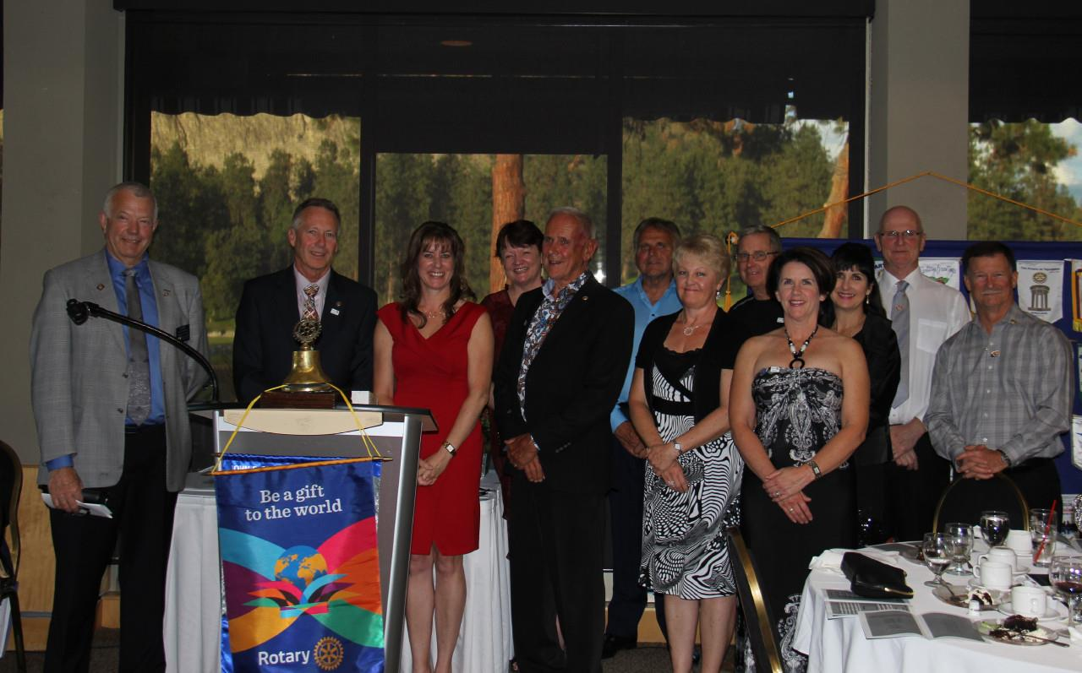
2016-17 Executive and Officers

