Club Plans for the Future

Posted and written by Ed Kolybaba on May 02, 2016

Members of the Rotary Club of Kelowna Sunrise took part in a second dedicated Visioning session, focused at providing the club with a renewed strategic plan which will update
the club’s existing vision. The club had participated in the Visioning process and established a plan of action three years earlier. Participants worked through a five hour process in determining the club’s vision and as a means to move the club toward its desired actions and outcomes. While this process enabled the club to reach consensus on its priorities for the next five years, the work of determining just how these priorities will be achieved must still be determined.

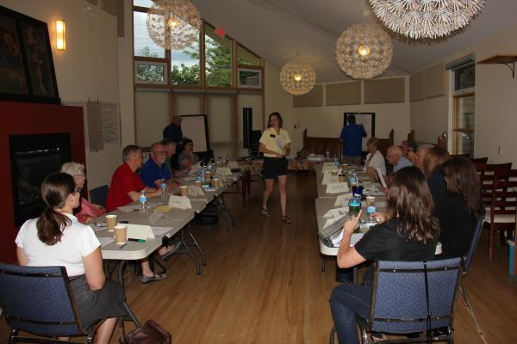

The event which took place in the Board Room of Cathedral Church of St. Michael and All Angels in Kelowna on May 03, 2016, enabled the seventeen club participants to express their thoughts on what their club could become five years from now and to begin to establish benchmarks for the club through a written plan that promotes consensus, consistency and continuity. Through the process, the members identified key goals and initiatives that will provide a road map for the club leadership and for the club members. From this dream comes a new sense of identity and a renewed commitment to enable the club to continue to be progressive, dynamic, growth orientated and more effective.
The visioning process was facilitated by Wolfgang Muhs from the Rotary Club of Peachland, Klaus Naumann from the Rotary Club of Kelowna Ogopogo and Marjolein Lloyd from the Rotary Club of Westbank. All three are part of a cadre of District 5060 trained facilitators who conduct Club Visioning throughout the district.
As the club continues to work with the vision framework developed on May 03, it will eventually experience continuity of leadership, vision and process, consistency in programming, projects and activities, and consensus and solidarity in purpose and action.
Club Visioning has been in place throughout the Rotary world since 2002, and is currently assisting Rotary clubs in over 100 Rotary districts across the USA, Canada, Australia, New Zealand, United Kingdom and other parts of the world. The majority of clubs taking part in this program have achieved positive outcomes.
Check out the Gallery of Photos for photos taken during the event.

