Elections for Club Executive and Officer Positions for 2017-18 Take Place

Written and posted by Ed Kolybaba on Nov 29, 2016

At its annual meeting on Friday, November 28th, members of the Rotary Club of Kelowna Sunrise elected three directors and three executive positions for the 2017-18 Rotary year. Huck Parfeniuk was elected as the Vice President, which enables him to fulfill the position of President of the club for the Rotary Year of 2019-20. Carol Farley was elected as the club’s Secretary with her responsibilities also commencing on July 01 of 2017. Mike Crowley was re-elected to the position of Treasurer, a position that comes up for re-election every year.
Recently inducted Rebecca White will assume the position of Director of the Youth Programs Committee; Teri Kanner will continue as Director of the Vocational Committee; and Chris Murphy will serve as Director of the Fundraising Committee. These positions will be for a two year term commencing with the Rotary Year 2017-18.
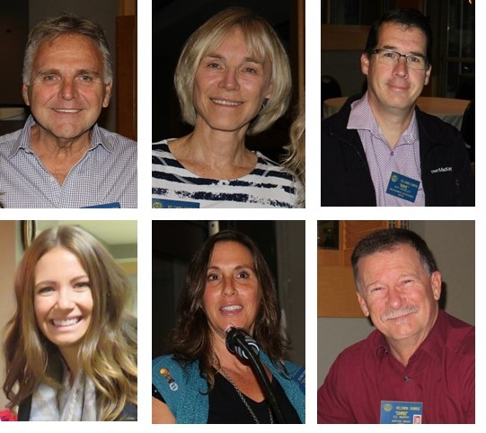
Heidi Miller (Programs Committee), Doreen Welsh (Fellowship Committee), Rene Bernard (International Service Committee), Max Mosley (Membership Committee), Huck Parfeniuk (Foundation Committee), and Jane Fletcher (Public Relations Committee) will continue into their second term as directors.
At the commencement of the 2017-18 Rotary Year, current Vice President Maribeth Friesen will automatically move into the position of President-Elect, current President-Elect Andy Griffin will automatically become the President of the club; and the 2016-17 President Pat McAllister will fill the role of Past-President.

