In-Coming President Expects a Club that is Vibrant and Relevant in 2016-17

Composed and posted by Ed Kolybaba on Jun 25, 2016

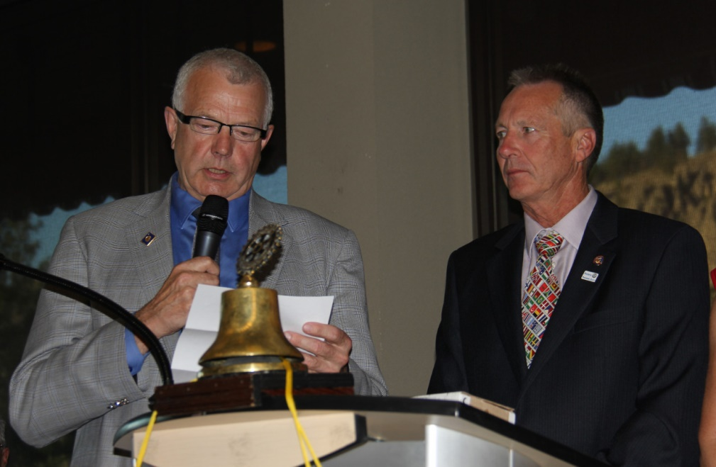

In-coming President Pat McAllister, in his inaugural address during the Rotary Club of Kelowna Sunrise’s Installation Dinner on June 25th, expressed his appreciation and the Official Board for the excellent leadership that enabled the club to remain healthy, vibrant and relevant. Even though we embodied these characteristics, McAllister pointed out that he believed that the in-coming leadership team, along with the members, needed to “improve our club to a higher level” by looking at ourselves personally and making sure that we, as individual Rotarians, were contributing to the maximum.” To this purpose, McAllister shared that the theme for the 2016-17 Rotary Year would be “My Rotary – Vibrant and Relevant.”
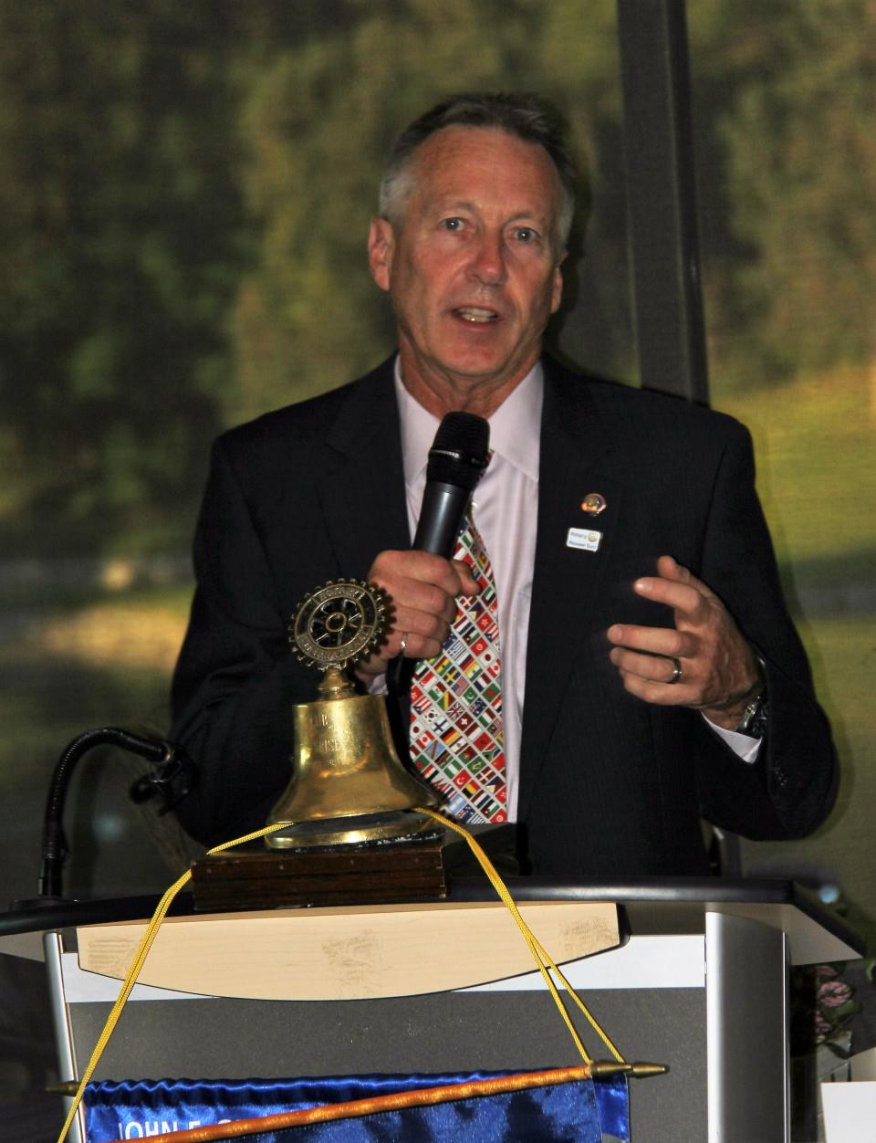
To be “vibrant,” McAllister stated that “we need to be welcoming, to our
members and to our guests/visitors.” He added that “We need to become
personally involved in club projects and committee functions; we need to
attend meetings and social club gatherings; and yes, we need to have a
smile on our face…. most of the time… and to always have FUN.”

“And now for the RELEVANT part,” expressed McAllister. To achieve
relevancy “we must find new fundraising projects that are repeatable that
all of us support, such as the up-coming club RibFest; we should be sure
that we donate to The Rotary Foundation, certainly according to our
means; we need to take advantage of district and global Foundation grants
that provide international aid and programs; we cannot forget to allot our time and finances to support youth and those less fortunate in our community and beyond; and each Rotarian must accept the challenge to personally enjoy a Rotary experience where each of use makes a difference,” outlined McAllister.

McAllister stressed in conclusion that to be a vibrant and relevant club, we must make a commitment to take action that supports and enacts the 2016-17 Rotary International Theme, “Rotary Serving Humanity,” as selected by In-coming RI President John Germ.

