Serving the Club has been an Honour and Privilege

Posted and written by Ed Kolybaba on Jun 24, 2016

While Out-going President Bill Reynold’s remarks at the 2016 Installation Dinner may have been few, they were words of appreciation and celebration. He expressed that it had been an “honour and privilege to be the club’s President” that brought excitement, achievement, success and fun to the meetings and activities of the club.

In appreciation of the club and its members, Reynolds gave thanks to the
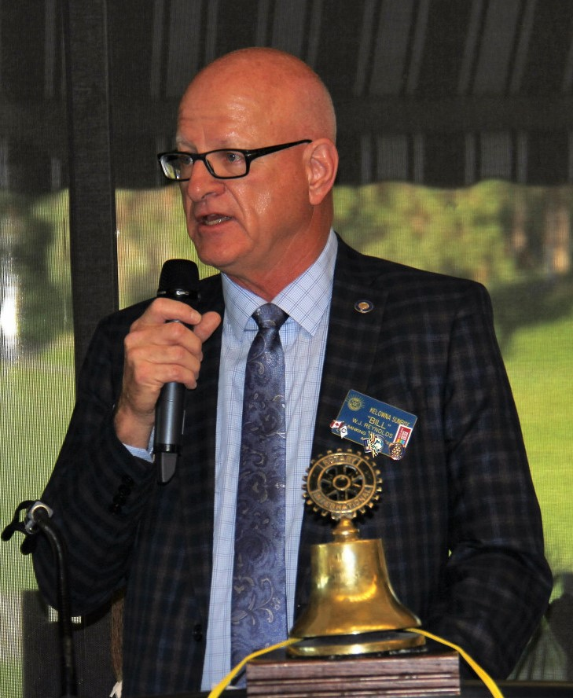
club executive and officers, the volunteers, and all of the club members
for their support and commitment to achieving the goals and objectives
of the club. “Thank you for the opportunity to serve you and our great
club,’ expressed Reynolds. He also identified and recognized many
Rotarians with a presentation of Certificates of Appreciation and
Certificate Citations during his remarks.

Reynolds also acknowledged two major supporters of the club for their
financial contributions and the use of their office facilities for executive
and other meetings of the club over the past years. Both Crowe MacKay
and Capri Insurance were presented with a plaque which described the
outstanding contributions of the two local businesses to the Rotary Club
of Kelowna Sunrise.

David Stewart, an outstanding friend and supporter of the club was presented with an Honourary Paul Harris Fellow for his support of and work at various club fundraisers, in addition of the use of a site for one of the club’s Fireside events.

Before passing the gavel to In-coming President, Reynolds highlighted the evening with the announcement and presentation of two major awards for outstanding service during the 2013-16 Rotary Year. The Dale Frandsen Award, which is presented to a club Rotarian who exemplifies the spirit of dedication, friendship, optimism and integrity which are the core values of a true Rotarian, was awarded to Doreen Welsh. The Rotarian of the Year, which is selected by the Club President and is presented annually to a Member of the Kelowna Sunrise Rotary Club for Inspiring Others to Model with Them “Service Above Self,” was awarded to Linda Frandsen.

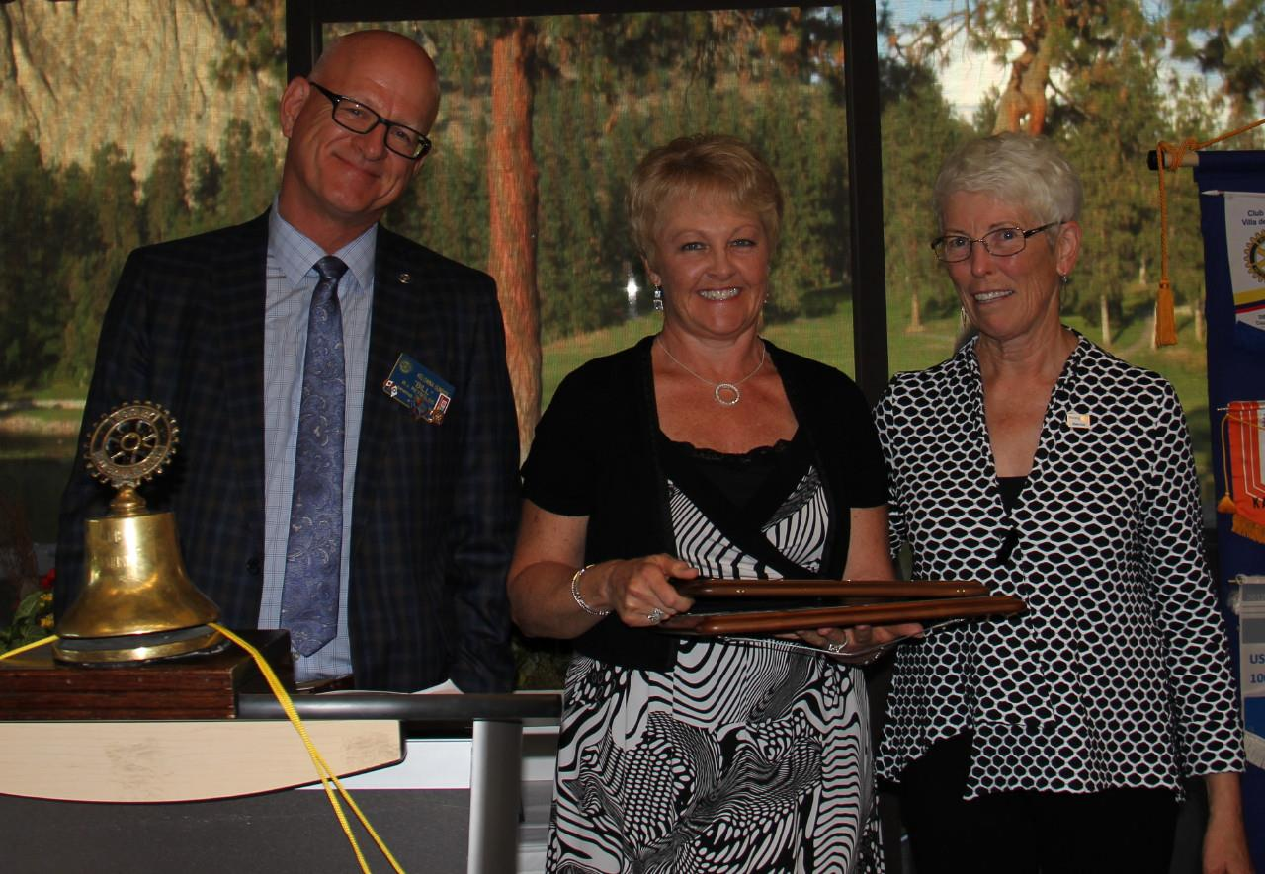
Doreen Welsh - 2015-16 Dale Frandsen Award Recipient

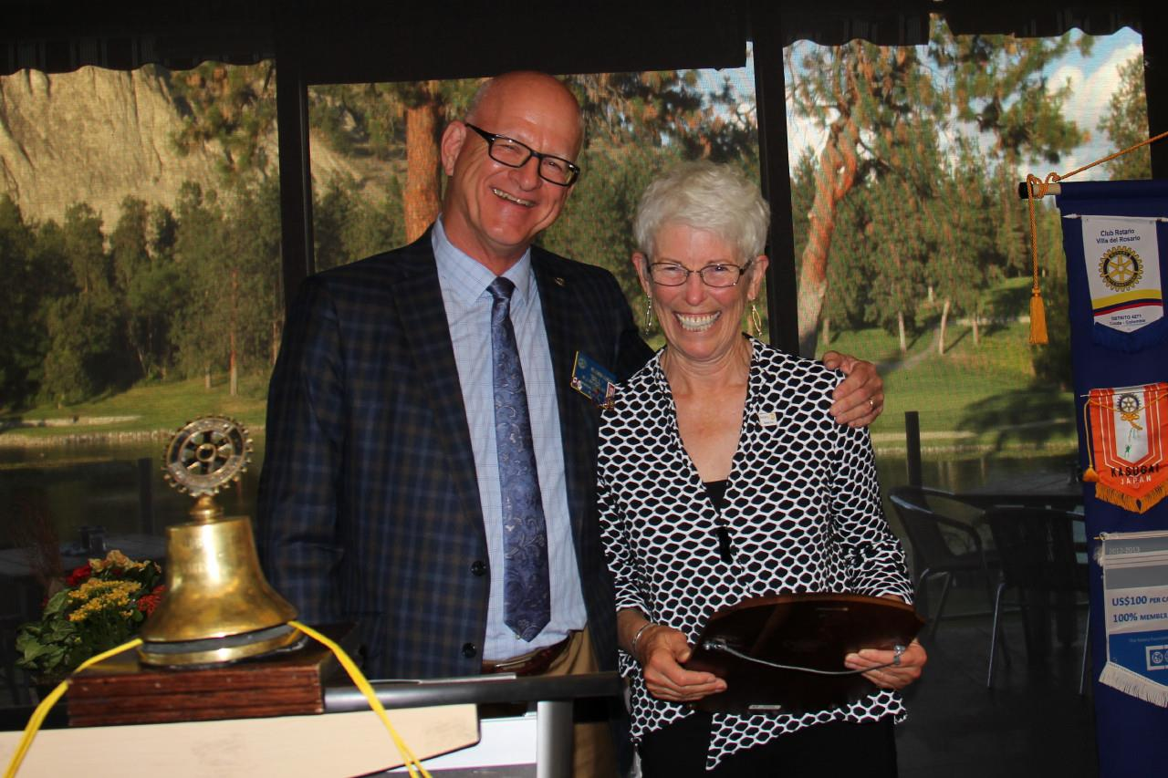
Linda Frandsen - 2015-16 Rotarian of the Year

Bill Reynold’s finally duty as the 2015-16 President, was carried out before departing the podium with the following words to In-coming President Pat McAllister: “ I hereby declare the new officers installed and present you with the gavel as symbolic of the transfer of the Club’s administration.”

