Falling in Love with Austria, Kenna's Experience

Written and posted by Ed Kolybaba on Nov 03, 2016

Kenna McEwan continues to update her friends, family and the Rotary Club of
Kelowna Sunrise members through
https://www.facebook.com/RotaryClubOfKelownaSunrise. Visit the
site and learn all about her adventures and how she has fallen in love with
Austria.

Take the time to appreciate the geography, history and culture of Austria through her words and photos. Learn about her experiences at the language school where she gained the ability to begin to converse in Germany. Find out more about her first host family, about her home town and nearby villages. Learn about her experiences in her school and how different the educational system is from our system.

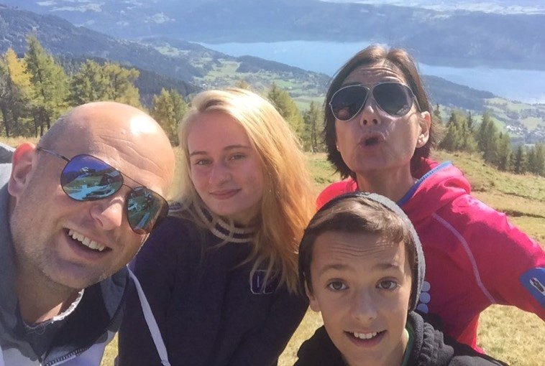

Experience her memorable time in the host family’s vineyard where like many people in the Okanagan she picked grapes and learned about the process of wine making through her many photos.

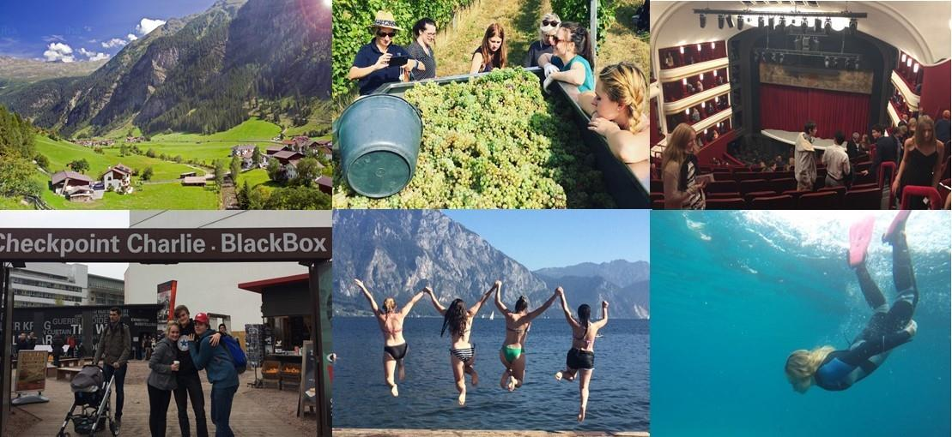

As she describes her experiences throughout October, you will discover, as she did, the grandeur and beauty of Vienna, with its outstanding architecture and gardens, and of course, the opera. She will take you to Croatia where she describes it as a “truly paradise,” and where she will share her experiences snorkeling, dolphin watching, and sitting by the sea just gathering in the beautiful sunsets. And she will finish off her travelling adventure by entertaining you with her experiences in Prague, Dresden and Berlin.

Her adventures will definitely make us all envious, but exceptionally happy for her!

For a profile on Kenna, check out the Rotary Youth Exchange site situated in the Service Areas and Committees site, followed by the Youth Program’s site.

