Rotary Youth Exchange Student Departs for Austria to Learn about, Experience and Enjoy a New Culture

Written and posted by Ed Kolybaba on Aug 07, 2016
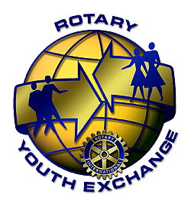
Kenna McEwan is off to Austria to enjoy what
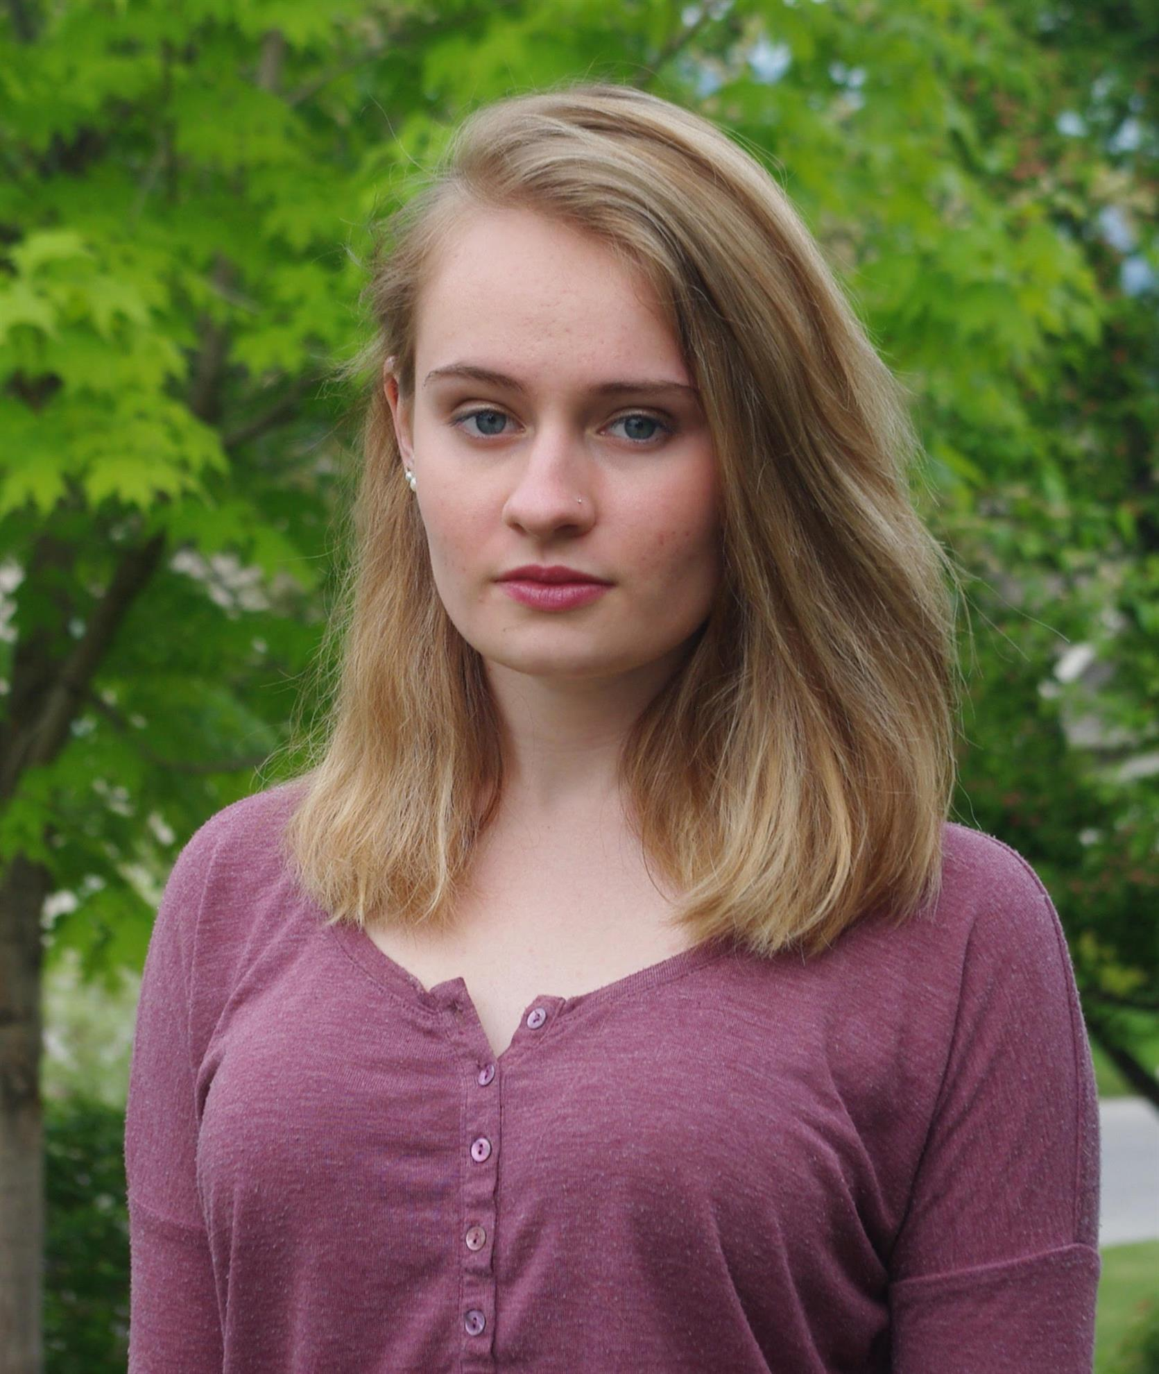
will surely be one of the most memorable
years of her young life. Kenna departed for
Villach, Austria, on August 08 to commence
a year-long experience as a Rotary Youth
Exchange Student. She is sponsored by the
Rotary Club of Kelowna Sunrise and hosted by the Rotary Club of
Villach Park in Austria. Kenna is the daughter of Colleen and
Chuck McEwan of Kelowna.

She attended and completed her grade eleven studies at Kelowna Secondary School in June of this year where she excelled in her academic studies and was on the ‘Principal’s Honor List’ and on the school’s ‘Work Ethic Distinction List.’

Among Kenna’s many achievements and community endeavours, Kenna has been a team member of the 1st place soccer team in the 2015 Kelowna Cup, has received a ‘Letter of Recommendation’ from city of Kelowna, has been a successful competitor at Regional Debate competitions has volunteered at Cottonwoods and at a youth camp, coached a grade eight girls’ soccer team, been an active member of the school’s Interact Club and the Model UN Club, served as a MC at a local government conference and attended the Southern Interior Youth Parliament as the Regional Secretary.

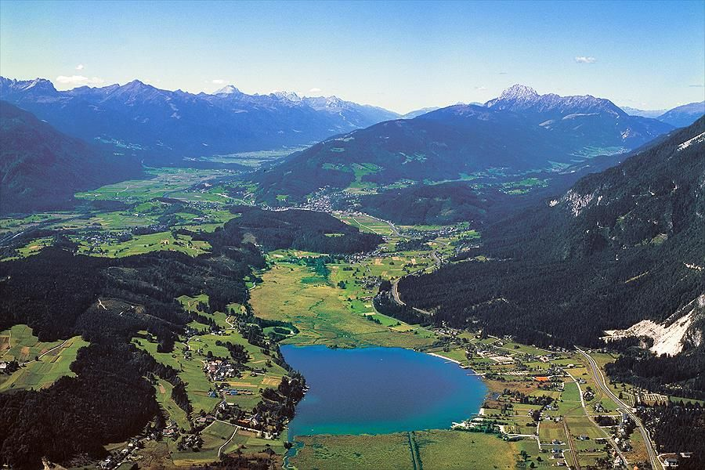
When asked why she had a desire to participate in a Rotary Youth Exchange Program, Kenna expressed that the seed to participate in the program had been planted in her early years as a result of her mother’s outstanding experience as a Rotary Youth Exchange student to New Zealand. Kenna shared many reasons for her participation in the program which she pointed out would enable her to grow as a person and as a highly contributing community member.

