Club President Leads by Example

Posted and written by Ed Kolybaba on May 31, 2016
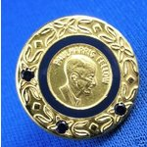
President Bill Reynolds was recognized on May 27th with a Paul Harris Fellow +3 Award
(PHF+3) for achieving a fourth level in the PHF program, which represents donations of
over US $ 4000 to The Rotary Foundation. In-coming 2016-17 Foundation Committee
Director Huck Parfeniuk made a presentation of a pin to Bill signifying this
accomplishment.

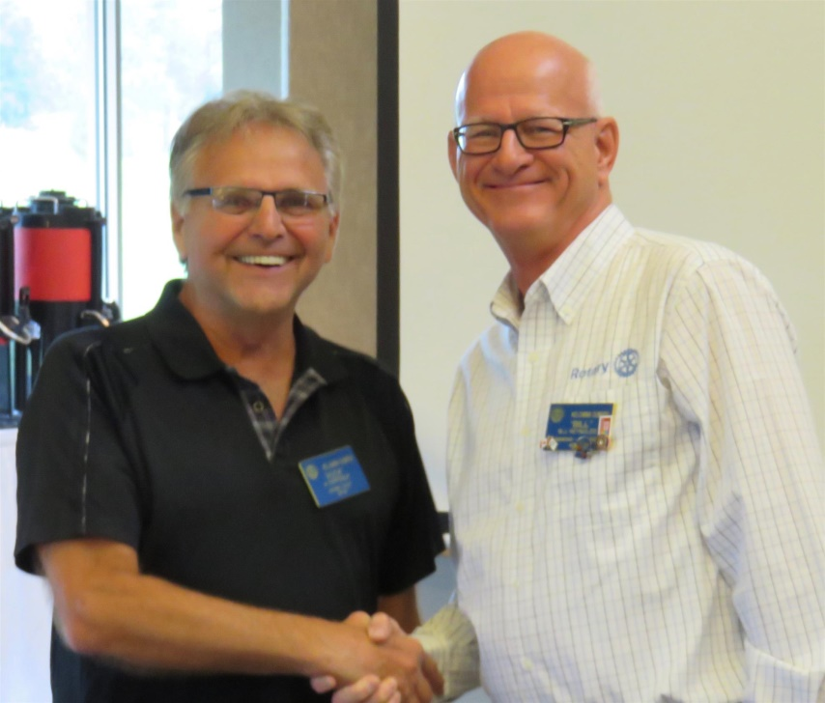

In making the presentation, Huck provided an overview of the development and achievement of The Rotary Foundation (TRF). He shared that at the 1917 Rotary International Convention, Rotary International President Arch C. Klumph proposed that an endowment “for the purpose of doing good in the world” be established. In 1928, the endowment fund was named The Rotary Foundation, and it then became a distinct entity within Rotary International. Since the first donation of $26.50 in 1917, the Foundation has received contributions from Rotarians around the world totaling more than US $ 1 billion.

Following the presentation, President-Elect Pat McAllister reminded the Kelowna Sunrise Rotarians that during the Visioning session, the majority of the membership involved in the Visioning exercise recognized that the club needed to increase the membership support for The Rotary Foundation by continuing its Every Rotarian Every Year status, by increasing the Sustaining Member number to 70 percent of the total membership, and by increasing the number of Paul Harris Fellow members to 50 percent of the club membership.

