Club Welcomes Auzzie GSE Team

Posted and written by Ed Kolybaba on Jun 03, 2016

“G’da mate, and ow ya goin mate?” Greetings from our Auzzie friends who arrived in
Kelowna during the evening of June 02nd and then visited the Rotary Club of Kelowna
Sunrise during the club’s regular meeting on Friday, June 03, 2016. The Australian
Group Study Exchange team, consisting of five “fair dinkum” Auzzies from District
9500 located in the state of South Australia, arrived in District 5060 prior to the
District Conference held in Yakima, and then continued with a grand tour of District 5060. The exchange will end on June 08th when the team heads back home.

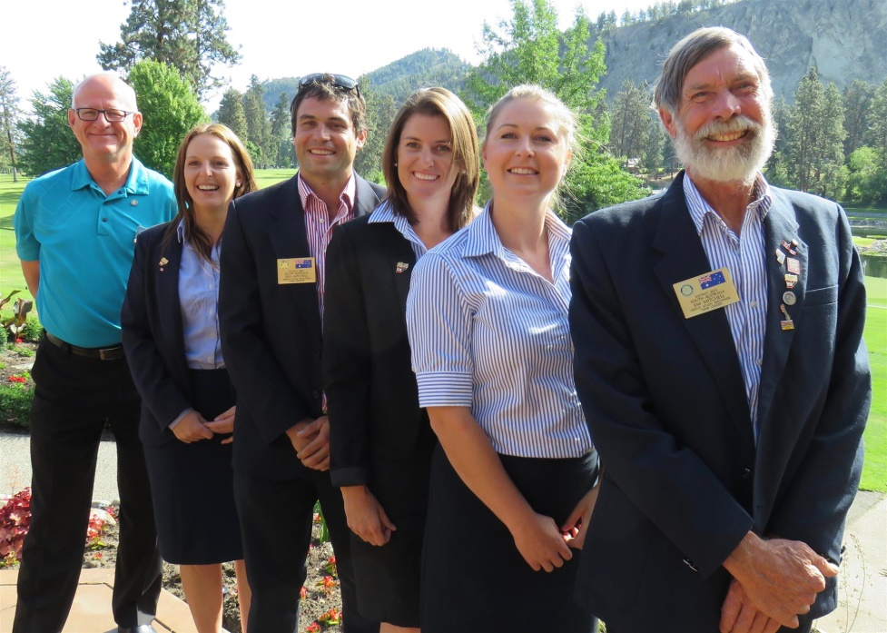

Even though the team was completely “knackerd” from a busy day and long evening visiting with their host Rotarians from the Rotary Club of Kelowna Sunrise, they each made a “gonzer” visual presentation which outlined their professions and personal interests.

The team consists of team leader Jim Mitchell, a sheep grazer, one could call a “cockie” working his 700 hectare farm in the Barossa Valley in South Australia. Jim is a 30 year veteran of Rotary, a volunteer fire fighter and a professional wool classer.

Team member Alice Fargher is an operations manager at Angorichina station, a 60,700 hectare sheep property in the Flinders Ranges. She is also actively engaged in her family farm of 4500 sheep and some feral goats. She holds a Bachelor Degree in Sport and Recreation Management and has attained a pilot’s license.

Ben Mitchell, the second male on the team, is a graduate of the University of Adelaide with a Bachelor of Science in Viticulture. He is currently a technical vineyard officer for Wakefield Wines (Taylor Wines) which is located in the Clare Valley. As others on the team, Ben works on his family’s farm, in this case a vineyard, on weekends.

Team member Jessica Crettenden attained a Bachelor of Agriculture from the University of Adelaide and since 2011 has worked as a research scientist at the Minnipa Agriculture Centre, a government research facility where she specializes in sheep research.

The fifth team member, Claire Webber, is employed as a researcher and liaison officer for the Australian Southern Bluefin Tuna Industry Association. Her Bachelor of Administration focused on Marine Resources, and a Diploma of Aquaculture enables her to serve her passion in supporting the fishing industry and the fishers.

If interested, readers of this article can highlight the following hyperlinks located on UTube to listen to some modern and old Australian songs. To do so, highlight the hyperlink, then complete a right click with the mouse and finally click on “Open Hyperlink.”
https://youtu.be/fCMzVyInEuo?list=PLDFF0B27FECD03930 (I Still Australia Home)
https://youtu.be/lofgud4wLLo (Tie Me Kangaroo Down Sport by Rolf Harris)
https://youtu.be/XfR9iY5y94s (Down Under by Men at Work)
https://youtu.be/aZ4NuX0qWuY (This is Australia)
https://youtu.be/3mkidP2OUCk (Great Southern Land by Icehouse)
https://youtu.be/ZtpBUQoVups (I Am Australian by Mirusia Lowverse)

