Another Club Member Achieves Paul Harris Fellow Status

Written and posted by Ed Kolybaba on Aug 13, 2016

On August 05th, Dr. David Wikenheiser was presented with a Paul Harris Fellow pin for his generous contributions of over US$1000 to the Annual Fund of The Rotary Foundation since he was inducted into the club in 2011. Foundation Director Huck Parfeniuk congratulated David on his achievement on behalf of the club, explained how David’s financial contributions are making a difference for those in need throughout the world, and then presented the PHF lapel pin to David.

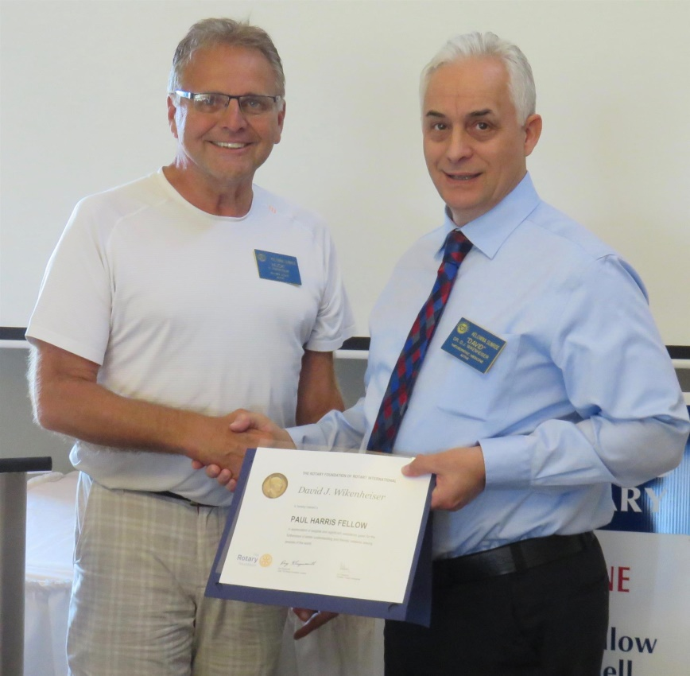

During the club’s 2016 Installation Dinner held in late June, the club had recognized Bob Fortier with a pin for his achievement of a Multiple Paul Harris Fellow (PHF+2) and Barb Penner for attaining Major Donor status with the Rotary Foundation.

As of August 05, 40 members within the club have achieved a Paul Harris Fellow or Multiple Paul Harris Award resulting in over US$166,000 in contributions to the Rotary Foundation. Total contributions to the Rotary Foundation Funding Programs from all club members since the club was chartered have surpassed US$287,000.

