Club Honoured by The Rotary Foundation

Story written and posted by Ed Kolybaba on Nov 24, 2016

The Rotary Club of Kelowna Sunrise was once again honoured by The Rotary Foundation
for its outstanding support for the Foundation through its annual donations to the Annual
Fund and PolioPlus Fund.

On Friday, November 25th, Huck Parfeniuk, the Director of the club’s Foundation Committee, presented past-president Bill Reynolds (2015-16), with a banner for achieving a status of a "100 percent Foundation Giving Club", the fifth major award it has received over the past four years. The banner is presented to clubs worldwide when every dues-paying member of the club contributes to the Foundation and when the club achieves a US$100 average giving per member during the Rotary year.

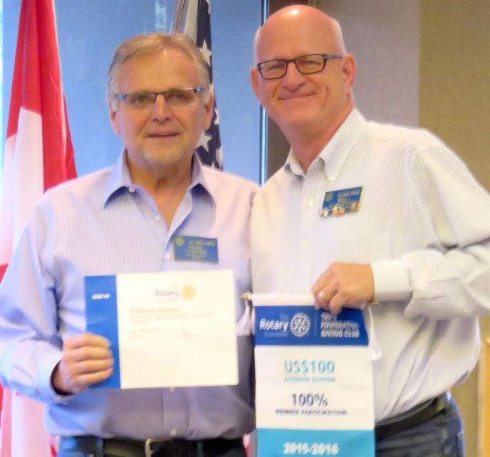

From a letter received by the club from The Rotary Foundation, Huck shared that Kelowna Sunrise club was:
- One of only 1,564 to achieve Top Three Highest in Per Capita Annual Giving honors in their district
- One of only 2,253 clubs worldwide to attain status as an 100% Rotary Foundation Sustaining Member Club (Every Rotarian, Every Year/Sustaining Club)
- One of 4,609 clubs worldwide to become 100% Foundation Giving Club, an award achieved when every dues-paying member within a club contributes to the Rotary Foundation and the average contribution is at least US $!00 to an Rotary Foundation gift designation
Additionally, The Rotary Foundation acknowledged the club’s attainment in achieving its 2015-16 goal to donate at least US$1500 to the PolioPlus Fund with a Certificate. In fact, the club had actually made a donation of US$2068.

Huck expressed that these great achievements have been attained with the guidance of Linda Frandsen as Director, along with her committee during the 2015-16 Rotary year.

