Club Member Makes a Difference for Millions

Story created and posted by Ed Kolybaba on Dec 08, 2016

When you make a donation to The Rotary Foundation, you are helping Rotary members
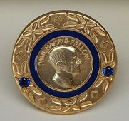
make a difference in the lives of millions of people around the world, by promoting peace,
preventing disease, supporting education, bolstering economic development, providing
clean water and sanitation, responding to crisis, and supporting many other humanitarian
causes.

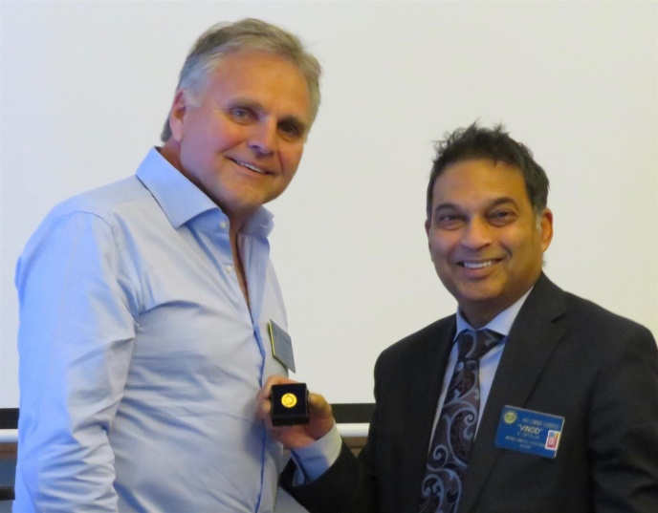

Vic Spolia was one such Rotary Club of Kelowna Sunrise Rotarian who believes strongly in making this difference. Vic puts this belief into practice by continuing to support the Foundation. On December 09, Vic was recognized by Foundation Service Director Huck Parfeniuk for achieving a level of PHF+2 for his continuing support for the difference the Foundation makes in the world.

