Club Members Recognized for Responding to those in Need around the World
Story composed and posted by Ed Kolybaba on Oct 22, 2016

Three club Rotarians were recognized for their continued financial support of The
Rotary Foundation during a presentation on the Foundation made by the Foundation
Committee on Friday, October 21st.

Barb Penner and Carole Farley were each presented with a pin and engraved crystal for their gift to the Endowment Fund of The Rotary Foundation. Both Rotarians were recognized for attainment of a Bequest Society level for their endowment gift of over US$10,000 to the Fund. Tom Paterson had the honour of making the presentation.

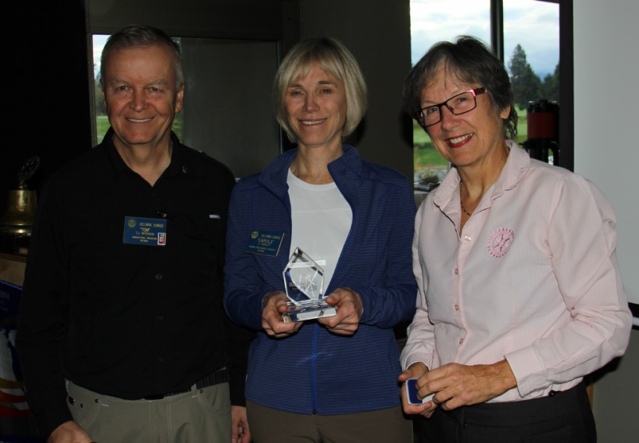

The club is proud of the number of Rotarians in the club who have been recognized for this achievement in the past, including club members Rene Bernard, Bruce and Donna Falkins, Jane Fletcher, Linda Frandsen, Ed Kolybaba, Greig McPhee, Paul and Colleen Mulvihill, Chris Murphy, Tom and Wendy Paterson, Bill Reynolds and Jerry and Anke Sedmak.

During the Foundation presentation, Linda Frandsen presented a Paul Harris Fellow + 6 pin to Ed Kolybaba for his continued support of the Annual and PolioPlus Funds.

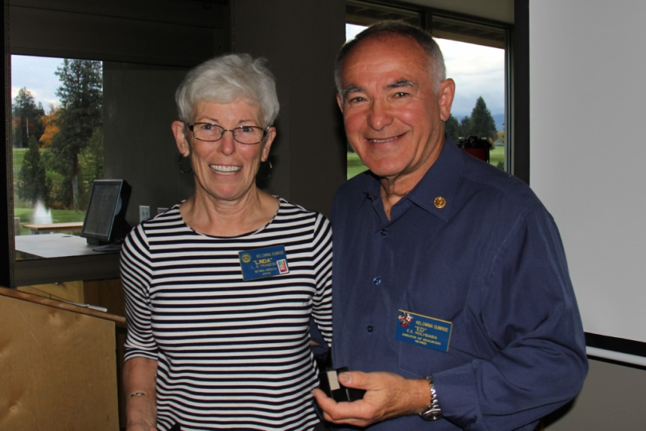

The club’s Foundation Committee, chaired by Director Huck Parfeniuk, which also includes Tom Paterson, Helmut Hubert, Ed Kolybaba, and Linda Frandsen, along with the members of the club, congratulate and thank the three members who were recognized for their continued concern and support for the advancement of world understanding, goodwill, and peace through the improvement of health, the support of education, and the alleviation of poverty.

