Club Rotarians Express their Support for the Humanitarian Work of the Foundation
Written and posted by Ed Kolybaba on Nov 30, 2016

The Kelowna Sunrise club continues to appreciate the financial support that its membership makes toward The Rotary Foundation. Recently, two Rotarians were recognized for their continuing support by being presented with Paul Harris Fellow lapel pins indicating their generous donations to the Foundation.

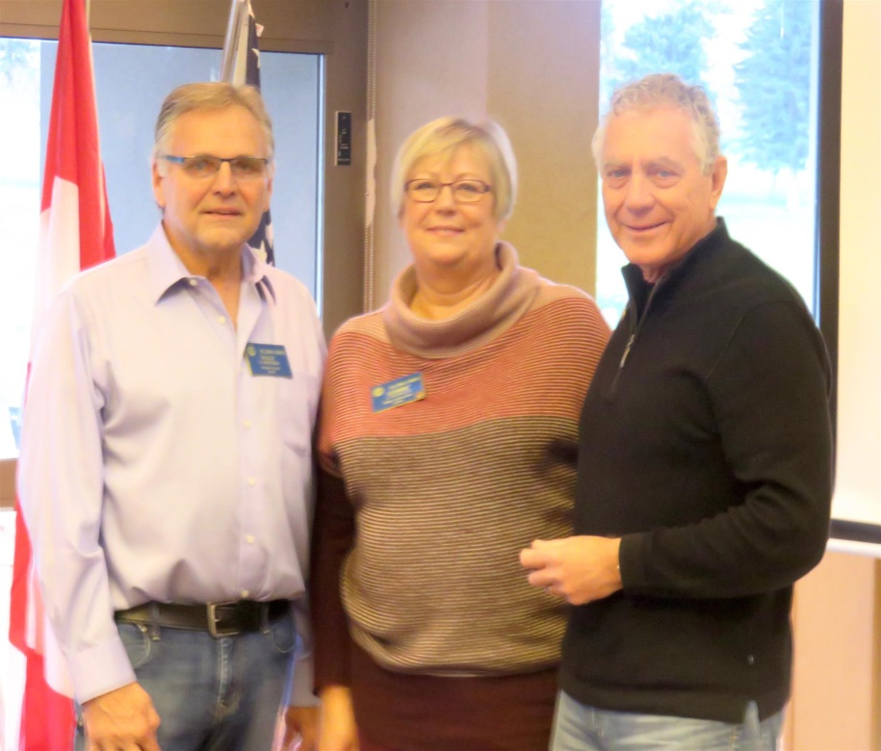

Rotary Foundation Committee Director, Huck Parfeniuk, presented Joanne Reynolds with a Paul Harris Fellow and Helmut Hubert with a Paul Harris Fellow + 8 on November 25th. Congratulations and appreciation are extended to Helmut for his continued support for the Foundation year after year; and to Joanne, a recently inducted Rotarian (July 2015), who has already recognized the value and commitment that we should all make to the Foundation and its humanitarian service.

