Thank You Sunrise Rotarians for Changing Lives
Created and posted by Ed Kolybaba on Dec 31, 2016

The Rotary Foundation, as it celebrates its centennial, will reach its goal of raising US300 million during the current Rotary year of 2016-17. Rotarians from the Rotary Club of Kelowna Sunrise are certainly are playing a part in realizing this goal. As of the end of December of 2016, half way through the current Rotary year, Rotarians from the club have contributed over US$9103.

Rotarians from the Sunrise Rotary club have participated in changing lives through their contributions to The Rotary Foundation and its programs which contribute to………

Eradicating polio

Thanks to Sunrise Rotarians, we are closer than ever to ending
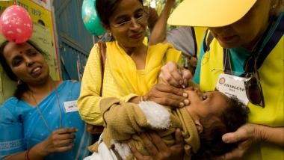
polio. The Foundation reports that the number of cases has been
reduced by 99.9 percent since 1988, and with its partners, have
immunized more than 2.5 billion children worldwide. To end polio for
good, every last child in Afghanistan and Pakistan must be
immunized, the newly detected outbreak in Nigeria must be
contained, and all of the partners in eradicating polio must be diligent
in the prevention of polio outbreaks in all of the current polio-free
countries of the world.
Promoting peace and conflict resolution

Thanks to Sunrise Rotarians, we are making a significant effort
to promote peace through the Rotary Peace Centers program which
was established in 2002. Each year, the program trains some of the
world’s most dedicated and brightest professionals, preparing them
to promote national and international cooperation and to resolve
conflict.

Providing education and overcoming literacy

Thanks to Sunrise Rotarians, educational projects that provide
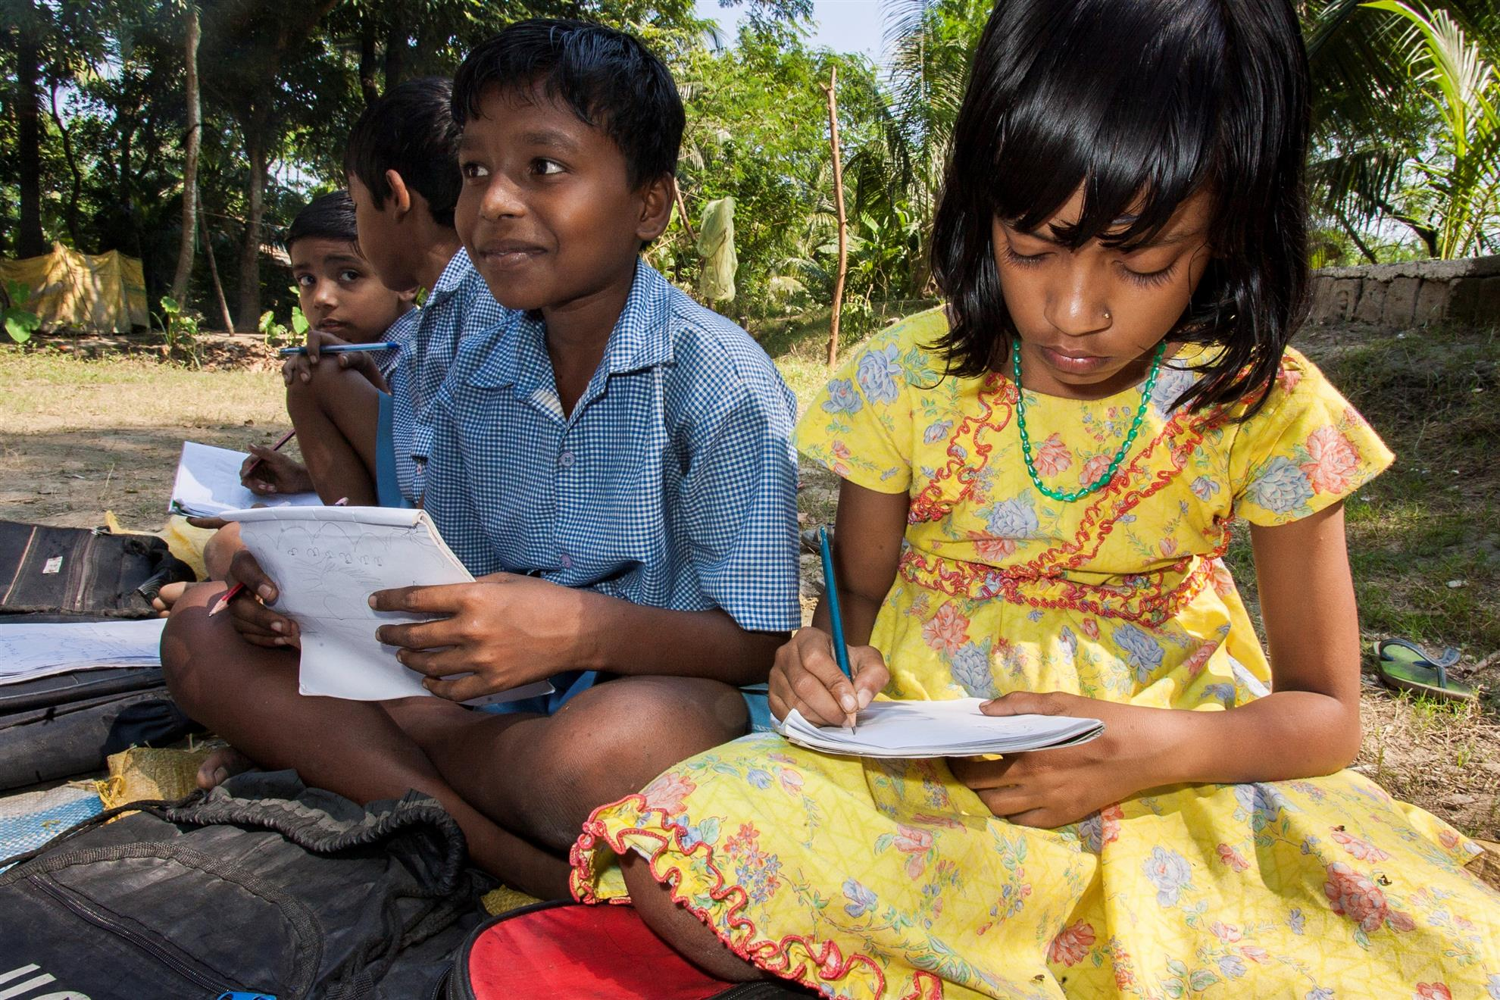
technology, teacher training, vocational training teams, student meal
programs, and low-cost textbooks are being made available to
communities in third world countries that do not have the financial
means to attain these basic educational needs. With over 67 million
children with no access to education and more than 775 million illiterate
people over the age of 15 in the world, Rotarians recognize the need to
continually financially support these projects; and in doing so create the
means to strengthen the capacity of communities to support basic
education and literacy, reduce gender disparity in education, and
increase adult literacy.

Preventing disease
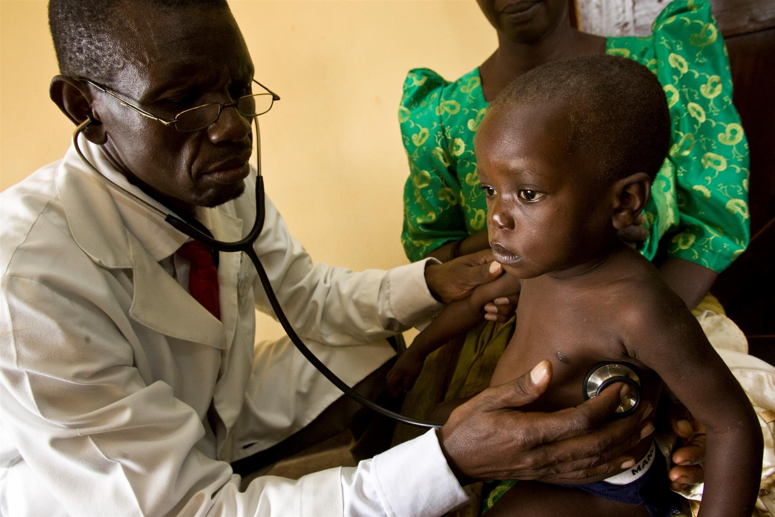
Thanks to Sunrise Rotarians, there is a concerted effort to prevent
and treat disease in countries. Health camps and training facilities are
being put into place to fight the spread of HIV/AIDS and malaria in
struggling communities. Infrastructure is being provided for doctors,
nurses, governments and partners who are unable to afford to pay for
health care; and infrastructure is being put into place for improved
drinking water and sanitation.

Ending hunger
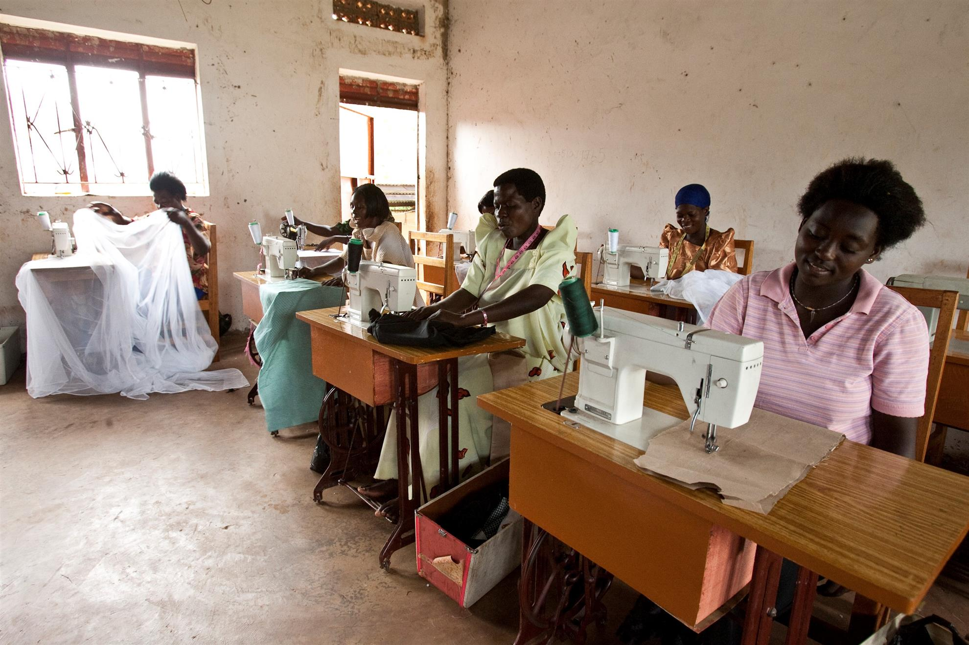
Thanks to Sunrise Rotarians, financial support and guidance is
being provided to local communities and citizens in underdeveloped
countries to assist them in the implementation of sustainable economic
development and the means for enhanced family income. Increased
access to and production of food, better management of natural
resources, and access to cleaner water ultimately will provide a means
to the increasing worldwide hunger problem.

