Tips from Okanagan Sun Football Games Help to Eradicate Polio
Story written and posted by Ed Kolybaba on Oct 22, 2016
Thanks to tips collected during the six home games of the Okanagan Sun, the club has now
achieved an estimated 39 percent of its goal to raise US$1500 for the PolioPlus program of
The Rotary Foundation.

At the regular meeting of the club on October 21st, club member Brian Fennell presented President Pat McAllister with the final allocation of tips from the final home game of the season for the Sun. Over the course of the six home games, Fennell shared that the members of the club who had served beverages at the two stations at the Apple Bowl had collected a total of $781.80 in tips.

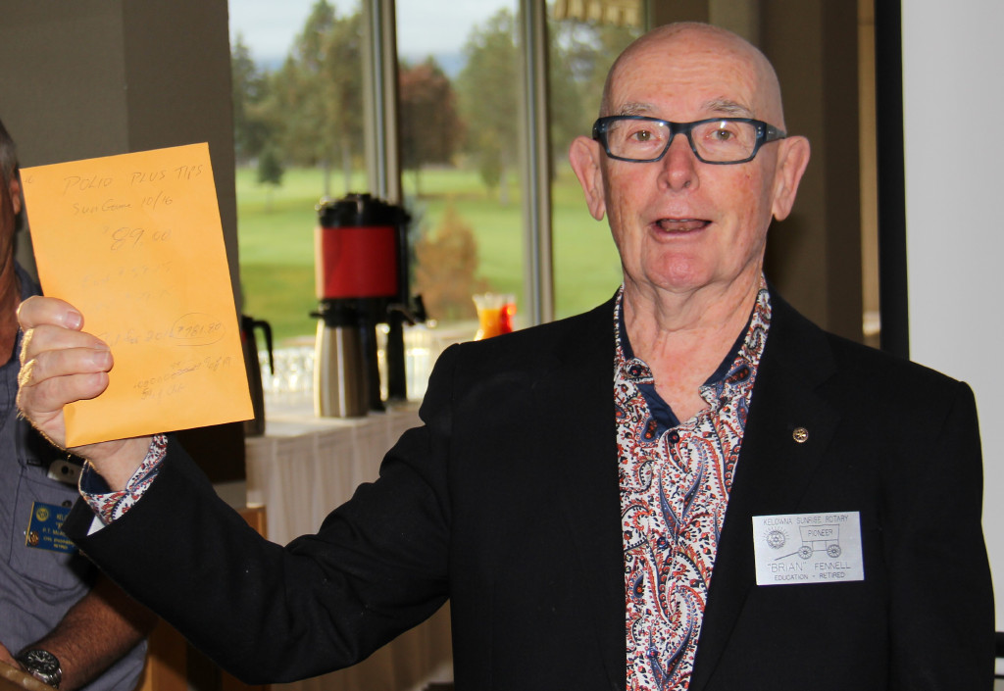

Brian Fennell has spearheaded the club’s volunteer beverage sale and service program at the Sun’s home games for many years, with teams of three to four club members volunteering at each of the two stations. The tips collected at the stations have been designated to supporting the PolioPlus program which is focused at eradicating polio from the world

