A Self Drive Geology Tour of Summerland, plus a Vineyard Talk and Bubbles’N’Bites at the Sumac Ridge Estate Winery – Sunday, March 31 2019
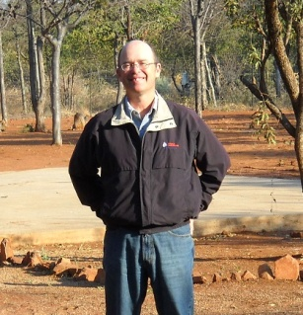
Join Summerland Rotarian Michael Zang and trace the numerous landscape changes throughout geological history at Summerland. See the many sub-tropical plant fossils under the Sumac Ridge Winery. Wonder at the tectonic movement of the Okanagan Fault lying beneath Okanagan Lake. See how the last Cordilleran Ice Sheet covered the Okanagan up to 3000m deep and carved Giant’s Head Mountain. And see how our local landforms make a toxic brew of Geological Hazards. All combined, these are the most unique landforms of the Okanagan. Those who wish can finish the tour with a vineyard talk on viticulture/terroir and a Bubbles’N’Bites experience at the Sumac Ridge Estate Winery. You will enjoy five vivacious sparkling wines paired perfectly with small bites. Relax in a seated harvest-style setting in the Steller’s Jay sparkling wine cave. Discover the Sumac Ridge portfolio of handcrafted traditional Methode Classique sparking wines and learn the traditional process of making sparkling wine.

Tour Details
Difficulty Level: 1
Price: $30 + tax, less a Discount of 10% for the Bubbles’N’Bites. Wines purchased at Sumac Ridge Winery has a discount of 10%
The geology tour is free
Max Group: 12 for the Bubbles’N’Bites, the more the merrier for the geology tour
What to Bring  - Water  - All-weather Clothing  - Good Walking Footwear (just in case you want to walk to the top of GHM)  - Sun Hat/Protection | Area  Location: Summerland  Meeting Place: Trout Creek Visitor Pullout at 1:15pm  Transportation: Your or someone else’s car  Age Permitted  all

Sites of Geological Interest

Site #1, Trout Creek Visitor Pullout. Everyone meet up at 1:15pm at the Trout Creek Visitor Pullout at 1:15pm to sort out who will be doing the driving and start the tour at 1:30pm. We should car pool here to make parking at the other sites easier. After the tour the people who do not want to go to the winery can head back to get their cars.

Site #2, drive to intersection of Arkell Rd. and Dunn St.

Site #3, continue up Arkell Rd., Gartrell Rd. and go south on Happy Valley Rd. to a safe stop point.

Site #4, continue south on Happy Valley Rd., Hillborn St. and go south on Canyon View Rd. to the Trout Creek Trestle.

Site #5, continue south on Canyon View Rd. and turn north on Monro Ave. Continue north on Monro Ave. and stop just past the rail line.

Site #6, continue north on Monro Ave, go west on Victoria Rd. S. Turn right on Lenzi St. and then south on Shale Ave. Pull over half way along Shale Ave.

Site #7, return to Victoria Rd. S. and head for the top of Giant's Head Mountain (GHM) using Prairie Valley Rd., Giants Head Rd. and Milne Rd. This would be a good time to check out how the park redevelopment is going.

Site #8, return to Hwy. 97 and go north to the Hwy. 97 Scenic Lookout just north of Summerland.
Site #9, go south on Hwy. 97 and take the first right at Bentley Rd., stop just after the cattle guard, on the rights there is a large road cut.

Site #10, return to Hwy. 97 and go south to Sumac Ridge Drive. Stay to the left and park at the mailboxes.

Site #11, continue up Sumac Ridge Drive to the Sumac Ridge Estate Winery for the Vineyard Talk at 3:00pm and Bubbles'N'Bites event starting at 3:30pm. Everything should be wrapped up by 4:30pm.
Details of the sites can be seen in the Geology Tour of Summerland, a self guided tour pamphlet produced by The Summerland Museum and Archives.

References:
Roed, M. A. and Greenough, J. D., Editors, 2004. Okanagan Geology, British Columbia, Kelowna Geology Committee, 220 pp.
Geology Map taken from the Digital Geology Map of British Columbia, 2005
Roed, M. A. and Fulton, R. J., Editors, 2011. Okanagan Geology South, Geologic Highlingts of the South Okanagan, British Columbia, Okanagan Geology Committee, 238 pp.

Map of Summerland with Geology Site Locations
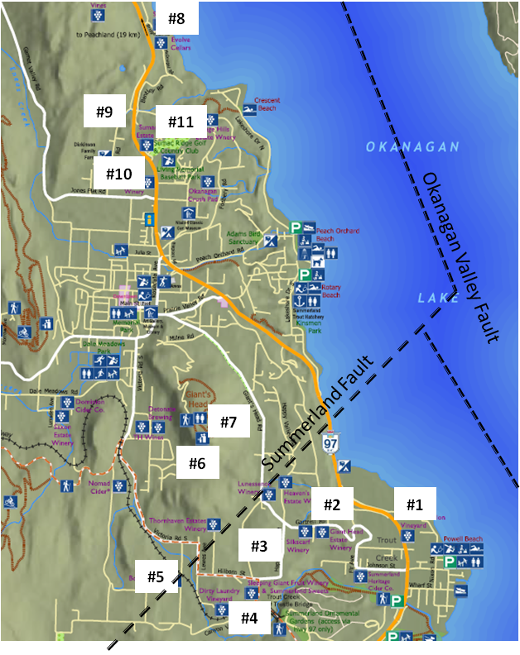

Brief Summary of the Basement geology of the Okanagan Valley
As seem in the map below, Roed and Greenough (2004) present an overview of Okanagan Basin bedrock geology and theories regarding geological evolution.
In general, bedrock present in the Okanagan Basin outcrops in the benchland and highland areas surrounding the valley bottom. Bedrock on the eastern side of the basin in the highland areas generally consists of faulted and fractured, metamorphosed, and intruded rock forming the Monashee Gneiss Shuswap Rocks, unit m (metamorphic rocks, undivided) and unit gr (granite, alkali feldspar granite intrusive rocks). These rocks are separated from bedrock on the western side of the valley by the Okanagan Valley Fault (which trends approximately north to south through the valley bottom, approximately through the centre of Okanagan Lake). Bedrock on the western side of valley generally consists of younger metamorphosed and intruded volcanic and sedimentary rocks, unit gd (granodioritic intrusive rocks), unit v (undivided volcanic rocks) and unit sf (mudstone, siltstone, shale - fine clastic sedimentary rocks).

Bedrock Geology Map of the Okanagan Valley
