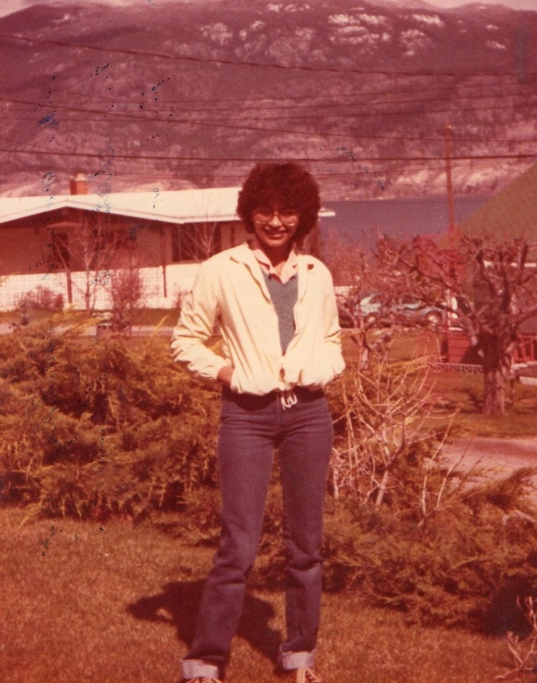
Circa1980-81 I was a 17 year old teenager from India, spending a year away from home, visiting North America for the first time. I spent one academic year, through the International Rotary Youth Exchange Programme from District 306, in Summerland B. C., attended Grade 12 in the Summerland Secondary School, lived with 5 Canadian Rotary families, and had the most memorable year of my life!! My year in Canada was a life changing experience! It was an opportunity for me to immerse into another culture, live as part of the Canadian families and the local community, connect / bond with peers from completely different backgrounds, be a regular student, represent my culture and country and all this, within the safety net of the Rotary! My host families, the Krauters, Seidels, Welshes, Smiths, & Paulsons….opened their homes and hearts to me, and carved an indelible place in my life which I could never replace or forget.

From1981-2011 My life took many dips and turns….I completed my BA , MSW, (worked as a personal counselor), got married with a medical student Nikhil, (who now practices Neurosurgery), got my LIB degree, practiced law for 12 years, relocated to Nikhil’s hometown Dhule, in North Maharashtra, had a daughter, Niharica, ( now 23 years), did a refresher course in and went back to Psychological Counselling, also do Interior Designing, and am presently doing myMA(Psychology). We travelled extensively through all this period…BUT, a trip to Summerland was # 1 on my bucket list !!!
CircaSummer2012…. Nikhil, Niharica and I decided to make a trip to Summerland !!!
Since Pat & Karl Seidel and the Krauters had kept in touch, and I had connected with school friends like Diana Troiano and others, there seemed to be reason enough, to spend a few days in Summerland…and so the trip was planned!! Summerland, Vancouver, Whistler and the Alaskan Cruise…. in that order of priority…. at least for me! Where do I began to describe the joy I felt, on seeing the sign “Welcome to Summerland”, the Okanagan Lake (where I had participated in the Polar Bear Swim on Jan 1st, 1981) Giants Head, a bear cub, the beach, visiting and dining out with the Krauters.. my first home in S’land, meeting Pauline Paulson, (whose spana kopita I had never forgotten), which Pat made for me, visiting Main Street, seeing the old School, the deli, remembering old times…the long walks to school, the old unchanged phone numbers, connecting and coffee with old friends Joey Seidel, Laura Kane, Darlene…picking cherries, …meeting Rotarians and old school teachers at the Rotary Barbecue, missing my host parents who have passed on , the Smiths, the Welshes, George Paulson, Mr. Fishendon our Principal…endless memories…and through it all… Karl was there.. taking care of all 3 of us in the Seidel home, ready to take us shopping to Kelowna, visiting the Canada Day fair Penticton, wine tasting at the Dirty Laundry, ice-cream at Summerland Sweets… I cannot describe the feeling of completion I feel, upon returning home, after our visit to Summerland… the ache of missing, the hole in the heart, for 30 odd years, finally healed!!!
With the same love and acceptance they had shown in 1980-81, the Seidels and Krauters, and the Rotary Club of Summerland, welcomed our family into their homes, notwithstanding their own age or health. Finally, Nikhil and Niharica could understand, why I had always said, that Summerland was more beautiful than Switzerland !! It’s the people who make the place beautiful. Since then, Karl Seidel, has visited us twice. Every moment of his trip is special….Thank you Rotary Club of Udhna for providing me this absolutely invaluable opportunity and experience.

