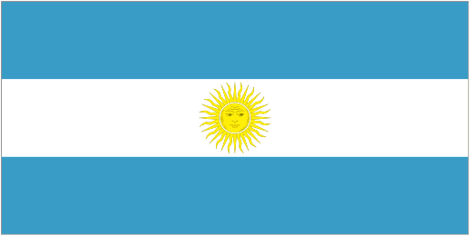







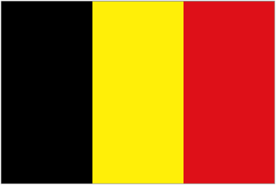







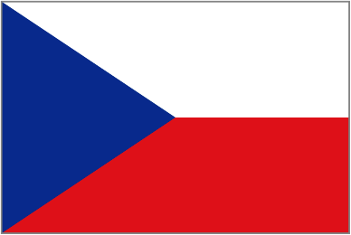









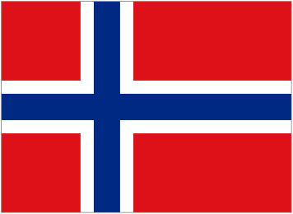

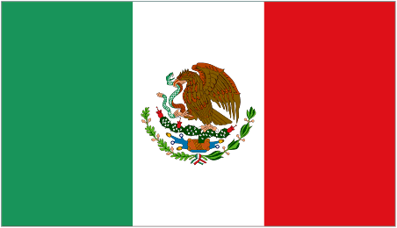

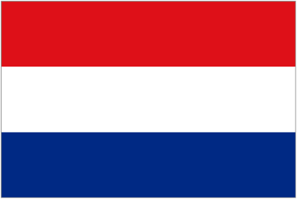



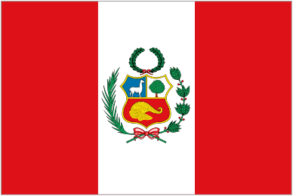

**Summerland Rotary Youth Exchange Program**

***Making a World of Difference*.**

✈ Live in a foreign country for a Year,

✈ Learn and experience a new country, culture, and a new language.

✈ Travel with fellow Exchange Students, represent your Country’s culture and ideas.

✈ It’s not a trip it is a lifetime experience, you can help bring the world closer - make some amazing friends

Are you ready for it ? …… Not sure ? ….. Need information ?

**Rotary International**

**District 5060**

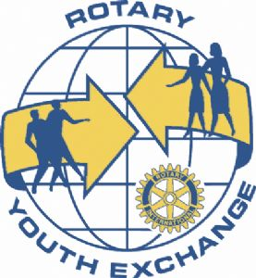

We’re looking for **Grade 9, 10, 11, 12** Students

*Students selected this year 2017 – depart on exchange August 2018*

**Deadline for Application: October 10, 2017**

**Applicant Interview: October 13, 2017 between 4:00pm-6:00pm**

**District Interview in Kelowna: November 18 - 19, 2017**

**For information please contact**

**Bob Van Balkom @ (250) 328-9941 or Michael Zang @ (250) 809-1264**













