John Hogarth Cowboy Poet
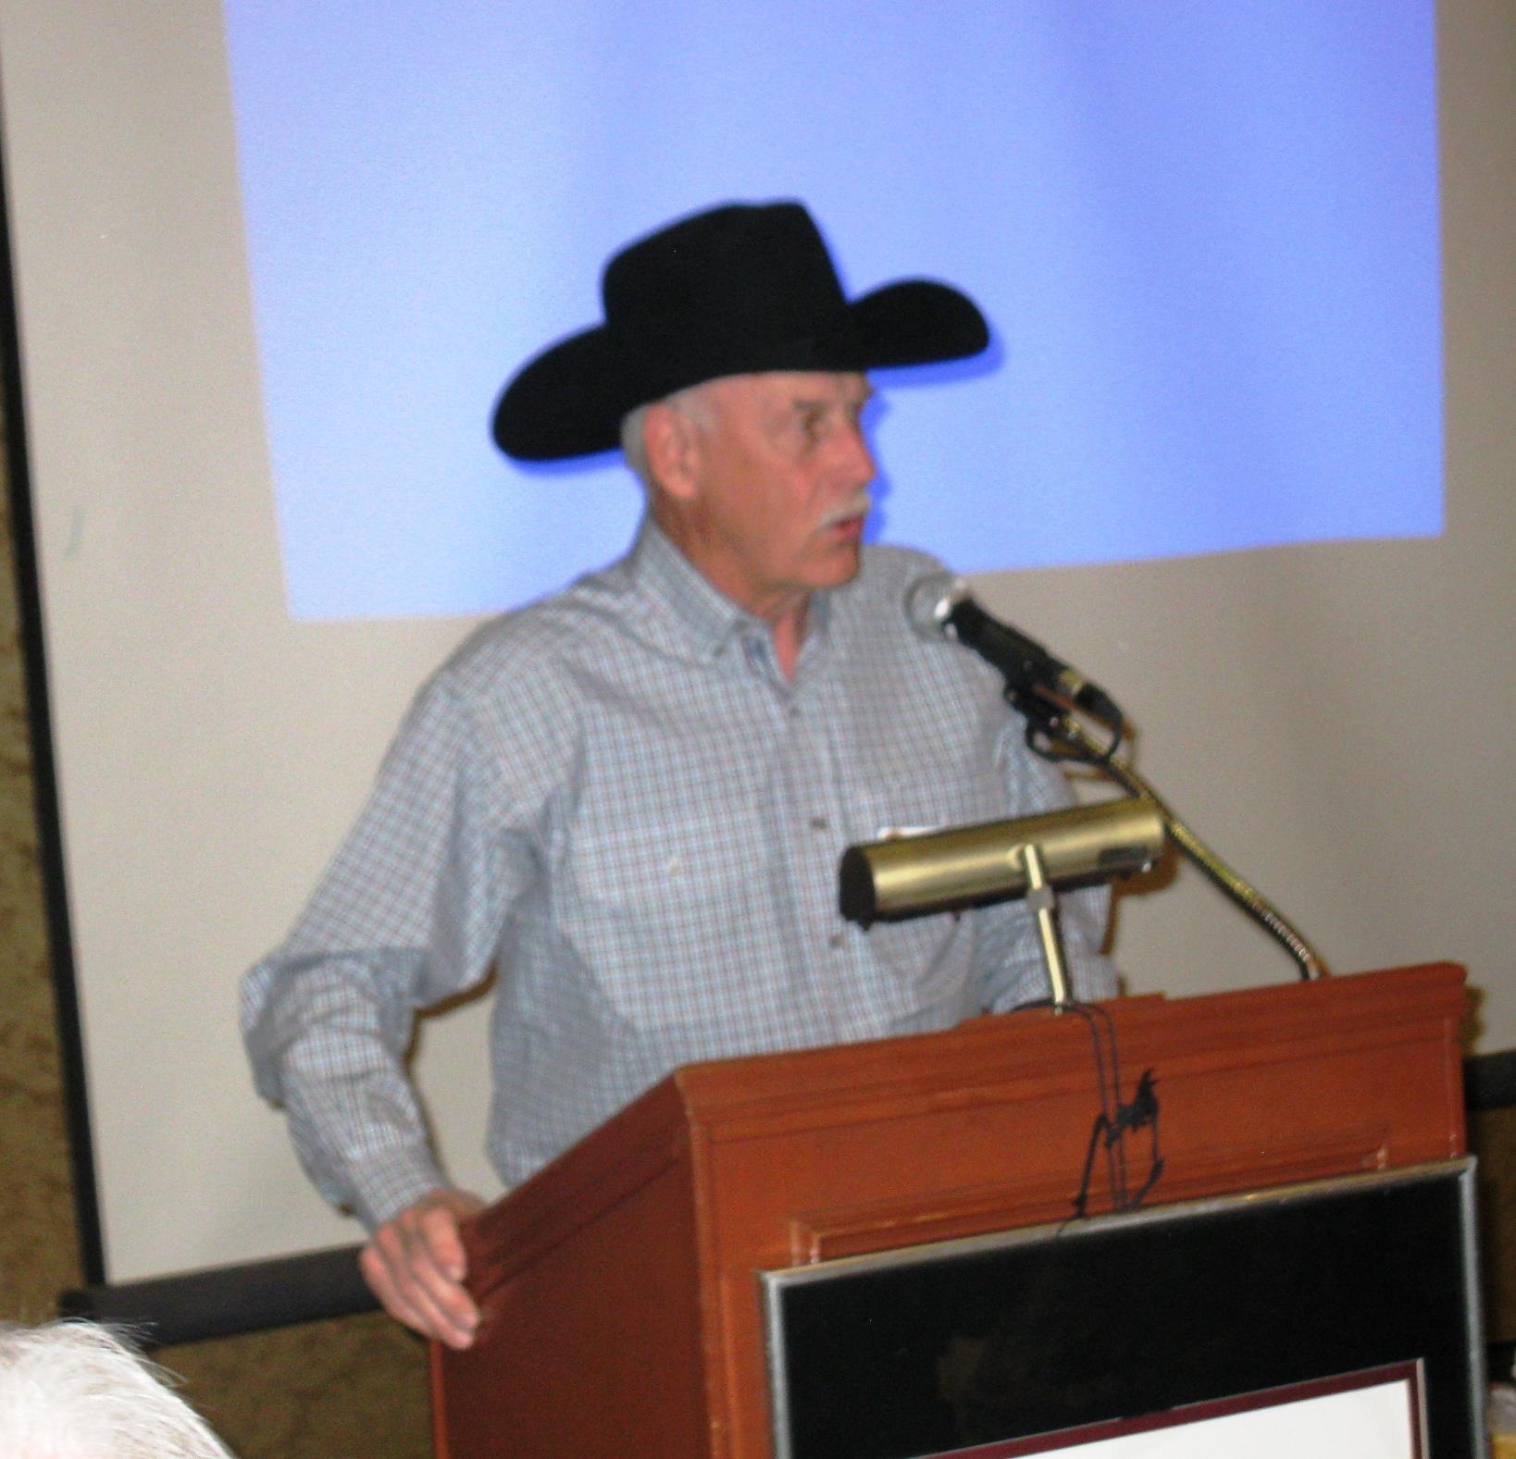

Rotarian John Hogarth (aka Cowboy Poet Jesmond Jake) dropped by to read his moving historical poem honouring the Vernon Rotary Club at their 90th celebration evening. The poem reviewed the history of the Vernon Rotary Club. See below:

THE FIRST NINETY YEARS 1925-2015
BACK IN THE YEAR OF TWENTY FIVE
WHEN MOST OF US HERE WEREN'T EVEN ALIVE
A NEW CLUB WAS FORMED IN VERNON TOWN
AND NINETY YEARS LATER IT'S STILL AROUND

THE VERNON ROTARY CLUB WAS ITS NAME
THE FIRST IN THE VALLEY ITS CLAIM TO FAME
A CLUB FROM VANCOUVER HELPED PAVE THE WAY
FOR TWENTY EIGHT MEMBERS THAT APRIL DAY

CLUB "NINETEEN HUNDRED AND SEVENTEEN"
IT WAS BEYOND PAUL HARRIS'S WILDEST DREAM
WHEN HE AND THREE FRIENDS MET TO CONTRIVE
THE FIRST ROTARY CLUB IN 1905

TWENTY YEARS LATER VERNON'S CLUB GOT ITS START
THE GROUP OF NEW MEMBERS WITH VISION AND HEART
SET OUT TO MAKE VERNON A MUCH BETTER PLACE
PIERS, PARKS, POOLS AND BEACHES GOT A ROTARY FACE

BACK IN THOSE DAYS THE TOWN WAS QUITE SMALL
JUST OVER 3000 THE CENSUS RECALLS
J. S. GALBRAITH WAS VERNON'S TOWN MAYOR
AND MR. ART GODFREY FIRST ROTARY CHAIR

VERNON NEWS WAS THE TOWN'S LOCAL RAG
THE CANADIAN RED ENSIGN OUR COUNTRY'S FLAG
THE HUDSON'S BAY WAS ' THEE ' BIGGEST STORE
WATKIN MOTORS WAS SELLING MODEL T FORDS

THE GREAT PADDLE WHEELERS WERE STILL ON THE LAKE
YOU GOT OFF AT THE LANDING, THERE A TRAIN YOU COULD TAKE
SHIPS AND TRAINS WERE THE BEST TRAVEL MODES
THE HIWAYS AND BYWAYS WERE ROUGH GRAVEL ROADS

ROTARIANS MET AT THE KALAMALKA HOTEL
IT STOOD THREE STORIES AND LOOKED PRETTY SWELL
NOON LUNCH WAS A DOLLAR, DUES WERE 25 BUCKS
IF YOU MISSED MONDAY MEETINGS YOU WERE JUST OUT OF LUCK

SERVICE ABOVE SELF AND THE FOUR WAY TEST
AND 'ONE PROFITS MOST WHO SERVES BEST'
FOR NINETY LONG YEARS THESE MOTTOS HELD SWAY
MAKING THIS CLUB A GREAT ONE TODAY

- See more at: http://portal.clubrunner.ca/818#sthash.kQvk8Ype.dpuf

