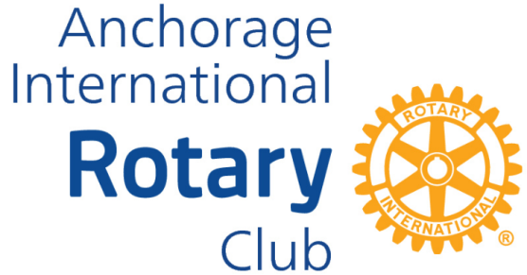

Donation/Service Project
Application

The Board will apply the 4 Way Test and RI guidelines. Does your project:
-Have a long-term, sustainable impact
-Include activities that align with the goals of one of Rotary’s areas of focus (peace, disease, water/sanitation, mothers/children, education, local economies, and environment)
-Address an important need identified by the community
-Strengthen the community’s capacity to address its own needs

Sponsor:

Application date:

Project name:

Describe the project in general. What other groups or organizations are involved in this project?

What is the expected time to complete and the manpower required for this project?

Describe how the project will affect the lives of the people/community it is intended to serve.

Outline club funding requirements and any matching/additional funds or additional funding sources.

Explain how this project would benefit Rotary and Anchorage International Rotary.

