SHORT FORM APPLICATION
FOR ROTARY YOUTH EXCHANGE

To: Chairperson, Youth Exchange Program, District 5010. I have read the enclosed brochure and am interested in being considered/my child being considered for the Rotary Youth Exchange Program.

Students Name: _____________________________________________________ _____________________
Address: ____________________________________________________________________________
City: ___________________________________State: ____________________ Zip: _______________
Phone Number: ( ) _____________________________________________________________
Date of Birth: ______________Grade: _____ School: __________________________ GPA: ________
email _____________________________

Type in a short response to the following:

1. Why do you want to be a Rotary Exchange Student?

2. What are your strengths? Your weaknesses (areas for improvement)?

3. What is your biggest accomplishment in life? Your biggest disappointment?

4. What other activities (community, church, school, etc.) are you involved in?

5. What are your long-term goals (i.e. what do you want to do when you “grow up”)?

6. What three (3) things make a good leader? How do you fit your definition of leadership?

7. Describe the American form of government.

8. Why do you think you would be a good representative of Alaska and the United States as an ambassador in another country?

My parent(s) are aware that I am applying for this program.
Student’s Signature: ______________________________________
Mother’s Signature: ______________________________________
Father’s Signature: _______________________________________
Date: _______________________
RETURN TO YE 5010 BY 4:00 PM on OCTOBER 30, 2018 AT; PHC, 33870 Polar St, Soldotna, AK 99669 OR FAX TO 907-262-9355 or drfrisk@gmail.com.

Timetables for Outbound Youth Exchange

Short form applications must be completed in detail and received by 2:00 PM on OCTOBER 30th 2018 AT; PHC, 33870 POLAR ST, SOLDOTNA, AK 99669 OR FAX TO 907-262-9355 OR EMAIL TO drfrisk@gmail.com.

- District 5010 Rotary Club appointees will interview students and their parents separately beginning on October 29th though November 5th, at Peninsula Health Center in Soldotna. The appointees will recommend suitable students for further consideration by November 5th.

- Attendance at the interview session and instructional seminars are required for the student and parent(s). After the student is selected, they will work on a “long form” application and then will “type”, sign and return five (5) originals of the completed long form (all original signatures) to the Rotary District by December 1, 2018. Your youth exchange officer will assist with this process. 1st of 3 installments is due December 1st, $2600.

- The District Committee will then make the student country assignment, which is subject to securing hosting agreements with Rotary clubs and their Districts throughout the world.

- A must attend orientation for all outbound students will be held in January at the annual “Winter Orientation” outing. All students must attend. The student expenses are paid by Rotary. Parents are invited to attend this session. The many aspects of the program are discussed including the experiences of students who have completed the program. The Friday night announcement dinner is especially interesting for parents.

- No student is to be regarded as a Rotary Exchange Student until the final approval by District 5010, official acceptance by a host Rotary Club in the assigned country and they board the aircraft for their destination.

- Students selected by the District Exchange Committee will depart for countries in July/August/September.

SOLDOTNA AREA CALENDAR

September, 2018 RECRUITMENT BEGINS

OCT 30th, 2018 THIS FORM IS DUE

OCT-NOV, 2018 STUDENT AND PARENT INTERVIEWS
PENINSULA HELTH CENTER
33870 POLAR ST, SOLDOTNA, AK 99669

November, 2018 LONG FORM COMPLETION

DEC 1st, 2018 LONG FORM APPLICATIONS DUE WITH FIRST $2,600 PAYMENT

January, 2019 ANNOUNCEMENT OF COUNTRIES TO EXCHANGE
AT WINTER ORIENTATION

Obligation of Student

- Students must abide by the decisions and rules of the program and willingly accept the advice and supervision of their hosts in another country.

- Students are expected to obey the laws of the host country at all times and accept the discipline of the host school and the host families. Students are expected to adapt to the home environment of the host families – the host families are under no obligation to adapt themselves to the student. Students must be of help to the host family, take on some duties, i.e. wash dishes, mow lawns, clean room, etc. Be part of the family…not a guest.

- Students are Ambassadors for their country and must at all times behave in a manner which will reflect credit on his or her family, community and country. Take home those impressions and experiences that will further international understanding, not being critical of conditions or philosophies uncommon to their native land. Students involved in drinking, driving, serious dating, drugs or violation of the program rules, will be expelled from the assigned country and returned home.

- Students are required to agree that they will not under any circumstances drive a motor vehicle while under the operation of the Rotary Exchange Program.

- Students are not permitted to “Go Steady” or develop any romantic entanglements. Dating, preferably in company, will be tolerated, but romantic involvement is to be strongly discouraged to the extent that an applicant breaching the rule could be sent home.

- Students should learn both conversational and written language of the country where hosted as much as possible prior to departure.

- Students must return to their country after the termination of the school year.

- Each student must attend school regularly and maintain passing grades. Rotary functions and exceptional educational events approved by the Rotary hosting club, should be attended.

Obligation of the Parents

- Parents/students will pay Rotary District 5010 a lump sum amount for the exchange. Since this rate may vary with time, the current figure will be provided by your Rotary Representative. The lump sum amount will be paid in three equal payments (December, March and June).

- The $7,800 lump sum amount paid to Rotary District 5010 will cover expenses for: round-trip coach airline ticket, visa expenses, blazer, patches, pins, basic slide show, medical insurance and language classes.

- The lump sum paid to Rotary, however, does not cover the $500 emergency fund that each student is asked to bring with them when they arrive in their assigned country. These funds are deposited with Rotary in the foreign country and are to be used for emergency purposes only. If they are not used, Rotary returns these funds to the students during their last month of stay so they can use funds as they/parents desire.

- Funds paid to Rotary do not cover the student’s personal needs such as clothing, travel expenses in the host country, passport, spending money, gifts and film. These expenditures are the responsibility of the parents/student.

- The lump sum may be refunded after selection, if there is some reason the student cannot continue in the exchange program. The parents/student will be refunded all of their funds paid to date, less $500 which will be retained by Rotary for administrative and other expenses incurred by Rotary. Once the student departs for the exchange, there will be no refunds.

- Students chosen as alternates will be asked to deposit $500 with their long form application. Should they not be selected to participate, these funds will be refunded to parent/student.

If you would like to be a host family for an inbound exchange student, please contact us.

ROTARY YOUTH EXCHANGE PROGRAM

Brief Facts on the Rotary Youth Exchange

The Rotary Youth Exchange Program provides for the selection and sponsorship of students in the 14-16 year old age group to travel to another country to spend the school year attending a junior or secondary school and to live with host families in that country under sponsorship of the local Rotary Clubs.

District 5010

District 5010 is an International Rotary District encompassing the Rotary Clubs of Alaska, USA; Yukon, Canada and Siberia, the Far East of Russia.

Objectives of the Program

- To further international goodwill and understanding by enabling the students to study first hand some of the accomplishments and social environments of people in lands other than their own.

- To enable Students to advance their education by studying in an environment entirely different from their own and undertaking study of courses and subjects not normally available to them in the schools of their own country.

- To broaden their own outlook by learning to live with and meet people of different cultures, creeds, etc. and by coping with day to day problems in an environment completely different from the one they have experienced at home.

- To act as Ambassadors for their own country by addressing Rotary Clubs and other youth or community groups in their host country and by imparting as much knowledge as they can of their own country with its accomplishments and problems to the people they meet.

- To study and observe all facts of life and culture in the country where they are hosted so that on their return to their home country they can pass on the knowledge they have gained.

Who is Eligible

- All applicants are selected solely on merit after local and district interviews.

- Students between the ages of 14 and 16 and attending high school full time.

- Applicants must be of good character and have good academic ability, a GPA of 3.0 or better, be self-confident, outgoing and pleasant in order to fit in the role of an Ambassador. They must have the flexibility to accept discipline and be capable of adjusting to new environments and living conditions.

- The District prefers to send students out in their sophomore or junior year.

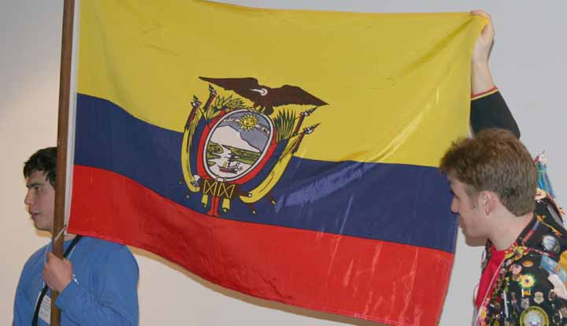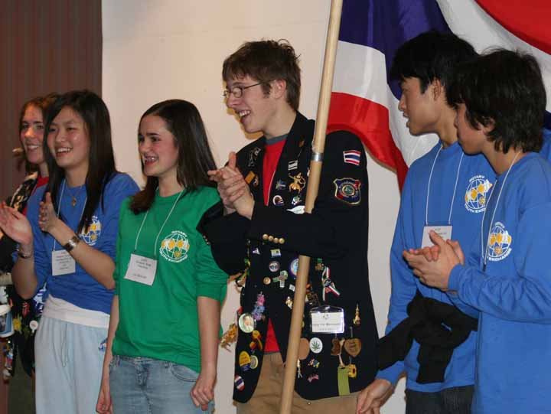

Host Family Obligations

Parents of students selected for the Rotary Youth Exchange Program agree to be a host for an incoming Rotary Youth Exchange Student during their exchange period. If parents cannot agree to host an incoming student, your son/daughter is still eligible for the exchange program.

- Provide food and lodging for the student in their home and to share family activities.

- Undertake to supervise the school and leisure hour activities of the student AS IF HE OR SHE WERE THEIR OWN SON OR DAUGHTER…NOT A GUEST.

- Encourage the student and integrate the student into the family as quickly as possible, using informal names and outlining chores normal to the student’s age and presenting household rules so that misunderstandings are less likely to occur. The student should always be responsible for making his or her own bed and keeping the room clean and tidy.

- It is desirable that the student has a room of their own, or at least share with someone in the student’s own age group and sex.

- Lend a helping hand at every turn and be friendly. The best measuring stick that you as a host family can apply is to ask yourself, “HOW WOULD I WANT MY CHILD TO BE TREATED IF HE/SHE WERE THOUSANDS OF MILES FROM HOME IN A STRANGE COUNTRY IN UNFAMILAR CIRCUMSTANCES?”

- It is desirable that the host family have a student of similar age and sex to the student being hosted. However, many very successful host arrangements have taken place where there are only young children, or none at all in the host family. Under no circumstances, should the student be considered “a built-in baby sitter.”

- Traveling with host families is encouraged. Students traveling must receive the prior written approval of the host Rotary Club and written consent from their legal parents and District Exchange officers. If travel is extensive, a detailed itinerary must be completed prior to travel commencement (and adhered to). The student must establish their financial ability to handle all contingencies.

- The student will require assistance and direction to learn the conversational and written language of the host country if different from their own. The guidance of the host family is required in this and all aspects of the program.

- Seek prompt medical attention for the student if they become ill.

If you would like to be a host family for an inbound exchange student, please contact us.

Countries with which we Exchange

Bolivia, Brazil, Czech Republic, Denmark, Ecuador, Finland, France, Germany, Hungary, India, Mexico, Poland, Russia, Sweden, Switzerland, Taiwan, Indonesia, and Thailand. This list is subject to change at any time.

Read more at www.ye5010.org

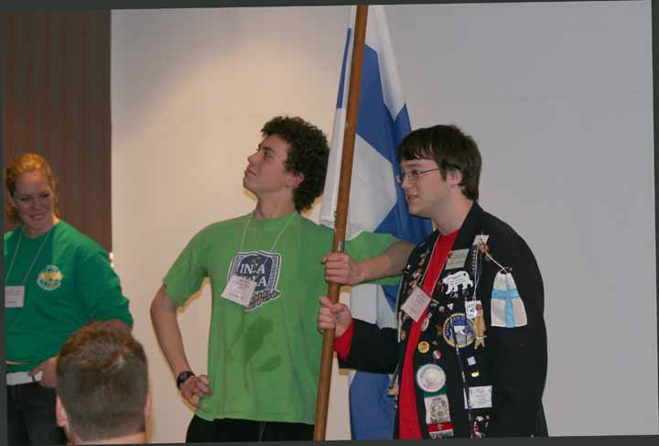

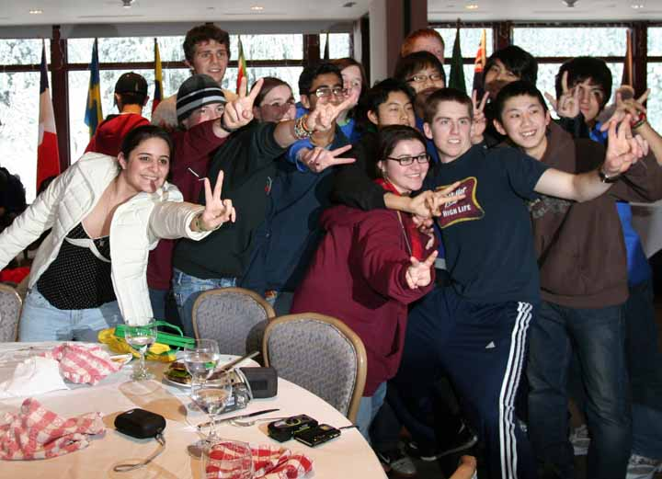

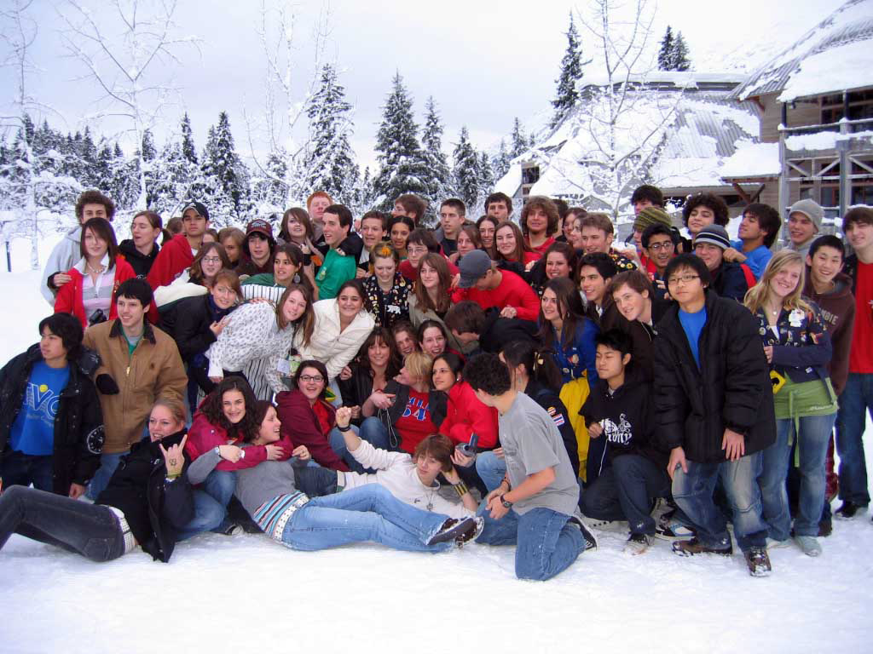



District 5010
Alaska, USA
Yukon Territory, Canada
Siberia and Far East, Russia
www.ye5010.org

Rotary District 5010 Youth Exchange Program

200 West 34th Avenue, Box 393
Anchorage, AK 99503

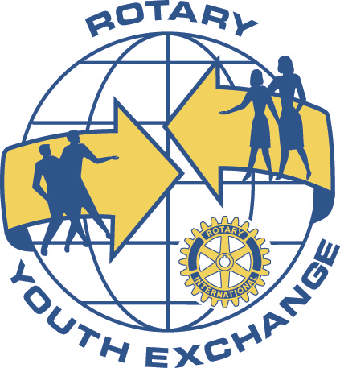

FOR QUESTIONS CONTACT
Dr. Evan Frisk, SOLDOTNA ROTARY
907.260.4844 or 907.398.4837
drfrisk@gmail.com

