A History of
The Rotary Club of Cranbrook Sunrise
1997 - 2020

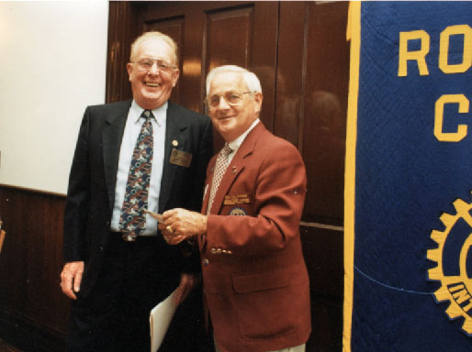
In June of 1996, 32 Cranbrook Rotarians and spouses attended the Rotary International Convention in Calgary, Alberta. During one of the sessions George Watson, the President that year and Jim Cupidio, Secretary, suggested to Colin Campbell and Jim Chiu that it would be a great idea to have a new club chartered in the same year as the Cranbrook Rotary Club's 75th Anniversary. We agreed and a committee was formed with 4 members of the Cranbrook Rotary Club: Jim Chiu, Colin Campbell, Hardy Nielsen and Gordon Walmsley. Jim Chiu was the Governor's representative to the club and applied for the provisional club status immediately. We began meeting regularly at the Town and Country Inn in late August. By the end of the year the required 20 members were on board and the charter was applied for.
Our first President Hardy Nielsen with District Governor Bill Hiatt during our Charter Night celebration, June 1997.

It was touch and go with RI but as luck would have it, the charter for the Rotary Club of Cranbrook Sunrise was issued on March 21, 1997, not exactly the same day but the same month 75 years after the Cranbrook club's charter was issued. We all celebrated at the Cranbrook club's birthday party and at our Charter night held at the International Hotel at Fort Steele in June.

Our membership immediately fell to 14; it took several years to get back to 20, but that seems to be normal for most new clubs. Now the club is well established with the membership in the 40-45 range, above the global average for Rotary club size.

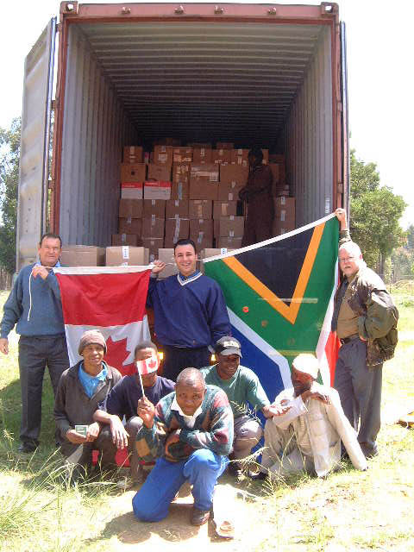
From the very beginning the club has been an active club. We have successfully completed many community and international projects ranging from an international book project in partnership with a South African Rotary Club and establishing Village Banks in Bolivia and the Philippines, to building Harmony Park near one of the downtown entrances, raising funds for building the Fieldhouse at Moir Park, and taking an active part in the construction process.
Books from Cranbrook Sunrise arrive in South Africa.
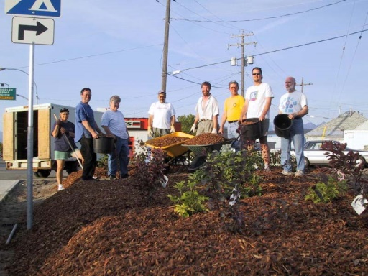
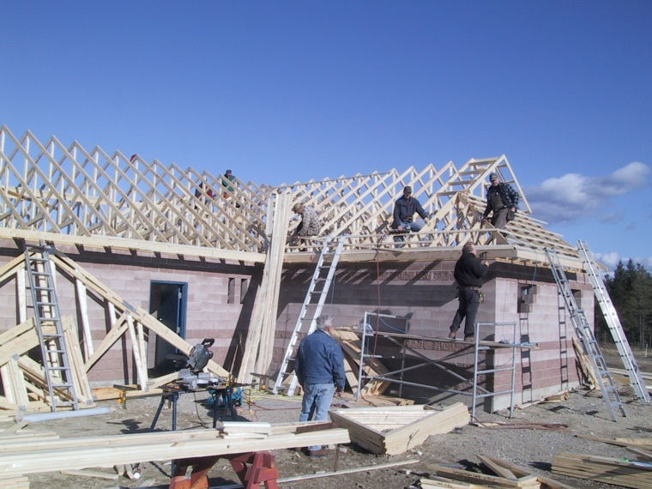
Sunrise Rotary work party during the construction of Harmony Park, May 2002.
The rafters go up on the Moir Park fieldhouse with Warren Trimble directing the volunteers, Oct. 2005.

Construction of the Fieldhouse was undertaken to celebrate Rotary's 100th anniversary in 2005. The club raised in excess of $100,000 in cash and in-kind donations from businesses

and individuals in the community and the balance through fund raising activities such as a car lottery and golf discount card sales to complete the project.

The club raised even more money, and restored artefacts that represent a significant part of Cranbrook’s history – the ‘ALCO engines - that stand in their glorious colours and are a tourist and rail-fan attraction. These will stand as a testament to the dedication of Sunrise Rotarians to our community for years to come.
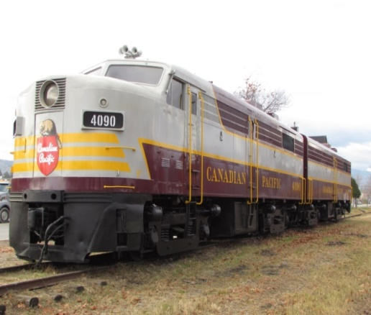
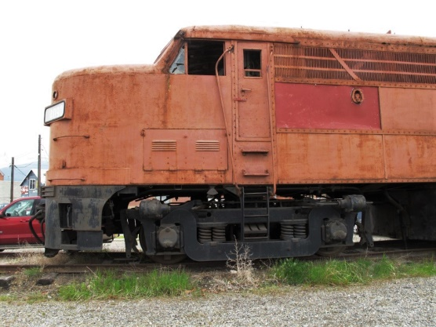
The club has been an active supporter of Youth Exchange, and RYLA and provides 5 scholarships annually for university students who are entering third, fourth or fifth year of post-secondary studies. We are particularly proud of the Sharon Gibbon Memorial Scholarship awarded to an applicant studying Fine or Performing Arts. As well, an Entrance Scholarship is awarded each year to a Mount Baker student proceeding into Vocational or Trades training at a college.
The Alco locomotive restored to its original colours, October 2014.
The Alco locomotive before restoration.
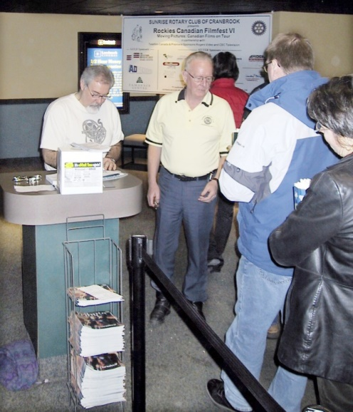
Film fans arrive to take in one of the many films screened during Rockies Canadian Filmfest VI.
For a club as active as Cranbrook Sunrise, fundraising is a major challenge. From the start, the club searched for ways to raise funds through events that would enrich the community while providing financial support for our activities and programs. The first of these came about after a member attended the Vancouver Film Festival and discovered that an organization called Moving Pictures made VFF films available throughout the province. This led to the development of Rockies Film Festival (https://rockiesfilmfest.com/index.html) an event that brought to the theatre a varied selection of films not likely to be shown locally otherwise. From its beginning in the Spring of 1998, the ‘fest and a monthly film series which developed from it, were a success, drawing an appreciative audience and adding a regular event to the local cultural scene. The festival and series continue today, more than 20 years after the original presentation.

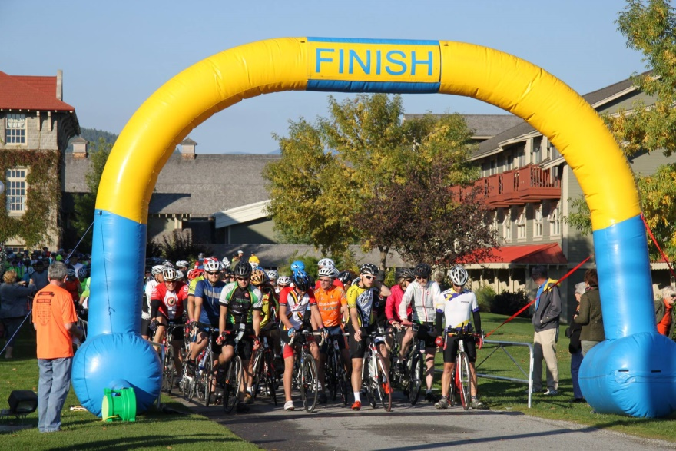
In 2013 the club organized the Kootenay Rockies Gran Fondo, a cycling event that now annually draws approximately 500 riders to our community for a ride through the gorgeous scenery of the local mountains.
Riders line up at St. Eugene Resort for the start of the Kootenay Rockies Gran Fondo, Sept. 2014.
Since its inception, the Cranbrook Sunrise Rotary Club has been a major supporter of the Rotary Foundation. The annual contribution to that organization by both the club and its members averages more than $8,000 or in excess of $150US per member. Additionally, the club and its members are strong supporters of the Global Polio Eradication Initiative.
It is noteworthy too that club members have been very involved at the District level. Over the years Sunrisers have filled roles from District Governor to District Chairs of the Foundation, International Youth Exchange, and Membership and volunteered as members of many District Committees.
So it is clear that as this history of Cranbrook Sunrise Rotary is being written in August, 2020, the club has evolved from its early beginnings in 1997 as a group of 14 mostly inexperienced members to a complete Rotary Club, functioning effectively at all levels of the Rotary world.
Authors:
Original version by Colin Campbell
Revision and update in August 2020 by Allan Davis and Bill Gibbon

