**



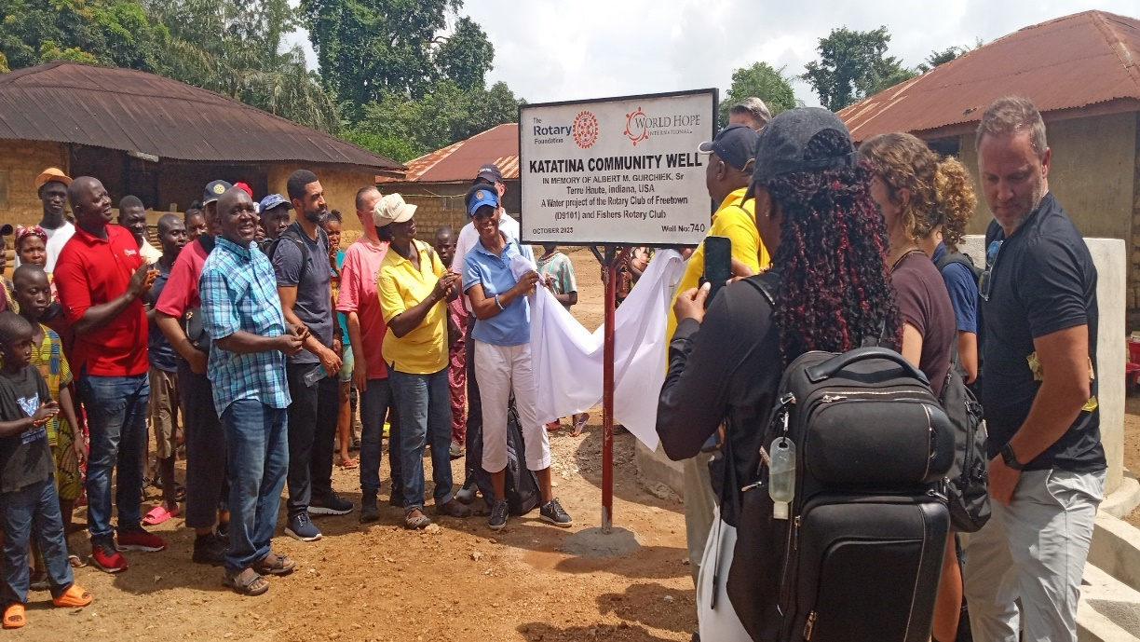

**Borehole handing over ceremony at Katatina Community.**

World hope international (WHI) and Rotary international has a long-time partnership relationship for many years. This relationship stands on providing water services (drilling of borehole water wells & construction of water dam) and training of Water management committees (WMCs) in both institutions, based community, urban, peri urban centres and rural settings.

WHI through Rotary funds has drilled 11 water points in Freetown, Bombali and Koinadugu Districts, established and trained 11 Water user committees.

**The municipality of Freetown city and the provincial settlements.**

|  |  |  |  |  |
| --- | --- | --- | --- | --- |
| **No.** | **District** | **Location** | **No. of water**  **points** | **Status** |
|  | Freetown city | Majay town | 1 | Pump installed and functional. |
|  | Pentecostal primary school, Fort Street. | 1 | Pump installed and functional. |
|  | Alton Hope school, old wharf wellington | 1 | Pump installed and functional. |
|  | Jui Bible college | 11 | Pump installed and functional. |
|  | Grammar School-Murray town |  | Pump installed and functional. |
|  |  |  |  |
|  | Aberdeen Municipal school | 1 | Still under construction, due to heavy iron content intrusion. |
|  | Bombali | Katatina (grant) in Biriwa chiefdom | 1 | Pump installed and functional. |
|  |  | Matogo community | 1 | Pump installed and functional. |
|  |  | Gbassia community school | 1 | Pump installed and functional. |
|  | Koinadugu | Brighton Horizon school-kabala | 1 | Pump installed and functional. |
|  |  | Dogolia community | 1 | Pump installed and functional. |

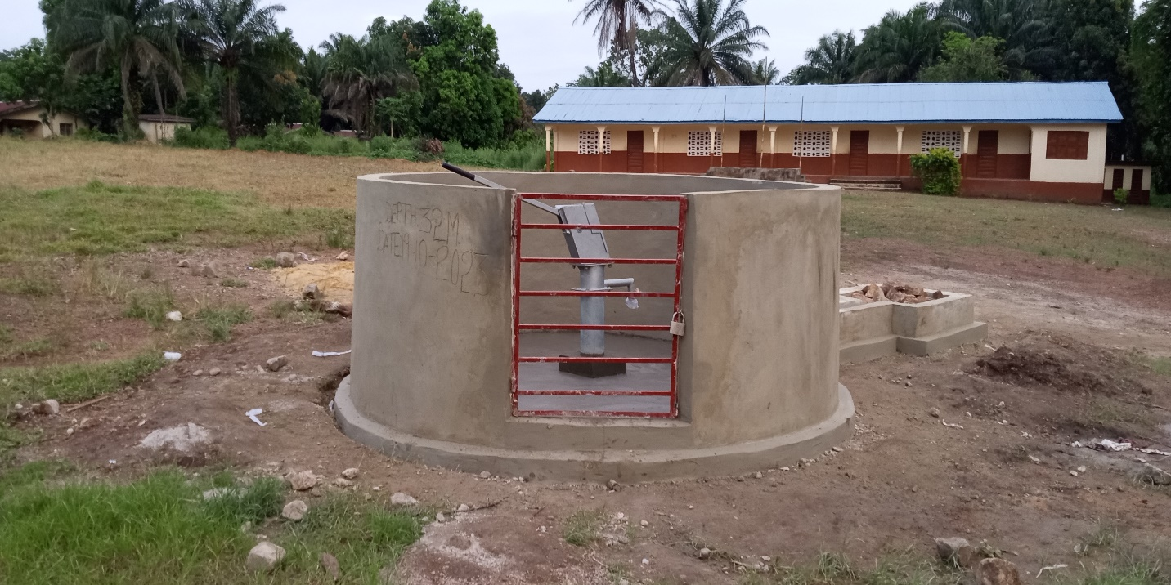

**Completed well at the Gbassia community primary in Bombali District.**

A total of 11 water user committees were established and trained each comprising 7 members totalling to 77 members. Each of the water user committee was provided with basic start-up maintenance tool kits.

**THE TOOL KITS**

|  |  |  |
| --- | --- | --- |
| **No.** | **Item** | **Quantity** |
|  | Grease | 2 |
|  | Screwdriver | 1 |
|  | Wire brush | 1 |
|  | 17mm spanner | 1 |
|  | 19mm spanner | 1 |

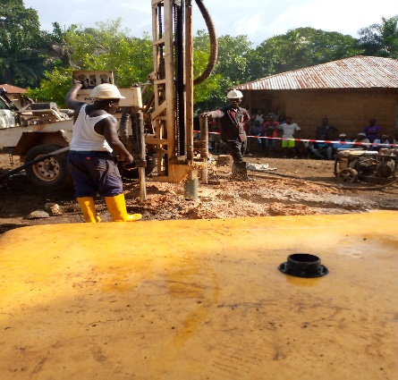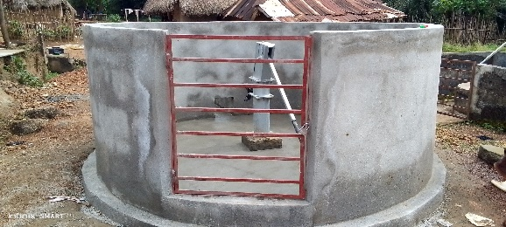

Completed water point Matogo community. Borehole drilling on progress.