

Zoom Board Agenda September 21, 2021
Rotary Club of Lethbridge
1. Call to order - 12:40 in attendance Shilpa, Tracy, Lynda, Thomas, Kim, Adam, Steve, Loralee
2. Approval/Amendments of minutes from August 24, 2021 - Approved
3. Approval/Addition of the Agenda - Approved
4. Business arising from minutes
a. Org Chart Review - Discuss Vacancies
Lynda makes a motion to accept Pat Killoran as Secretary - Tracy seconded - carried
b. Shilpa - PR TOR attached for review and discussion
Connect David Agema regarding potential member that has social media expertise.
c. Tracy - High school awards within indigenous communities
Stand-off no reply as of yet from superintendent. Contact name received for a councillor at Pikanii. Shilpa Stocker has a connection.
d. Kim - update re: Lobsterfest as multi-club event
$10,000. Most clubs sound interested in being involved
5. Treasurer's Report: $14,500 doesn’t include raffle. $10,000 from raffle in profit. $5,500 in sponsorship outstanding. $900 outstanding owed by ribbers.
Fundraiser - Helen and Jeff Warren. Policy regarding a process to make sure those approving expenses are not also the budget creator. Preference for Rotarians is okay.
6. New Business
a. Removal of members with unpaid dues
Kim to connect with Matt, Bev and Al. H.
b. Change in Membership portfolio structure - Lynda
Lynda makes a motion that the Membership Director position be split into two different director positions Club Service Director and Club Administrator and the discontinuation of the Fellowship Director position as it resides under the Club Service portfolio. This will be taken to general membership for approval as it requires a change of by-laws. Seconded by Loralee. Carried.
c. Results of COVID survey and hybrid meetings - Kim and Lynda
> One unvaccinated
> Four uncomfortable attending with other vaccinated Rotarians
d. Jeff Warren fundraiser proposal - Thomas
50/50 whoever is closest to Jeff’s finishing time. Each entry/square is a certain amount of money. Peru theme dinner. Timed event. Thomas makes a motion that Jeff Warren’s race be the center of a fundraiser with the profits going to DoGoddery Fund. - seconded by Joanna. Carried.
e. Ribfest 50/50 - Thomas
Still no winner. Next year we need to make sure the media is aware so that there’s a strong indicator to find someone. Ticket needs to have contact information. If a winner is not found we will bring a proposal to the board.
f. November foundation/polio month activities - Move for Polio walk is October 24th. PR needed. Raising funds - 3K walk and fellowship. November is foundation month - speakers and international projects. Silent Auction. Walk to city hall with a flag raising. Downtown for visibility. CASA to City Hall. Connect with Shilpa and Pat.
g. Network of Neighbours - Stayed until next meeting.

7. Committee Reports
a. Membership Report Directors - Lynda Kavanagh (attached)
b. Fundraising Report Director - Thomas Guo (attached)
c. Service Report Directors - Todd Brown (attached)
d. New Generations Report Directors - Tracy Hamilton (attached)
e. Fellowship Report Directors - Melanie Meier
f. International Report Directors - Adam Weersink (attached)
g. Foundation Report Director - Steve Craig (attached)
h. Public Relations Director - Shilpa Stocker (attached)
8. Adjournment
9. Next Meeting: Oct 19, 2021 at 12pm

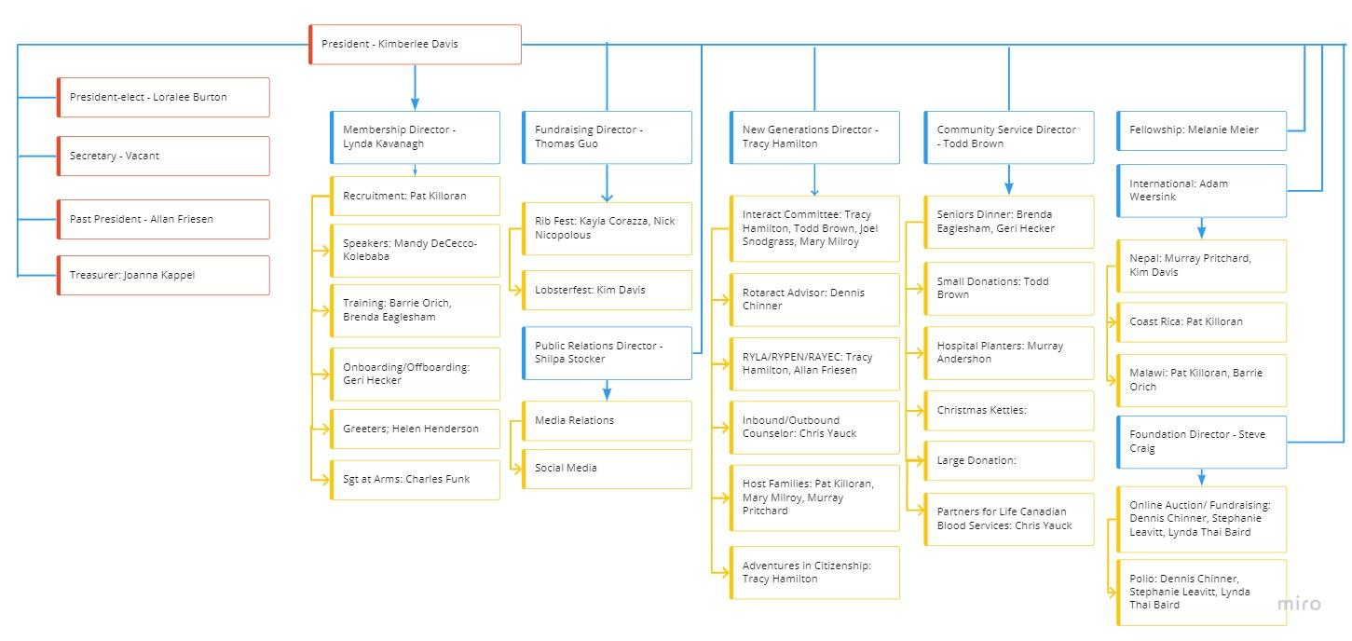
Rotary Club of Lethbridge
Public Relations Committee
Terms of Reference and Planning Document

Role of Public Relations Committee: To develop and execute a plan to tell the public about Rotary and promote the club’s service projects and activities promoting the values and work of the organization.

Target Audience: Media and Community.

Tie in to Strategic Plan 2021-2024:

- Community Awareness:
- Tell our Rotary Story and showcase the impact we have in the community.
- Develop relationships and partnerships so people want to join us to make a difference.
- Promote and communicate our club’s activities, successes and opportunities to engage the community.

Objectives:
- To educate members of the community and prospective members about Rotary.
- To supply media with background information, information about specific initiatives, etc., including impact Rotary has on community.
- To raise public awareness in order to garner sponsorships, volunteers, attendees at events.
- To highlight Rotary’s work (service, networking and fellowship opportunities of membership); and publicize club activities in order to engage the community.

Tactics:
- Social Media (FaceBook, LinkedIn, Twitter, InstaGram)
- Mainstream media advertising (TV, Radio, Print, etc.) to promote specific things
- News releases – To make community aware of service projects that meet a community need; international service project supported by club; notable or prominent speakers at club meetings; fund raisers, events, etc.
- Fact Sheet about Rotary (history, objectives, project emphasis)

Requirements from other Committees:
Each Committee needs to identify what it needs from PR at the beginning of the year and as each major event/initiative is developed.
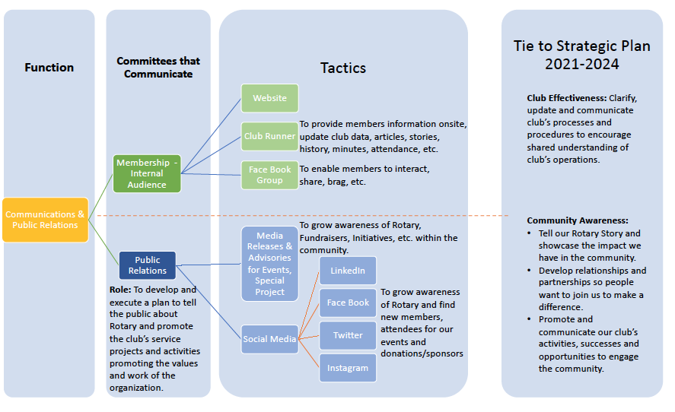
Requirement from Board:
- What are our key messages for not only Rotary but the Rotary Club of Lethbridge?
  - What is Rotary?
  - Who are Rotarians?
  - What does our Rotary Club do?
- Assistance developing Media List
- Need two Sub-Committee Chairs.

Sub-Committees Required:
- Media Relations - To grow awareness of Rotary, Fundraisers, Initiatives, etc. within the community.

- Social Media - To grow awareness of Rotary and find new members, attendees for our events and donations/sponsors.

Organization Chart:

Public Relations

Media Relations

Social Media

A Proposal to Raise Funds for the Club’s DoGoodery Fund
Jeff Warren has entered a challenging mountain bike race in Peru – the Machu Pichu Epic is a 5-day
marathon race in the Cusco region of the Andes. Jeff, teamed with his son, will start at an elevation of
3200 m., and will climb a total of more than 7300 m. over the 5 stages, starting Monday, October 4th and
finishing on Friday, October 8th
.
I contacted Jeff and asked whether he would be willing to have the Club use his effort as a fund-raiser.
Jeff agreed and asked that the funds go to the Club’s DoGoodery Fund at the Community Foundation of
Lethbridge and Southern Alberta.
Thomas Guo, our Fund-raising Chair, met with Jeff last week, and shot this video
https://youtu.be/u6t8mC2Q8LI Kim has agreed that we can show this video at the meeting on Sept 27th
,which Jeff plans to attend just before he leaves for Peru. We would like to briefly introduce the idea, show
the video, and then ask for donations.
I have talked to the Community Foundation, and we can submit donations several ways:
• Donate via Canada Helps: https://www.canadahelps.org/en/charities/community-foundation-
of-lethbridge-and-southwestern-alberta/ (Choose: Apply your donation to a fund set up by this
charity, then select Rotary Club of Lethbridge DoGoodery Fund)
• Send a cheque to the Community Foundation: Unit #50, 1202 2 Ave. S., Lethbridge, T1J 0E3
• Make a donation at the meeting. Joanna can accept cash, cheques, or payments via Square. We
will list names and addresses and amounts given for each donor, and the Community Foundation
will issue them a receipt for tax purposes.

I am struggling to find a hook to get members to open their wallets. My current plan is to enter the name
of every donor in a draw for a prize, with the winner to be drawn by Jeff after his return from Peru. If you
have other ideas, please discuss them with Thomas at the meeting.

Thanks for your consideration
Helen Henderson



DIrectors Report – PUBLIC RELATIONS
Report Date | Portfolio | Director
September 2021 | Public Relations | Shilpa Stocker

Summary Of Past events
- Researched and developed Public Relations Org. Chart, Terms of Reference, Planning Document
- Developed Templates for Media Releases/Advisories

Upcoming Events

requirements
- Approval on TOR and Planning Document.
- Is there an “About Our Club” document anywhere?
- Is there a Fact Sheet About our Club anywhere?
- Agreement on our Key Messages for OUR CLUB.
- Sub-Committee Chairs, especially Social Media

Items Requireing Board Input/Assistance/Approval
Approval on TOR and Planning Document.
Is there an “About Our Club” document anywhere?
Is there a Fact Sheet About our Club anywhere?
Agreement on our Key Messages for OUR CLUB.
Sub-Committee Chairs, especially Social Media

