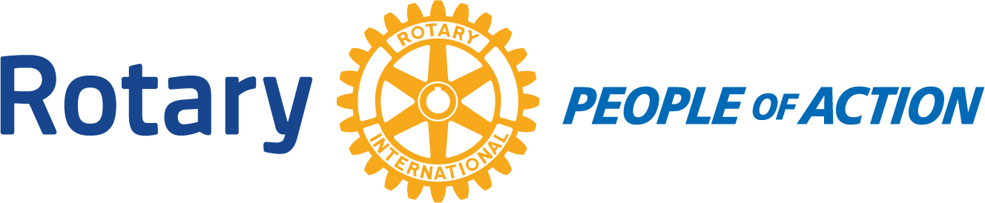

Rules for
Revv’d Up Rotary Round UP Scavenger Hunt/ Car Rally
Saturday October 3, 2020
Staggered start times Entry Fee $100.00/vehicle
Object: to collect items, answer questions, and take photos of your team at the required locations and be back to the start point in 3 hours.
Start at the Town of Okotoks Operation Building (118 North Railway Street) at your emailed start time, you have 3 hours to complete your task and return to the Operations Parking Lot. Be on time! or loose points for being late!
- You may have between 2-6 players on your team.
- There must be a seat belt for every member of team.
- Bring a mask and hand sanitizer.
- Your start time will be emailed to you. Don’t be late!
- You must work as a team throughout the 3 hours.
- Not all teams have the same package of questions, clues, and challenges.
- When asked to take a picture, all members of your team must be in the picture.
- All pictures need to be on the same phone, or camera, throughout the entire 3 hours.
- There is a point system to decide who will be the winner.
Although this is a race, the total objective is to have FUN, FUN, FUN...Work as a team, with no speeding tickets and humour still intact. Hint: you may not be able to finish all the challenges in the 3 hours!

Contact Trish Henderson @ rotarypjh56@gmail.com or 403-585-5571 with any questions.
Entry Fee $100.00 per vehicle
Entry Name and Registration-please print clearly

FAMILY/TEAM NAME: _____________________________________PARTICIPANTS: ________________, _________________________,___________________________,________________________________
ADDITIONAL MEMBERS OF YOUR TEAM:

Email: ___________________________________
Phone number of contact person________________________
We accept email transfers, the square, and cheques for payment. Make cheque out to Rotary Club of Okotoks
P.O. Box 84, Okotoks Alberta T1S 1A4

