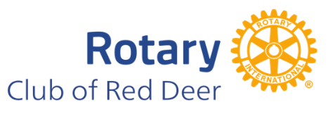
The Rotary Club of Red Deer is pleased to announce that applications for our Spring 2026 Community Grants are now being solicited. We support projects that demonstrate IMPACT in our community.
We believe the best story wins! We welcome proposals for ALL projects, however our priorities for this granting period will be:
- Mental Health
- Youth
- Community Development
Requirements of all applications:
- Registered Not for Profit status is required
- An understanding and connection to Rotary’s Mission and Mandate
We have a two phase application process
- Short form application seeking an overview of your project for initial screening by the Committee
  - Applications for the Short Form Applications will be received up to March 15, 2026
  - Short Form Application Form: click here
  - All applicants will be informed of their status after review by the Committee
- Long form application requires a more detailed information for projects selected to move beyond the first phase
  - We will announce the Spring 2026 Form application date after short form applications have been reviewed.

For more information please contact:
Vangi Willington
Chair: Community Grant Committee
Email: Rotaryclubofreddeer.grants@gmail.com

