Cox’s Bazar, Bangladesh Literacy Project Grant Support Document 2019-2020
“Mothers of Intention” is a literacy program of “The Amorak Society”, a Canadian charity #876304676RR001 working in the slums of Bangladesh to educate working mothers in literacy who then teach five children. They create one-room schools of 25 mothers, by renting a dwelling in the slum where the mothers live. To date, they have twenty such “schools” in the slums of Dhaka and Khulna. Presently, they are in the process of setting up three new schools in Cox’s Bazar with the assistance of three Rotary entities.
The three “entities” are two clubs The Rotary Club of Cox’s Bazar Shaikat (also spelt Saikat) and The Rotary Club of Cox’s Bazar City. The third entity is Cox’s Bazar Inner Wheel sponsored by Cox’s Bazar Shaikat.
To date Rotarians from the Cox’s Bazar Shaikat have:
- hired a teacher with input from Amarok
- supported and mentored the teacher
- met with Amarok multiple times to ensure they're clear on what we do and how
- located a rental place and negotiated the rent
- served as an ongoing mentor to the teacher
- regularly communicate with Kuntal, Amarok’s Country Director
Rtn, James Kroeker, Director of The Rotary Club of Dryden’s International Services Committee (ISC) established contact with the Rotary Club of Cox’s Bazar Shaikat to act as the “host” club with Dryden as the lead donor club in an application for a District Designated Fund application for the 2019-20 year to fund the Rotary Club of Cox’s Bazar Shaikat Mother’s School for the 2019-20 year.
The Dryden ISC has set two major criteria in place as we move forward with this request: the establishment of a process of accountability and a goal of sustainability. These are being built into our Memoranda of Understanding with the Host club and the third-party Amarok Society. (Appendix A)
In District 5550 we have worked with the Rotary Club of Winnipeg-Assiniboine and the Rotary Club of Kenora to present a joint proposal for a District 5550 DDF request in the amount of $2500.00. (See Appendix B for Budget details)
We have also established contacts with the Rotary Club of Cox’s Bazar and supplemented those contacts with Canadian Bangladesh nationals living in Canada. The representative of the Cox’s Bazar Shaikat Club (RI Dist 3282 Bangladesh) is Rtn. Hasnain Sabih Nayak, B. Arch, MPH; Chair, International Service Committee 2018-19. The Rtn who is most actively engaged is Abu Shama. In Canada we are using Anwar Sadat in Toronto and Ahmed Kawser of the Rotary Club of Winnipeg Downtown as mediators.
It should be noted that Cox’s Bazar is a small city of approximately, 70,000 population. It is the centre of the Cox’s Bazar District (population 2,900,000) which in turn is part of the Chittagong Division. The District also accommodates the camps of the Rohingya Refugees. There are three slum areas within Cox’s Bazar, the largest having a population of 8000 and is the location of the Cox’s Bazar Shaikat Mother’s School.

APPENDIX A
Draft of Proposed MOU
The Amarok Society of Canada will in exchange for a grant of $10,000 CDN provide to the Canadian rotary entities:
- A statement of account of expenditures at the six month and twelve-month points.
- The number of “Mothers” being educated with the date(s) on which they started.
- A projected timeline and steps you take to establish a “school” site.
- A picture of the outside and inside of the structure rented.
- A report on any significant barriers you faced in getting the “school’ set up and how they can be avoided in the future and suggestions on how the program can be improved.
- Agree that Amarok will assume any costs in excess of $10,000 CDN associated with the start-up of the Cox’s Bazar Women’s School and that
- Amarok will work with the Rotary Club’s in the host country to develop a plan to sustain the schools locally.
These terms have been verbally agreed to.
Example Draft MOU between The Canadian Rotary entities and The Bangladesh Rotary entities.
- a statement of understanding that the Rotary entities are willing to be the host club(s);
- a commitment from the Host clubs that they are putting local money into the project, the amount to be expressed in Canadian dollars as a symbolic sign of their commitment to this International project;
- that each entity supply the Canadian clubs with a name of a member and e-mail address by which the Canadian entities can communicate with each Bangladesh Rotary entity;
- a statement of receipt of the district grant money when it is issued;
- proof in the form of pictures that representatives of the club have visited the “school” or examples of how they are contributing to the school’s on-going success.
These terms are presently under discussion.

APPENDIX B
One Year Sponsorship Proposal. - Amarok Bangladesh Literacy Project
Training for 25 Mothers for homeschooling of 125 children
Projected Expenditure of Funds:
Photocopying | $150
Teacher's salary | $850
Assistant's salary | $400
Monitoring component with teachers and mothers | $2,900
Director - adminstrative and staff development component | $1,500
Staff meetings and workshops including travel | $450
School rent* | $750
School supplies for mothers and children* | $300
Instructional supplies & development by teachers and mothers* | $2,000
Travel accommodation & meals of Canadian Staff for 2 weeks in Bangladesh | $5,700
Total Cost for one "school" unit | $15,000
* eligible costs for Rotary grant
Source of funds:
Rotary Club of Dryden | $3,000
Rotary Club of Winnipeg-Assiniboine | $3,000
Rotary Club of Kenora (to be confirmed) | $1,500
Rotary District Grant applied to * eligible costs | $2,500
Bangladesh Rotary Club(s)** and Amarok Society of Canada | $5,000
Total source of funds | $15,000

** Club Contacts
- Rotary Club of Cox's Bazar Shaikat, (HOST CLUB)
Hasnian Sabih Nayak - hasnain_toi@yahoo.com
Mr. Jahangir (Pres.-Elect) jahangir422812@gmail.com
- Inner Wheel of Club of Cox's Bazar, Ms Zebunnessa nesscoxsbazar@gmail.com

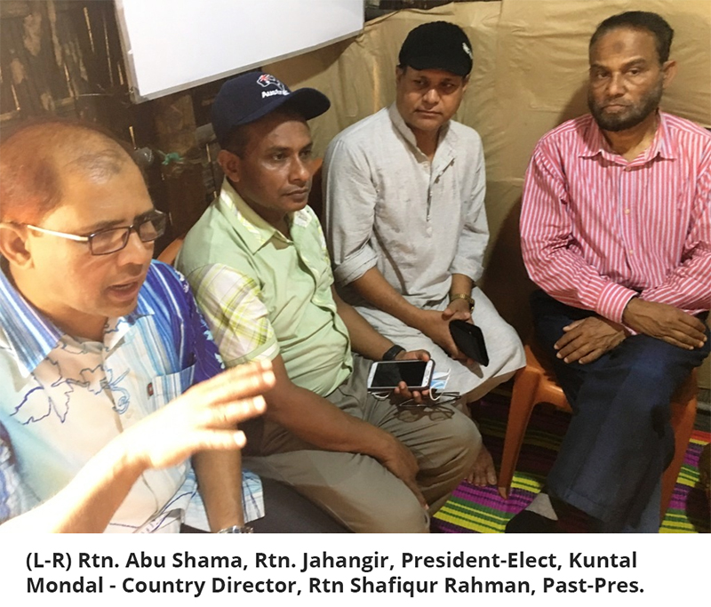
Canadian Mediators:
Anwar Sadat CFP, PhD; Consultant - Tax ,Accounting & Financial Planning
A S Tax, Accounting & Financial Services, 345 Wilson Avenue, Suite No:402
M3H 5W1 certifiedfinancial95@gmail.com Tel 1+(647)772-7693 Fax: 1+416-693-9883
(Home) 38 Lily Cup Avenue, Scarborough, ON M1L 0H4 Tel (416) 693-9883

Amed Kawser PhD, 179 Singh Trail, Winnipeg MN R2R 2A5 Kawser3891@yahoo.com

Location of Cox’s Bazar Slum where the Rotary ‘Shaikat’ Mothers’ School is Found

