Invitation to Swedish Rotary Sailing Camp, Stockholm , Sweden
2025, Aug 13 – August 23.

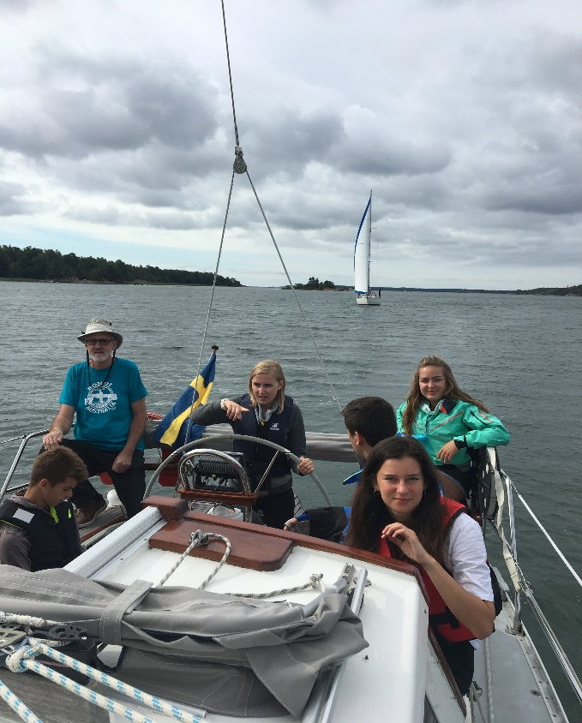

Nynäshamn Rotary Club in co-operation with Rotary Clubs around the Stockholm area, invite girls and boys from Your country (according to the camps capacity of 25) to an international Youth Sailing Camp in summer 2025.
Date: Wednesday august 13 to Saturday August 23, 2025
Contact address: Stefan Bokfors, Sailing Master, Ängsholmsgägen 91, SE 14992 Nynäshamn. Sweden
Mobile: +46708145100, e-mail: Stefan.bokfors@synergia.se
Aim to camp: To meet and get to know young people from different countries while participating in sailing, sightseeing and leisure activities
Language: English
Lodging: With families in Nynäshamn and on-board sailing yachts
Cost: Participants will be charged Euro 850 (should be paied in advanceduring month of June 2025) and will also be responsible for travel expenses to and from Stockholm, Insurance, pocket money and personal expenses.
Program. After sightseeing in Stockholm, daily sail-training from Nynäshamn and the as a crew-member on-board a sailing yacht.
Insurance: the participant must be insured against illness, accidents and third part damages. A copy of the insurance- receipt should be sent to the sailing master together with the application.

General, clothing and equipment: Capability to swim 200 meter and to speak English is a must! The applicants who are accepted will receive a detailed list of clothing and equipment.
Arrival/departure. Arlanda (Stockholm Airport) or Stockholm Central Railway Station and ferry-harbours in Stockholm will be accepted during Wednesday August 13 and departure Saturdau August 23. (There will be a Wellcome party 19.00 on August 13 in Nynäshamn)
Age: Between 18 and 20 years
Attention: Only youngsters who are interested in sailing life are adviced to apply to the Camp!
During the last period of the Camp can be rough sailing and hard work on-board!
Application: It is open for application until April 13 2025 to Sailing Master, address above and a copy to camps@rotarystudent.se. Please use Rotarys application from attached file (Rotary International, Rotary Youth Exchange, Short-Term Exchange Program (STEP) application) or link STEPApplicationEEMAProposal17.5.08 (nayen.org)
Mark carefully if you have some food restrictions or health-problems. Accepted applicants will receive further information there-after.
To the Rotary Clubs: We strongly recommend Rotary Clubs to support and help by giving interested youngsters with poor economical resources the opportunity to visit Sweden and discover sailing!

Welcome to the beautiful Archipelago in Nynäshamn (near Stockholm).

