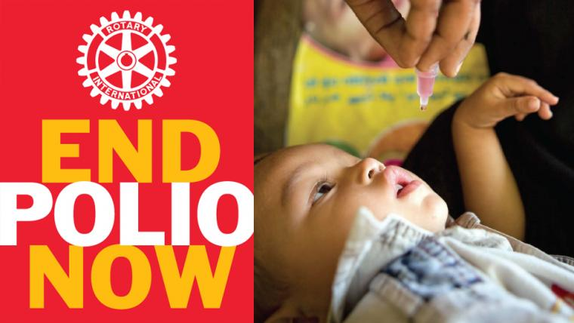

Polio is a highly infectious disease that invades the nervous
System and can lead to total paralysis in a matter of hours.

The virus is transmitted from person to person, there is no cure for polio, and it can only be prevented with the polio vaccine.
Polio mainly affects children under the age of 5, since 1988 polio cases have decreased by 99%, from an estimated 350,000 cases to 31 reported cases as of Oct 21, 2016.
- 27 Cases of wild poliovirus
- 4 Circulating vaccine-derived poliovirus (cVDPV)
As long as a single child remains infected all children are at risk of contracting polio.
Polio is down to 3 countries Afghanistan, Pakistan and Nigeria. After 2 years of being polio free Nigeria reported 2 cases.
Rotary brings together a global network of volunteer leaders who are dedicated to tackling the worlds pressing Humanitarian challenges.
Rotary connects 1.2 million of more than 34,000 clubs in over 200 Countries; our work improves lives at both the local and international level. From helping families in need in our own communities to working towards a polio free world!
Rotary has contributed more than 1.5 billion dollars and countless volunteer hours to fight polio.

.

