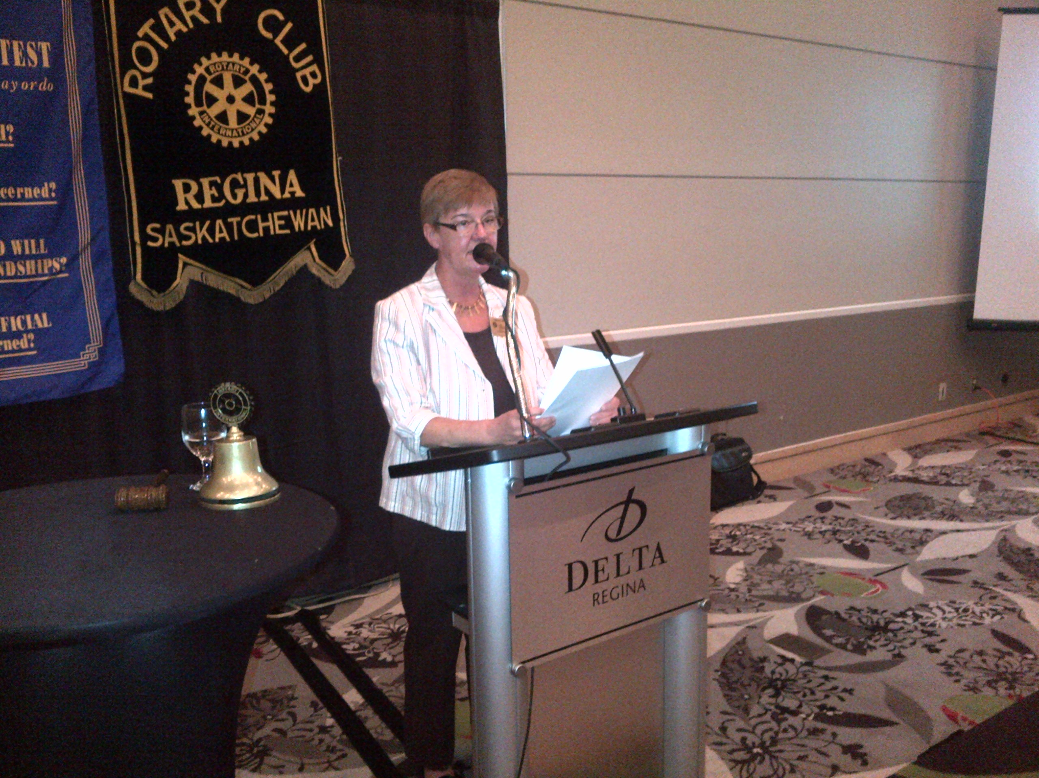 

**Membership:** Although both Rotary International and District 5550 have set some very ambitious goals for increases in membership (the district has set a goal of 20% increase) our focus next year will be membership engagement and networking. We are asking each director to recruit individuals in the club to assist with their areas of responsibility. We’re looking at two structured networking events at Club Assemblies and to further develop an orientation process/program for new members.

**Service projects:** We will certainly continue to support the excellent work of Shelter Box, the Ripple Effect, and PolioPlus; we have set a goal of reviewing the club projects/activities this year including both our work at Soul’s Harbour and the monthly Bingos. We also hope to identify one sustainable international service project by mid-November.

**Club administration**: As we have reverted to a fully volunteer board, we need to spread out some of the duties and responsibilities that were held by the previous secretary/treasurer. We will be developing a club administration committee and are working on succession plans for both the treasurer and secretary as well as recruiting a new vice-president.

President Carol Bryant outlines her Club Priorities during her Inaugural Address to the Membership

The Four-Way Test:

1. Is it the TRUTH?
2. Is it FAIR to all concerned?
3. Will it build GOODWILL and BETTER FRIENDSHIPS?
4. Will it be BENEFICIAL to all concerned?

July 15, 2013

[Date]

**Rotary International/Foundation:** As I will report later, one of Rotary International’s primary focuses next year is to keep the foundation relevant; the foundation is one of the things that allow Rotary to be more than a service club. Through its matching grants program is provides resources to change lives. The goal is to attract non-Rotarians to contribute to what can arguably be one of the most effective and cost-efficient ways of doing good in the world. We certainly support this initiative and will be increasing club members’ awareness and understanding within the club through presentations/education sessions as well as reaching out to the community for support.

**Leadership:** Our District will be introducing a Rotary Leadership Institute this fall with a rollout in September; we have budgeted to send two members to these three one-day modules that “help future club leaders prepare for their club and community leadership role through a quality training and education experience.”

**Communications:** RI is also stressing the need to heighten communications both amongst members and in the community. We are looking to strengthen communications through social media and enhanced website traffic.

**Continued…**

Camille Toussaint will arrive in Regina on August 18 and will be with us until next June.

She will be attending O’Neil High School and will be an honour member of our club and will regularly be at our meetings.

We will need to arrange for Rotary volunteers to pick her up at O’Neil and transport her back and forth to club meetings.

Camille is from Luneville France. Her parents are florists in this small city of 20,000 near the German border. She is 17 years old and has a younger sister and brother.

Camille is an honor’s student and is involved in equestrian riding. She wants to major in international business when she attends university.

Her goal in Regina is to improve her English and make good friends with her fellow exchange students and her classmates at O’Neil.

Meet our 2013/14 Exchange Student



**The Old Philosopher**

**Past President Doug**

**Rotary District Governors and the First Exchange Student**

Since 1925 the Regina Club has nominated only 7 district governors.

The first was George Rooke who took office in 1925/26. George was a Chartered Accountant with the predecessor of Deloitte Touché.

The next was in 1938/39. He DG was Percy Reed, the Provincial Dairy Commissioner at the time. I

Then in 1944/45 N.B. Williams, Sask. Liquor Board Commissioner became the District Governor.

Fifteen year late, in 1959/60, it was the turn of Charlie Dunn, the Provincial Minister of Highways. Bill Clark, an officer with Sask. Tel in 1970/71, followed him.

In 1975/76 Biff Crouch, Manager of Silverwoods Dairy become Governor. And, finally in 1990/91, Jim Toth, a local educator, was inducted. Jim is the only living past DG from the Regina club.

We will soon welcome a French exchange student who will spend a year in Regina, hosted by our club as part of the international student exchange.

In 1971 we hosted our first student, from Australia. The student was Miss Neree Evans from Tamworth. She was a most charming ambassador who delivered an outstanding talk at the District conference on June 5th of that year.

**WANTED - Donations of Furniture and Household Goods**

Are you downsizing, replacing your furniture, moving, etc? There are families in Regina who are in need of such items. **Project People** is a network of volunteers who help those who are hungry, homeless or at risk in Regina.

The Regina Rotary Club presented this group with Costco gift cards last year. They were planning to use some of the cards to purchase gas for their truck that delivers used furniture to needy families.

**Larger household goods** (furniture and beds for example) can be made available to Project People by calling: **306-533-5117**.

Individuals and agencies distribute the furniture to people according to requests that have been submitted.

**Smaller household goods** can be delivered to Indian Metis Christian Fellowship at 3131 Dewdney Avenue. Such items are made available free to people each Thursday morning.

The Canadian Diabetes Association picks up goods not taken by community members for its fundraising purposes

As most rental properties already include the major appliances (refrigerator, stove, etc.), Project People suggest that appliances should be donated to Habitat for Humanity’s Restore outlet at 1740 Broder Street, Regina, or call phone: 306-522-9705.

Submitted by Joanne Alexander