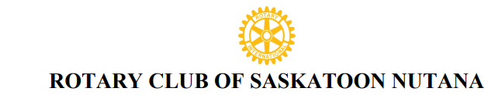
Reference: AM001
ASSOCIATE MEMBERSHIP - ROTARY CLUB OF SASKATOON NUTANA
Private and Confidential
Completed by the new member applicant. Information to be forwarded to the Rotary Nutana Club Sponsor or Club Secretary or Membership Chair.
ROTARY PROPOSER/SPONSOR (if applicable)
Proposer/ Sponsor Name ______________________________ Rotary Club: ____________________
Proposer Affiliation/ Relationship with applicant: __________________________________________

ASSOCIATE MEMBER APPLICATION
Applicant Name ______________________________ ________________ Preferred Title: ______
First and Middle Name(s) Last Name (Mr. Mrs. Ms. Dr.)
Birth Date: _______________ Married: _______Spouse/ Partner Name: _____________________
Children: __________________________________________________________________________
Residence Tel # __________________________ Cell #: _____________________________
Work # _____________________ E-Mail: ________________________________________
Home Address: _____________________________________________________________________
Street, City, Province, Postal Code
Business Name: _________________________________
Type of Business/ Profession: _______________________
Business Address: __________________________________________________________
Street, City, Province, Postal Code
Business #: ______________________ E-Mail: ___________________________________
Suggested Rotary Classification: ______________________________________________________
I am applying to become an associate member of the Rotary Club of Saskatoon Nutana. Permission is granted to publish my name to the Saskatoon Nutana members to inform them of my intent for membership. Upon acceptance by the membership of the club and board members, I agree that I will abide by the principles and bylaws that affect all Rotarians. My initiation fee of _________ to cover initial administration and international fees for the Rotary year will be paid before formal admission to the club.

Signature: ______________________________ Date: _______________

