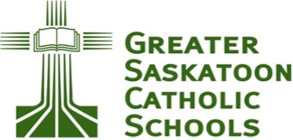

mâmawîcihtowina

The vision for awâsisak kâ-nîmîhtocik – St. Francis School is that the School will serve as a catalyst to realizing First Nations community aspirations and as an incubation site for research and innovation. The best pathway to these is through ways known to First Nations people through ancient wisdoms and contemporary adaptability. Education of Indigenous youth in the arts and culture of First Nations people is essential to finding and following this pathway.
The Rotary Club of Saskatoon Nutana and Greater Saskatoon Catholic Schools (GSCS) have partnered to support and sustain Arts and Culture in the School curriculum. This involves contributing to the schools’ culture-related startup costs, and the ongoing cost of specialized instruction, technical equipment, regalia, instruments, and related materials. All of these are essential to Indigenous cultural education, and their cost goes above and beyond funding from the Province. But the partnership between Rotary Club and Greater Saskatoon Catholic Schools is more than a financial matter. It envisions supporting the School, as a member of the community, in actualizing the Truth and Reconciliation Commission’s Calls to Action.
These objectives need the support and involvement of the community at large. With this in mind, and with the generous support of the Saskatoon Community Foundation, the Saskatoon Nutana Rotary Club has established a fund called mâmawîcihtowina, a Cree word meaning “All helping one another”. The fund will be administered by the Saskatoon Community Foundation, assuring reliable and responsive management, and will be governed by a group of Rotarians and GSCS representatives with the guidance of resource people from the Indigenous and education communities.

Reconciliation, in the meaning of the TRC Calls to Action, means creating and sustaining trusting relationships of friendship and partnership between Indigenous and non-indigenous community members. We invite you to become a friend of the mâmawîcihtowina fund as a step on your path to reconciliation. We will keep you informed of what we are doing to foster and sustain the vision of awâsisak kâ-nîmîhtocik – St. Francis School, and how you can get involved. You can accept our invitation by contacting us at nutanarotary@gmail.com. You can donate to the fund by visiting the Saskatoon Community Foundation’s dedicated link at: Https://saskatooncommunityfoundation.ca/funds/mamawicihtowina/

Thank You
kinanaskomitin


