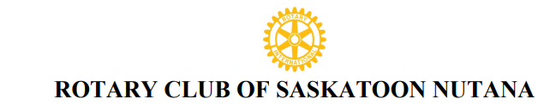
Reference: CM001
CORPORATE MEMBERSHIP PROPOSAL AND APPLICATION
DATE________________________
Private and Confidential
Completed by the new member applicant . Information to be forwarded to the Rotary Nutana Club Sponsor or Club Secretary or Membership Chair.

ROTARY PROPOSER/SPONSOR ( if applicable)
Proposer/ Sponsor Name _________________________________________ Rotary Club: ____________________
Proposer Affiliation/ Relationship with applicant : __________________________________________________

Primary Contact Name: _________________________________
Position of the Primary Contact’s Name: ________________________________
Corporate / Business Name: _______________________________________
Type of Business/ Profession: ____________________________________________________________
Business Address: _____________________________________________________________________
Street, City, Province, Postal Code
Cell #: _________________Business #: _________________ E-Mail: ___________________________
Name(s) of Corporate Associates that can attend scheduled meetings and core club activities as a proxy (with a name tag) for the Primary Contact: ( 3 names maximum)
____________________________________________________________________________________
Length of time as a corporate member in Saskatoon: ________________
List of business, professional, and community associations the proposed member supports:
_____________________________________________________________________________________
_____________________________________________________________________________________
Names of Rotarians who know the corporate member applicant:
_____________________________________________________________________________________
I apply, to become a corporate member of the Rotary Club of Saskatoon Nutana. Permission is granted to publish my name to the Saskatoon Nutana members to inform them of my intent for membership. Upon acceptance by the membership of the club and board members, I agree that I will abide by the principles and bylaws that affect all Rotarians My initiation fee of ___________ for the primary contact and for each proxy member, to cover initial administration and international fees for the Rotary year, and club fees of _________ will be paid before formal admission to the club.

Signature of Primary Applicant ________________________________ Date: ________________

