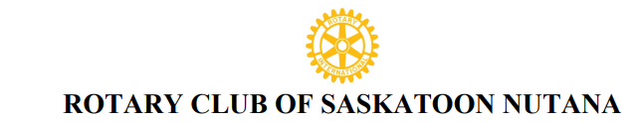
Reference: NM001
NEW MEMBERSHIP PROPOSAL AND APPLICATION
DATE________________________
Private and Confidential
Completed by the new member applicant . Information to be forwarded to the Rotary Nutana Club Sponsor or Club Secretary or Membership Chair.

ROTARY PROPOSER/SPONSOR ( if applicable)
Proposer/ Sponsor Name _________________________________________ Rotary Club: ____________________
Proposer Affiliation/ Relationship with applicant : __________________________________________________

NEW MEMBER APPLICATION
Applicant Name ______________________________ ________________ Preferred Title: ______
First and Middle Name(s) Last Name (Mr. Mrs. Ms. Dr.)

Birth Date: _______________ Married: _______Spouse/ Partner Name: _____________________
Children:___________________________________________________________________________
Residence Tel # ____________________ Cell # ___________________
Work # _____________________ E-Mail : ________________________________________
Home Address: ______________________________________________________________________________
Street, City, Province, Postal Code (Land Location if applicable)
Business Name: _________________________________
Type of Business/ Profession: _______________________
Business Address: ___________________________________________________________________
Street, City, Province, Postal Code
Business #: ______________________ E-Mail: ___________________________________________
Suggested Rotary Classification: ______________________________________________________
I apply, to become a member of the Rotary Club of Saskatoon Nutana. Permission is granted to publish my name to the Saskatoon Nutana members to inform them of my intent for membership. Upon acceptance by the membership of the club and board members, I agree that I will abide by the principles and bylaws that affect all Rotarians My initiation fee of _________ to cover initial administration and international fees for the Rotary year will be paid before formal admission to the club.

Signature of New Member Applicant ______________________________ Date: _______________

