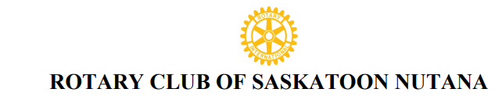
Reference: TM001
TRANSFER MEMBERSHIP PROPOSAL AND APPLICATION
DATE________________________
Private and Confidential
Completed by the new member applicant . Information to be forwarded to the Rotary Nutana Club Sponsor or Club Secretary or Membership Chair.
ROTARY PROPOSER/SPONSOR ( if applicable)
Proposer/ Sponsor Name _________________________________________ Rotary Club: ____________________________________
Proposer Affiliation/ Relationship with applicant : __________________________________________________
Applicant Name ______________________________ __________________________ Preferred Title: ______
First and Middle Name(s) Last Name (Mr. Mrs. Ms. Dr.)
Previous Rotary Club and Club ID: _____________________________
City/ Country: ___________________________________________
From : ______________________To: _____________________________
Rotary Member Number:_______________________________________ Is your membership current? Yes/No
Rotary Club Positions Held: _______________________________________________________________________
Previous Rotary Club Contact : ____________________________ Contact #:_______________________________
Birth Date: _______________ Married: _______Spouse/ Partner Name: ________________________________
Children:___________________________________________________________________________
Residence Tel # _____________________________ Cell # ______________________________
Work # _______________________________ E-Mail : ________________________________________
Home Address: _________________________________________________________________________________
Street, City, Province, Postal Code (Land Location if applicable)
Business Name: __________________________________________________________
Type of Business/ Profession: ________________________________________________
Business Address: _______________________________________________________________________________
Street, City, Province, Postal Code
Business #: __________________________________ E-Mail: ___________________________________________
Suggested Rotary Classification: ______________________________________________________
I wish to transfer my Rotary membership to the Rotary Club of Saskatoon Nutana. Permission is granted to publish my name to the Saskatoon Nutana members to inform them of my intent for membership. Upon acceptance by the membership of the club and board members, I agree that I will abide by the principles and bylaws that affect all Rotarians My initiation fee of _______ to cover initial administration and international fees for the Rotary year will be paid before formal admission to the club.
Signature of Transfer
Member Applicant ________________________________________ Date: _______________________________

