Rotary District Conference
May 4-6, 2018
Grand Bend, Ontario
“WHERE THE FUN NEVER SETS”
Alternative Programs
Tour Operator: Brad Oke – Smackwater Jacks Tour Guide: Ed Fluter

Friday May 4
Highlights of Grand Bend and Lambton Shores
- Oakwood - 11:30 am Pick up
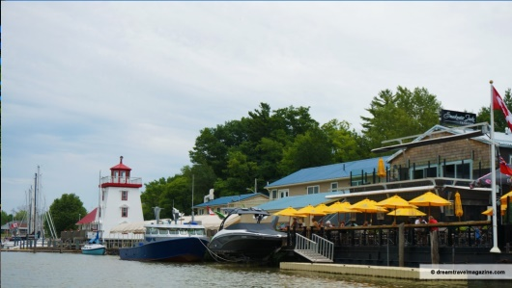
- Smackwater Jacks - 12:00 – 1pm - Lunch and optional walk thro Art Shops
A front row seat to one of the most beautiful sunsets in the world on their spacious patio on the river's edge.

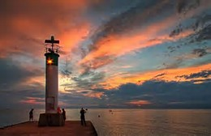
- Grand Bend -1:00 – 1;30 – Drive thro with commentary on highlights including Arts Eats and Beats , Turning Circle, Rotary Stage, Historical Walk, Site of old Casino, Beach Enhancement ( Blue Flag)
- Drive along Hwy 21 pointing out Rotary Trail , Lambton Heritage Museum, and Antique Flea Market

- Drive by Pinery (Brochure ) with narration of highlights such as Dynamic Dunes and Carolinian Forest
- Port Franks - 2:00 - Drive by with commentary on the Dunes, the Hidden Lakes, entrance of Old Aux Sable River
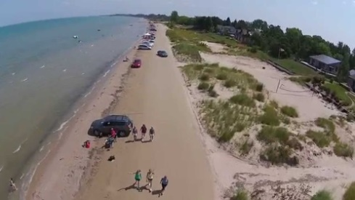
- Drive along Army Camp Road with commentary on Camp and First Nations
- Ipperwash Beach - Drive to Ipperwash Beach Club for Ice Cream stop and drive along Ipperwash Beach

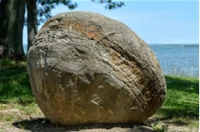
- Kettle Point –2:30- Home of Kettle Point and Stoney Point First Nations -Commentary on “Kettles”, a geological phenomenon found only tree places in the world

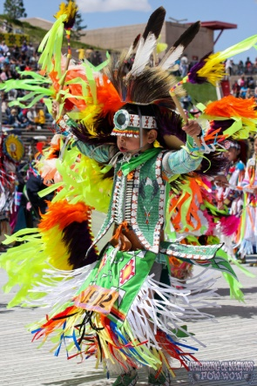
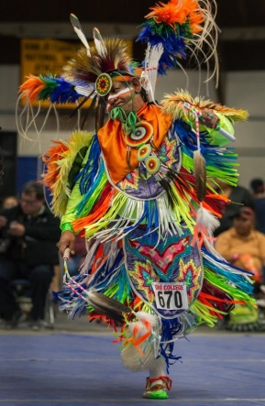
- Kettle and Stoney Point Wow – 48th Annual – July 14-15, 2018

- Drive to Rock Glen by - passing Forest and Arkona but commentary on villages. Arkona is popular for pick your own apples and cherries

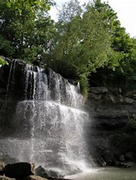
- Rock Glen - 3:30 – Waterfall, Carolinian Forest dragged here by receding Ice Age, 350 million year old fossils continually appearing with erosion, museum featuring First Nations artifacts, and Devonian Period Fossils

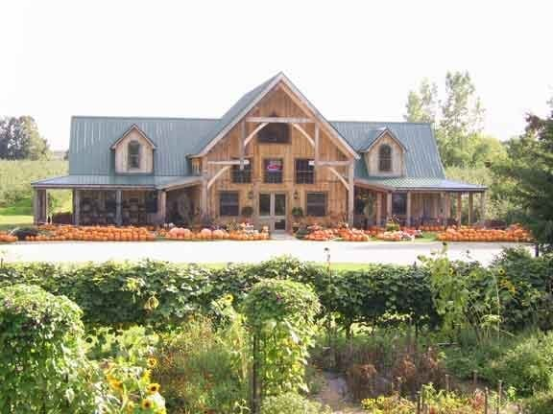

- 4:00 –4:30 - Stop at Twin Pins Apple Orchard for tasting of Gold Medal winning Apple Ciders

- 5:00 - Return to Oakwood

Rotary District Conference
May 4-6, 2018
Grand Bend, Ontario
“WHERE THE FUN NEVER SETS”
Alternative Programs and Entertainment
Tour Operator: Brad Oke – Smackwater Jacks Tour Guide: Ed Fluter

Saturday May 5
Highlights of Huron County and Bayfield
- Oakwood 11:30 - Pick up from
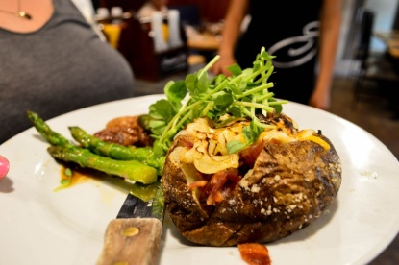
- Smackwater Jacks 12-1:00 pm –for lunch. Choose from menu

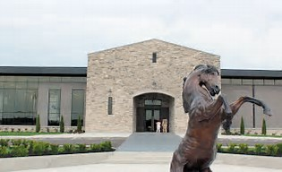
- Dark Horse Winery – 1:00pm - Deep in the heart of the lush, green Huron County countryside, right next to the iconic Huron Country Playhouse, you’ll find Dark Horse Estate Winery, the first fully functioning estate winery in Ontario’s newest winegrowing region

- Drive along Hwy 21 with commentary on St Josephs and Nascisse Cantin and proposed Canal from Pt Stanley to St Josephs

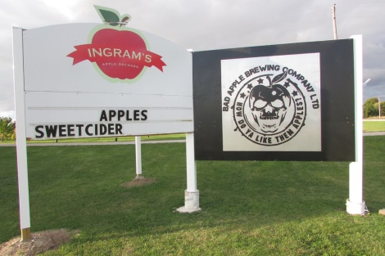
- Bad Apple Brewery 2:00 pm Bad Apple Brewing Company Ltd. is a licensed beer manufacturer. We make small batches of a variety of beers. Located on picturesque orchard along the shores of Lake Huron, Bad Apple Brewing Company has the freshest cider available for making taste bud tantalizing apple beer. Other new Brew Companies in Huron - Stonehouse in Varna, Maelstroms in Seaforth, River Rd. in Bayfield, Square Brew in Goderich and Cow Bell in Blythe)

- Bayfield –3:00 – 4:00 - Drive Through – Yacht Club, River, Beach with Boat Wreck , Pier, Albion Hotel, Shopping .
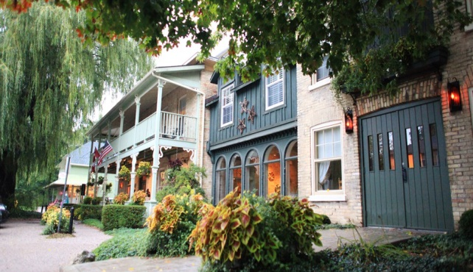
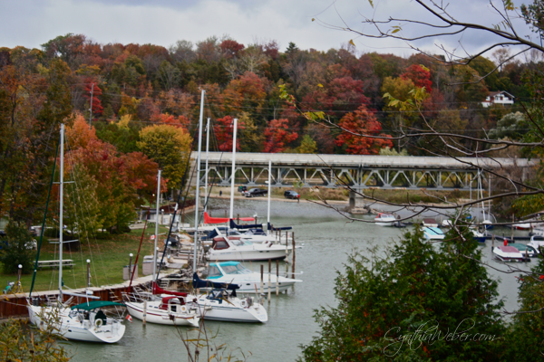

- 4:30 - Return to Oakwood

Additional Information-
- Price – $40 @ per day - Lunch, Transportation, Tour,
Entry Fees , Tastings etc
- Weather – Come prepared
- Transportation –Tour Bus – Compliments of Smackwater Jacks

Sunday – May 6
Optional Activities
- Golf
- Tour Grand Bends Arts Eats and Beats Sites
- Grand Bend Walking Tour
- Pinery Visit
- Dark Horse Winery
- Huron County Craft Beer and Wine Tour
- Bayfield Shopping.
- Lambton Heritage Museum
- Pinery Antique Flea Market

