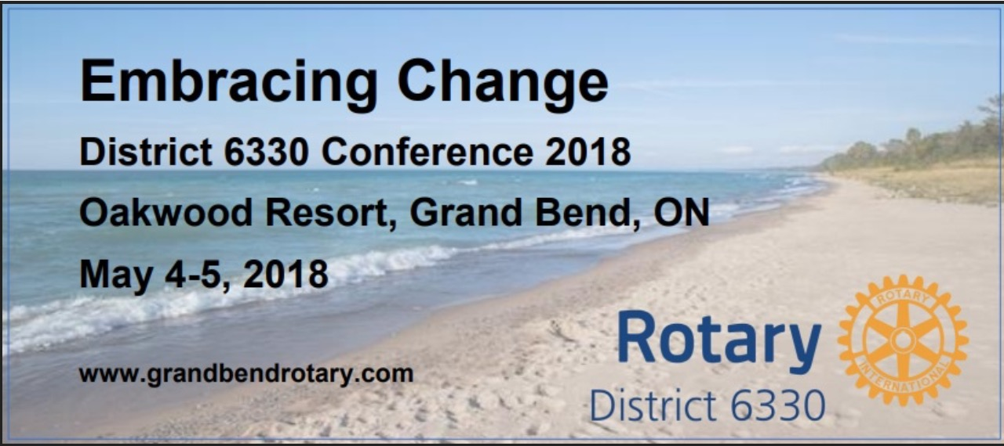

**SATURDAY PROGRAM SCHEDULE**

**Saturday, May 5, 2018**

**Morning**

8:00 AM Registration Opens

8:00 AM Breakfast

8:30 AM – 9:15 AM House of Friendship Opens

9:15 AM – 9:45 AM Alternate Program “Painting with Teresa Marie”

Meet in the Hotel Lobby

9:15 AM – 9:45 AM Welcome & Opening Remarks

Celebration of Life

9:45 AM – 10:30 AM Plenary Session “ Embracing Change by Seizing the

Helm not the Lifeboat” with Dennis Shackel

10:30 AM – 10:45 AM Break

10:45 AM – 11:45 AM Breakout Sessions

1. Road to Rotary
2. The Climate Crisis, and the Road to Energy Freedom

11:30 AM Alternate Program – Highlights of Huron County & Bayfield

11:45 – 12:00 Youth Exchange Video

**Lunch**

12:00 – 12:45 PM Youth Program (we will learn from our youth)

**Afternoon**

12:45 PM – 1:30 PM Youth Exchange and Interact Student Presentations

1:30 PM – 2:30 PM Plenary Session - Understanding Change with Kristine Clark

2:30 PM – 2:45 PM Break

2:45 PM – 3:45 PM Breakout Sessions

1. Road to Rotary
2. The Climate Crisis, and the Road to Energy Freedom
3. Understanding Change Workshop

3:45 PM – 4:00 PM Next Year’s Conference: Hanover Club

4:00 PM – 4:15 PM Wrap-up

**Dinner**

5:00 PM – 6:00 PM Pre-dinner Cocktails & Entertainment

6:00 PM – 7:45 PM Dinner

7:45 PM – 8:45 PM The Future of Rotary – Amanda Watkin

**Evening**

8:45 PM – 10:00 PM Shuttle to Jazz Event with Grand Bend’s Art Centre’s Annual Concert: Mardi Gras in Grand Bend with

Red Hot Ramble. Or Free time in the Oakwood Pub

**Sunday, May 6, 2018 –** No Conference activities. Stay and Enjoy Grand Bend’s

Weekend Art, Food and Music Festival.

**FRIDAY PROGRAM SCHEDULE**

**Friday May 4, 2018**

**Morning**

9:00 AM Registration opens

9:45 AM – 11:15 AM PDG Council Meeting

10:00 AM House of Friendship opens

11:30 AM Alternate Program “ Highlights of Grand Bend

and Lambton Shores” Meet in the Hotel Lobby”

**Lunch**

11:45 AM – 12:30 PM Welcome & Opening Remarks

Featured Speaker – Amanda Watkin

(Rotary International President’s Representative)

12:30 pm – 1:45 pm Working Lunch – **Embracing Change**

(we will learn from each other)

**Afternoon**

1:45 PM – 2:45 PM Forum – Embracing Change

2:45 PM – 3:00 PM Break

3:00 PM – 4:00 PM Plenary Session “ The Evolution of a Smart City - Stratford

Embraces Change” with Joani Gerber

4:00 PM – 5:00PM District 6330 Annual District Business Meeting

**Evening**

5:30 PM – 6:30 PM Pre-dinner Cocktails

6:30 PM – 7:45 PM Dinner

7:45 PM – 8:30 PM “Love Your Greats: The Search for Environmental

Optimism” with Jennifer Pate

8:30 PM – 8:50 PM Heads and Tails “All Proceeds to Polio”

8:50 PM – 10:00 PM An Evening of Fun and Live Entertainment “Cabaret”