RENEE & LIN’S TRIP TO RWANDA
SOME PICTURES AND THE STORY BEHIND THEM

BURUNDI REFUGEES WELCOME IN RWANDA

UNHCR: FROM TENTS TO DECENT LODGINGS IN 2 YEARS
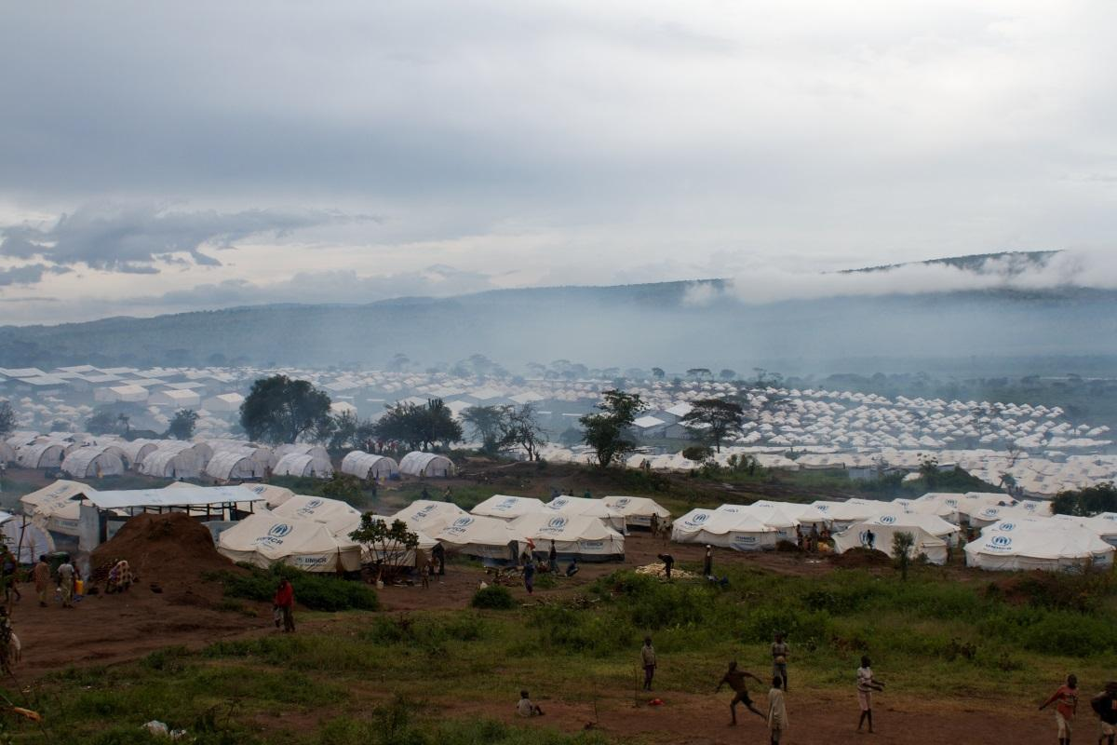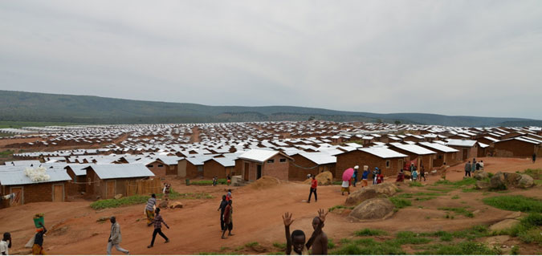
Population: 56000
water, electricity, elementary schools, health centres, central market, craft centre.
impeccable security measures

Rwandese individual citizens: Generosity
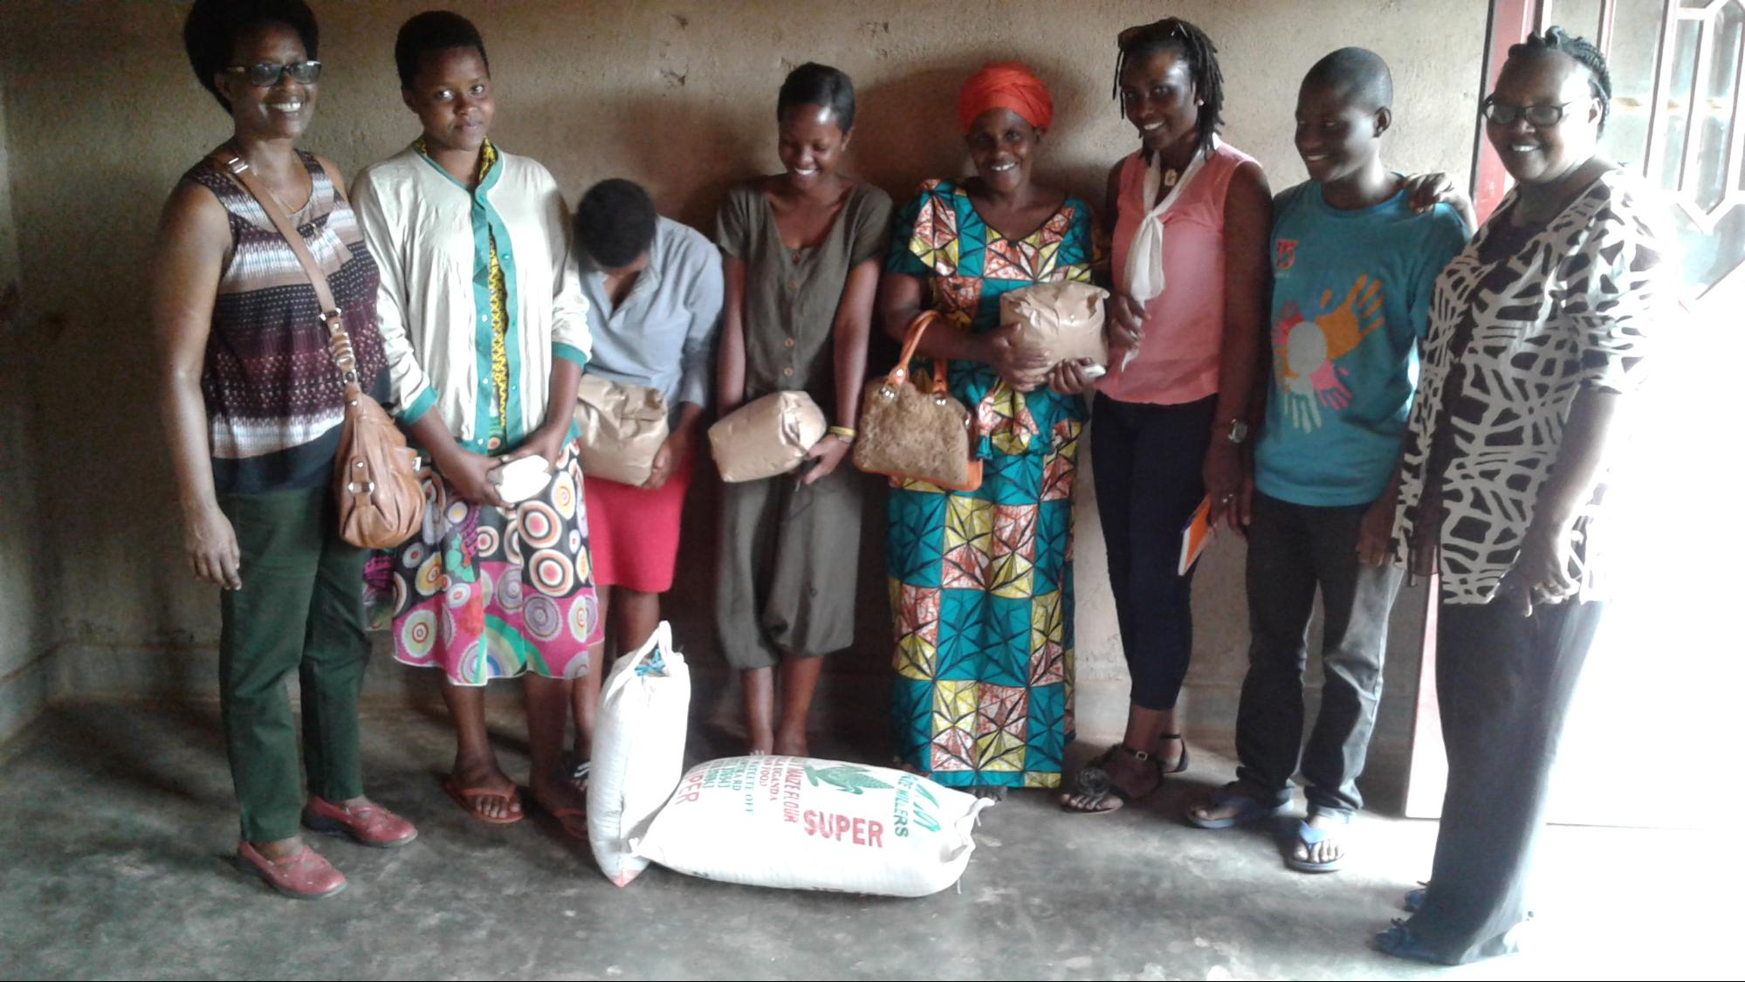
This family (Mom & 5 kids) fled Burundi following the slaughter of close neighbors inJune 2015. They landed at a Rwandese friend’s home in Kigali, Rwanda and spent a couple of months. The friend’s generosity led him to lend them his house in a village out of Kigali where they’ve been living since.

REFUGEES’ OWN STORIES : CHALLENGES

Our team on the ground has selected 20 families who are the most vulnerable. We visited them all. But we will give you only a sample of their various challenges.
From the very beginning of our visit, we were determined to genuinely listen to the stories of those afflicted Burundi refugees. We wanted to gain knowledge by attempting to share their experience. Here are some examples of their stories and worries relating to basic needs that are hardly met.

Resentment for camp life
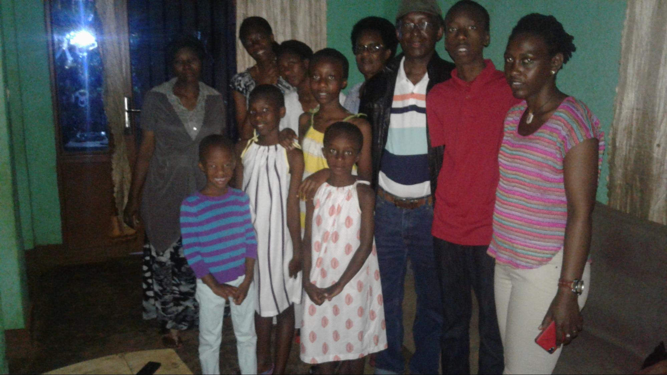

The family (2 parents & 6 kids) lived in an area, a hotbed for demonstrations against the third presidential term of Nkurunziza.
They did not join the Mahama UNHCR camp. The wife said that her experience in camp for internally displaced people in Burundi prevented her from taking her kids to Mahama in Rwanda. She is afraid of bad conditions of living and bad behaviour kids learn there.
The husband works at a carwash - makes the equivalent of $60 a month just to pay the rent. They need food for an equivalent of $80

This family is split
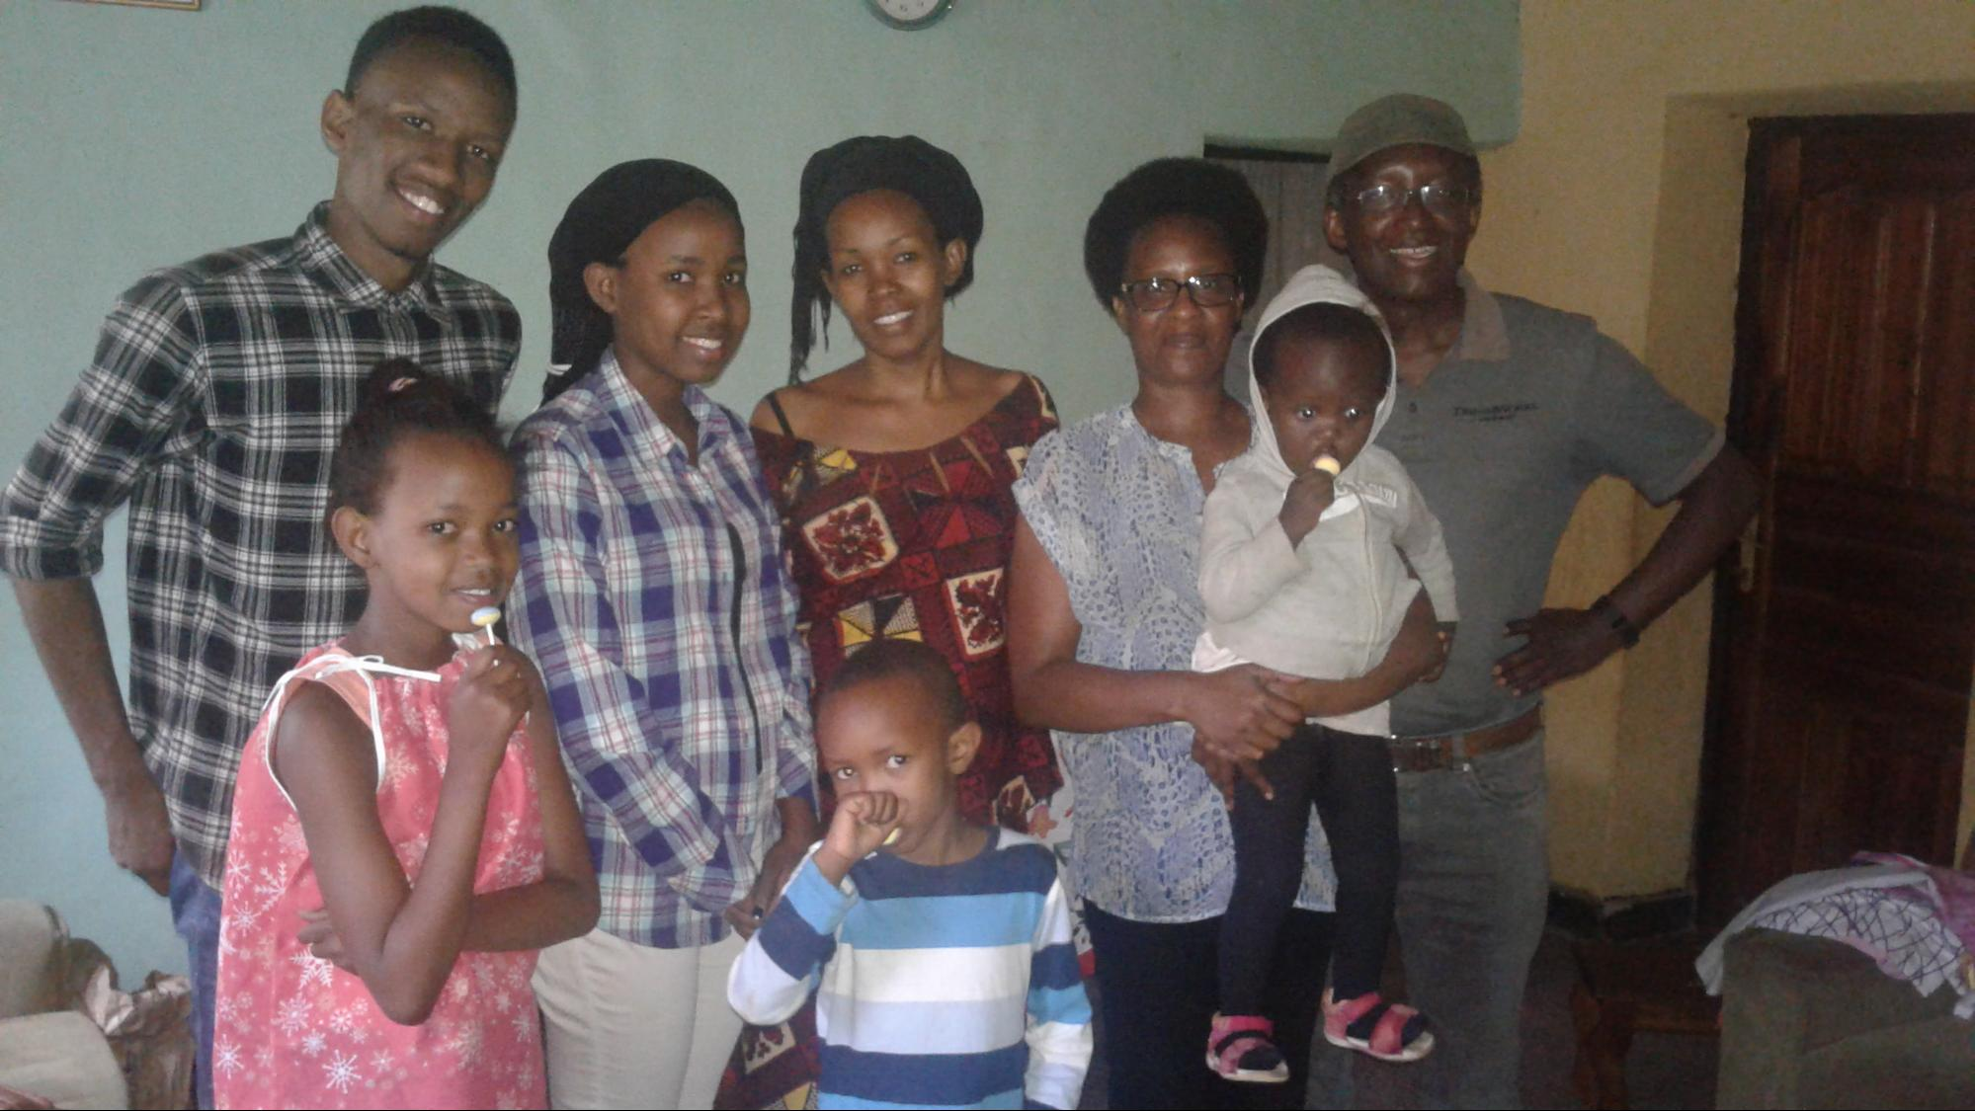
The wife & 4 kids stay with a Rwandese aunt. The husband & another child stay with another family.
It would be good to have a shelter of their own for a $50-monthly rent and money for food - $60/month

Mother’s hard choice
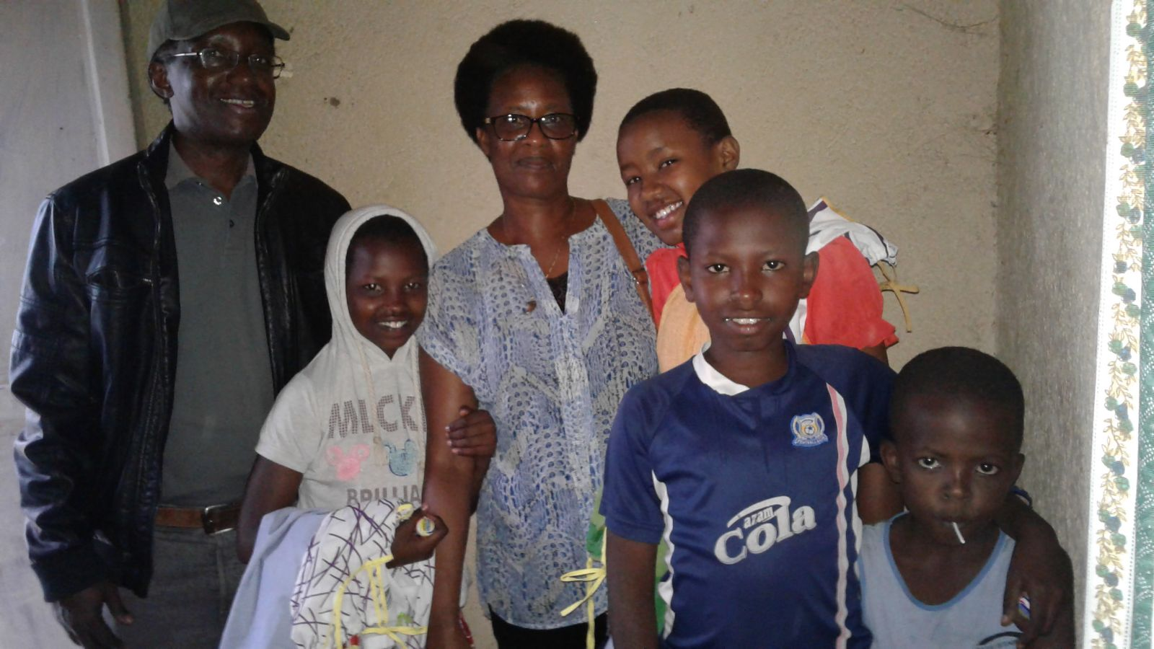
When they fled they went to Mahama Refugee Camp. Once there, the marriage started to suffer. The wife was disappointed by the living conditions and especially her husband’s behaviour that she decided to move to Kigali with her 4 kids.
She tries to sell jewelry and food. She wishes to get a loan of $500 so she can buy and sell clothing.
In the meantime she needs money for food :$50 and shelter: $40

Resentment for camp life & disease
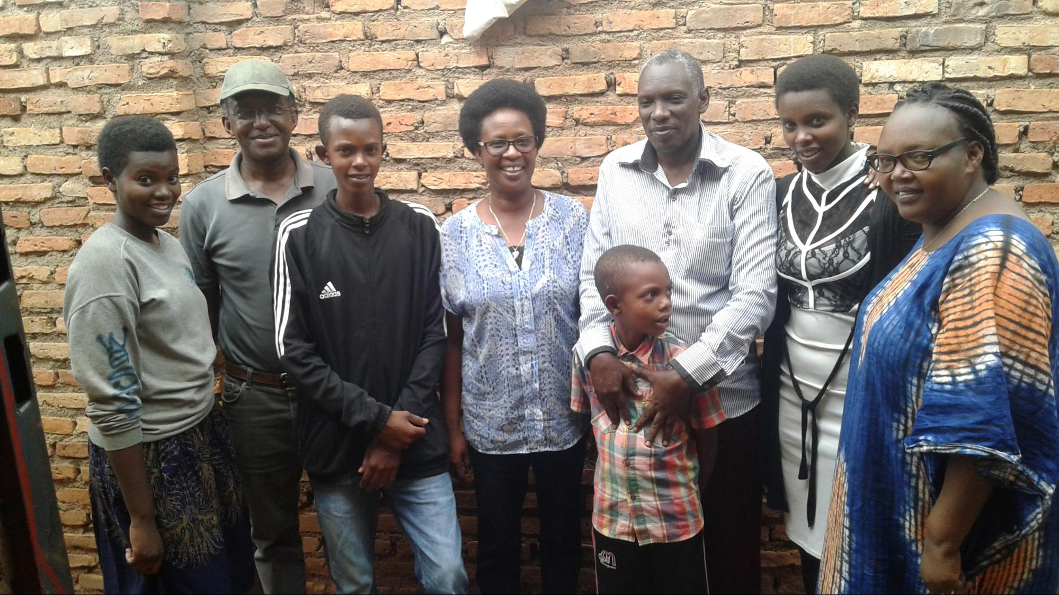
The wife is a Rwandese. When the family (2 parents & 6 kids) fled in 2015, they landed at Rwandese grandma’s. But few months later, the grandma died and the family was told to vacate.
The husband grew up in an internal camp in Burundi and cannot go back to Mahama camp. One son had malaria and had been taken to a health center by his coach.
The husband would like a loan $800 to start a small business: clothing .
In the meantime, they need money for food: $80

Survived torture but partner in car accident
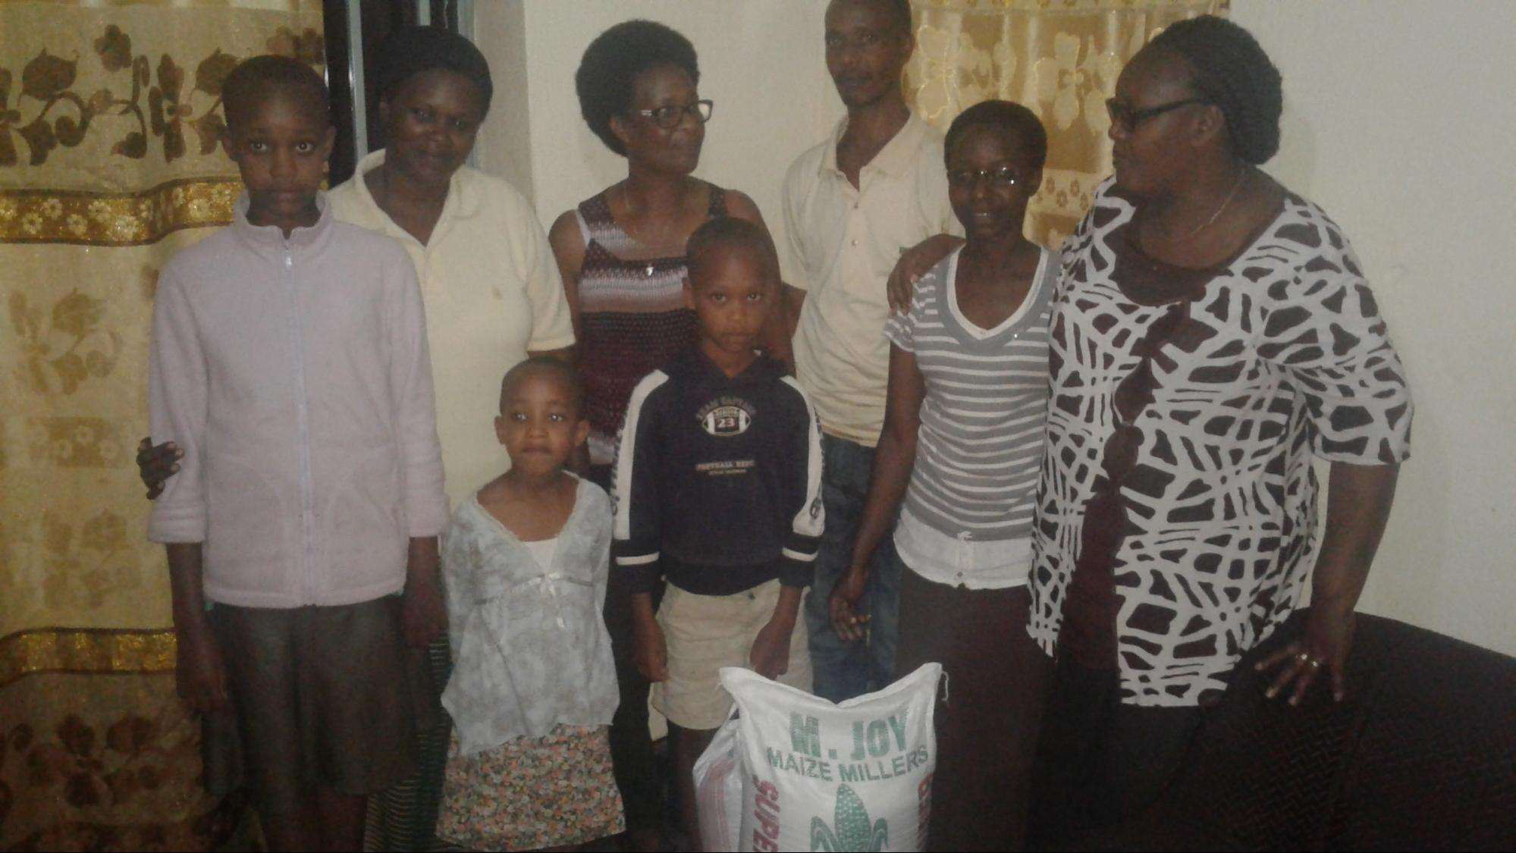
The family lived in Bujumbura. Due to threats, the wife came first with her 4 kids in 2015. The husband was tortured and left for dead in Burundi. But luckily he managed to get help and joined the family in 2016. The wife was recently in a car accident, she has broken ribs. She was told to wait until they heal on their own. She struggles to pay for adequate pain control drugs.
If the family gets a loan ($900) they would start a small business in the clothing industry. In the meantime, they need money for food: $60

No space to breathe
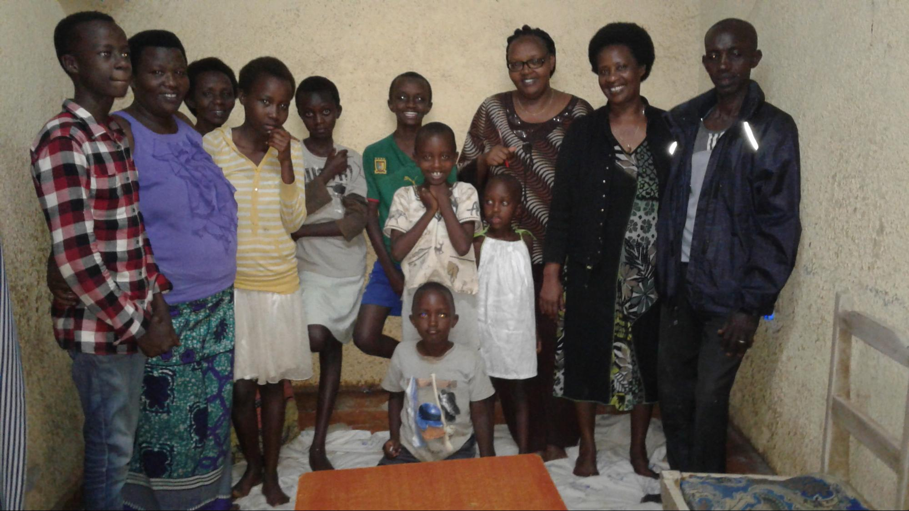
Three families living in a two bedroom shelter- they are 15 people crowded in that tiny space- they take turns to sleep - on the floor since they do not have beds or mattresses. They need food, a bigger shelter, and a minimum of basics things such as mattresses.

Death in the family
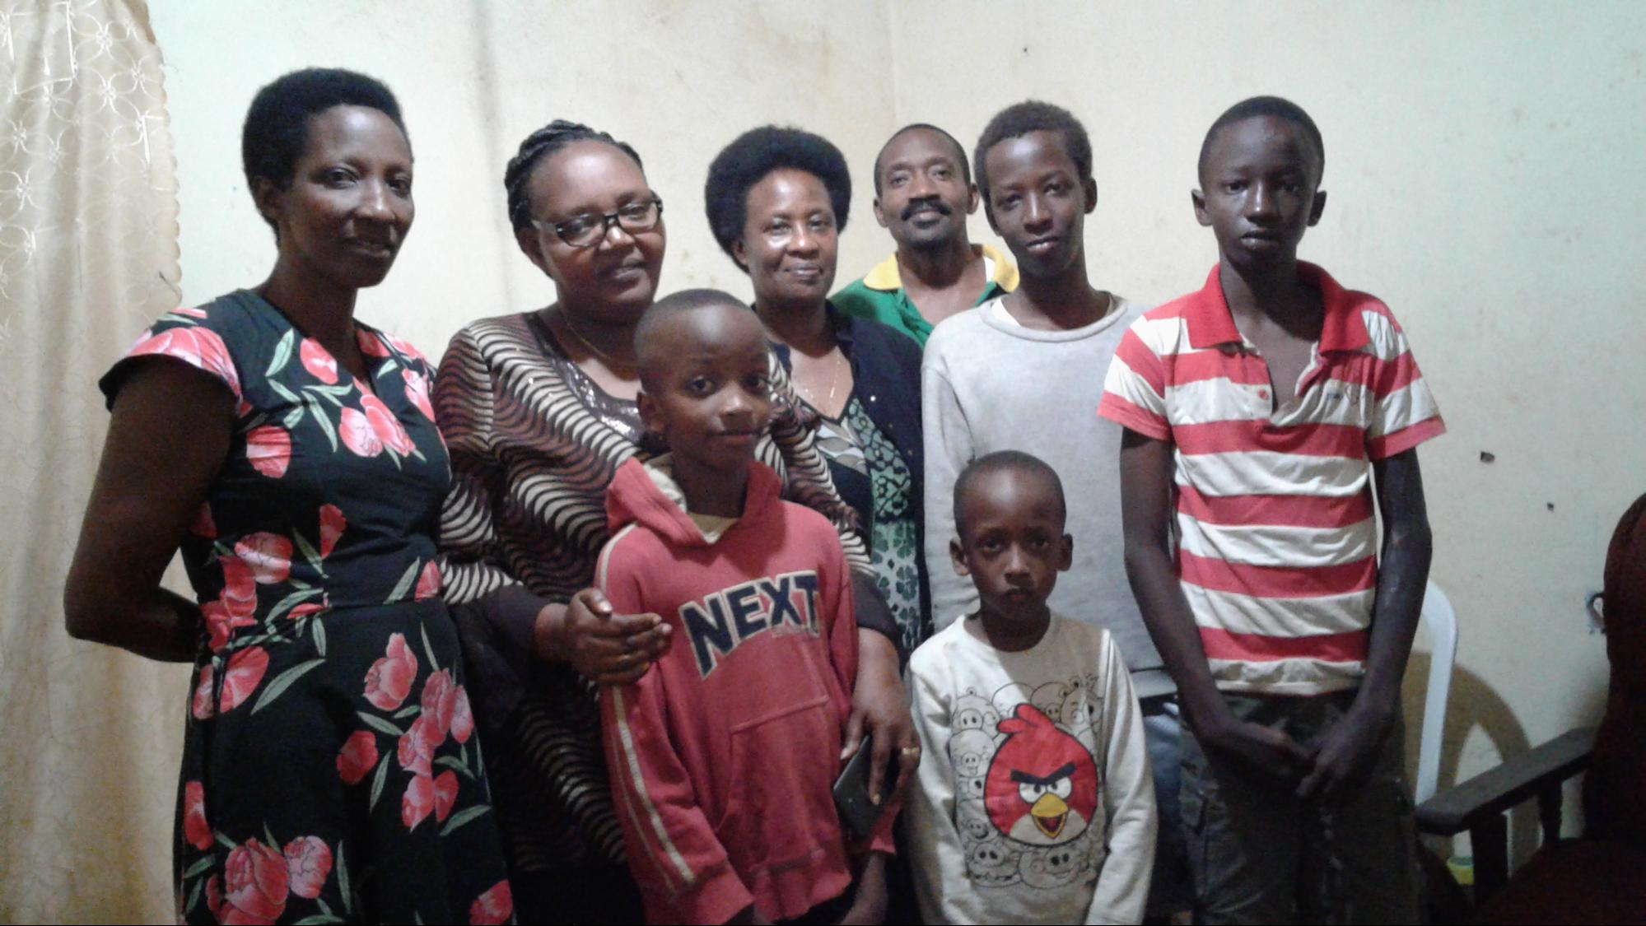
The family: 2 parents & 4 kids.
The husband recently died:was hit by a bicycle a month earlier -he did not receive the needed care - when he got hospitalised it was too late.
Now the children are shocked and traumatized. They cannot sleep, they have all kinds of pain such as chest pain or epilepsy. One son just returned from boarding school because he says he cannot live far from his mother afraid that she might die during his absence.
The . mother has started with $100 to sell tomatoes. She would like to get a bigger loan $500 to start buying and selling shoes.
In the meantime, she needs money to pay for shelter, food and drugs and counselling. Total $200/ month

THE WAY AHEAD
ROTARY CLUB’S SUPPORT
A wonderful Rotarian, Pat: dresses
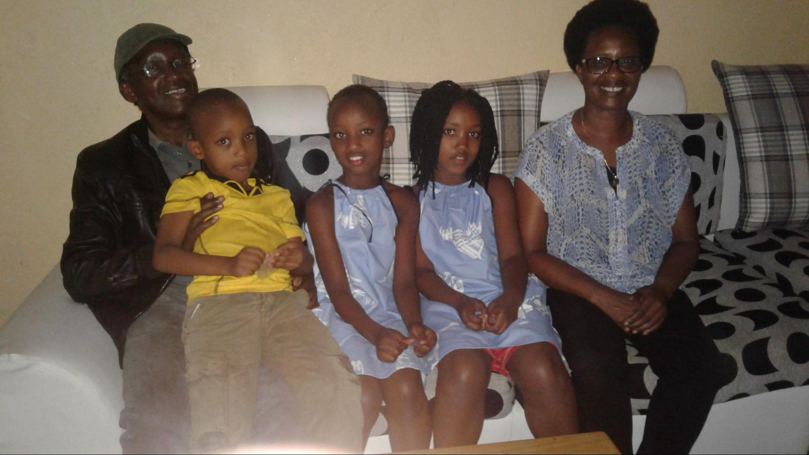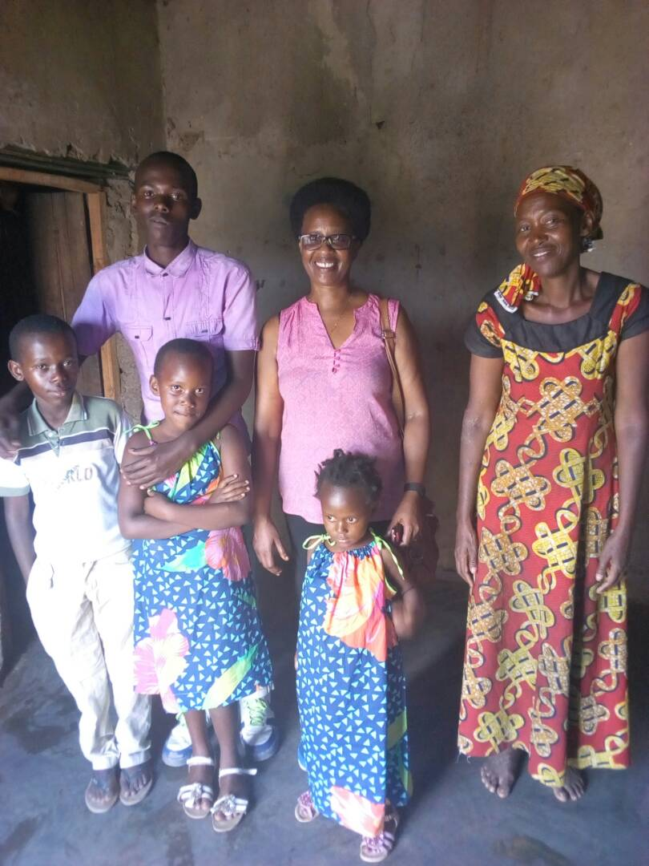
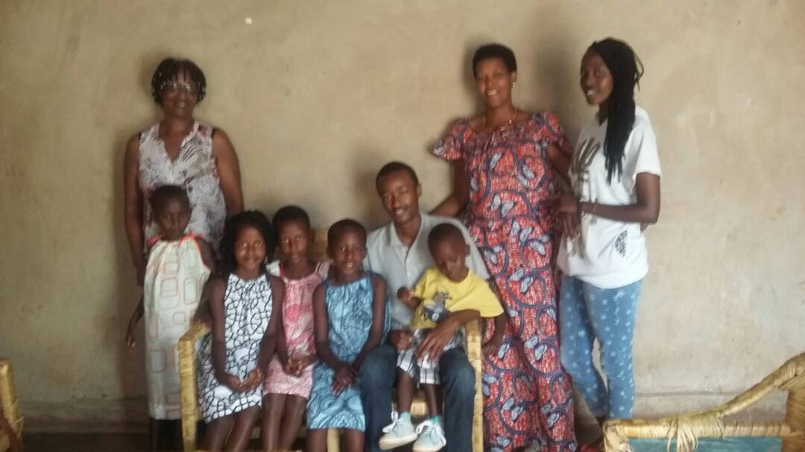,

Our club has been supportive all along

- Donations: $1500 in 2014
- Active in our fundraising efforts
- Wish to resort to talents in the club: ideas, networking...

Burundi Education Fund : joint action in Rwanda
- Renee’s brother, Egide lives in USA and is actively involved in fundraising activities. He is a rotarian himself and enjoys a wide network of committed humanitarians. He visited Rwanda twice last year and establish contacts and , assess needs. We went in his footsteps to have a same understanding of the situation of Burundi refugees.
- During the school year Jan 2017 - Nov 2017
    - 359 students benefited from BEF aid.
    - The number of families of these students: 142
    - 27 students graduated from high school
    - Total amount spent: 29 412 US dollars
    - Our contribution was 6000 US dollars
- Family members to commit
- urged at Christmas to get more involved in order to meet the basic needs of refugees:
    - housing/rent
    - Food
    - Clothing
    - Health
    - Kids schooling
    - Travel expenses
    - support business initiatives by refugees: secure bank loans

- Objectives: Continue fundraising activities
- Immediate needs: $20,000
- Long- term: $100,000 to help the 20 families
- A credit fund - so people can initiate their own businesses and be gradually self- reliant.

